**INTRODUCTION TO**

**INSTI-TOOL**

**INTRODUCTION:**

The “INSTI-TOOL” is an easy to use, visually appealing, and user-friendly application which provides all the necessary tool to manage an institution.

“Institution tool” provides unique RFID to everyone enrolled in the institution which includes students and Staff. This replaces the traditional ID cards used.

The unique RFID carries the information about the individual, given at the time of enrolling into the institution.

Students who are provided with the RFID will be using it to enter and exit the college, the reason for this being that the entry and exit time of the student be recorded, which will be used to provide statistics to the staff and parents/ guardians. The same can be used to fetch the details of the student by the staff. It can also be used by the librarian to feed the details about the borrowed books by the student. It too provides the details of fees and other dues.

Staff are provided with RFID through which they will login into the application and into their form.

This application has an inbuilt mailing functionality which will be used by the staff to send any query related to student or the institution like fees remainders, event notification, payment receipt.

Another feature of this application is that it has a notification function which is used for communication within the application.

Students and parents/guardians can login into the application using the register number (USN) of the student to check the details about their attendance, fees dues, book dues and view in-app notifications.

Parents will get to see the time of entry and exit from the college of their ward which ensures peace of mind.

More details about the application development are as follows-

**SYNOPSIS**

**INSTI-TOOL**

**AIM**

The main objective of the project **INSTI-TOOL (RFID)** is to help Colleges to integrate smart way of storing Students and staff data in one single place in a systematic manner

**DISCRIPTION**

**The project consists of 5 Modules**

1. **Login Module**- lets the user choose where they want to login, namely admin, teacher, librarian, parents, students where admin uses username and password, staff uses RFID this application automatically recognises the staff and will open the form related to them, parents will use students name, students will use register number to login
2. **Admin Module**- lets the admin to add\update\delete staff or students and lets the admin know\make changes to the data which is entered by lecturer and gives full control over the application and its database.
3. **Department Module**- As RFID recognises the staff, application automatically opens appropriate form and provides appropriate control respectively

* Principal module
* Head of the department module
* Lecturer module
* Librarian module
* Accountant module

1. **Parent Module**- it lets them see attendance and other basic information about the students and they will be able to see notices sent by department
2. **Student Module**- it gives the information of attendance, their fees details, library details and other related information

**UPDATE OVER EXISTING SYSTEM**

* This system saves the time of the student and of the administrator. It includes processes like registration of the student’s details, assigning the department based on their course, and maintenance of the record. This system reduces the cost and workforce required for this job. As the system is Systemized the information is present to everyone who has access.
* This makes the system easy to handle and feasible for finding the omission with updating at the same time. As for the existing system, they use to maintain their record manually which makes it vulnerable to security. If filed a query to search or update in a manual system, it will take a lot of time to process the query and make a report which is a tedious job.
* As the system used in the institute is outdated as it requires paper, files, and binders, which will require the human workforce to maintain them.
* As the number of the student increases in the institute manually managing the strength becomes a hectic job for the administrator. This computerized system stores all the data in the database which makes it easy to fetch and update whenever needed.
* With this new tool, all the data is just a “tap” away from accessing, data can be viewed accurately within seconds

**HARDWARE AND SOFTWARE REQUIREMENT**

The front-end of the project was developed using **Visual studio 2019 using visual basic with .NET framework 4.7.2**. Back-end **SQL Data Tools – 16.0.62111.11070**. The operating system used to develop the project was **Windows 11**. This application also needs an external **RFID reader** with **RFID cards** matching the frequency of the scanner to operate

* Lenovo: ideapad 330s
* Processor: Intel i5 8th gen
* Ram: DDR4, 8gb 2666mhz
* Storage: 360gb SATA SSD & 1tb Seagate HDD
* Keyboard: Logitech Y-U0009
* Mouse: Zebronics Transformer-M
* RFID reader: Time office Z11-ICV
* RFID cards: Rapid Radio 13.56MHz

**Minimum requirements**

* Intel Pentium IV processor or equivalent or higher
* 4 GB Ram or Higher
* 20 GB HDD or Higher
* RFID reader: Time office Z11-ICV
* RFID cards: Rapid Radio 13.56MHz
* Windows 10 or higher

**ER-DIAGRAM**

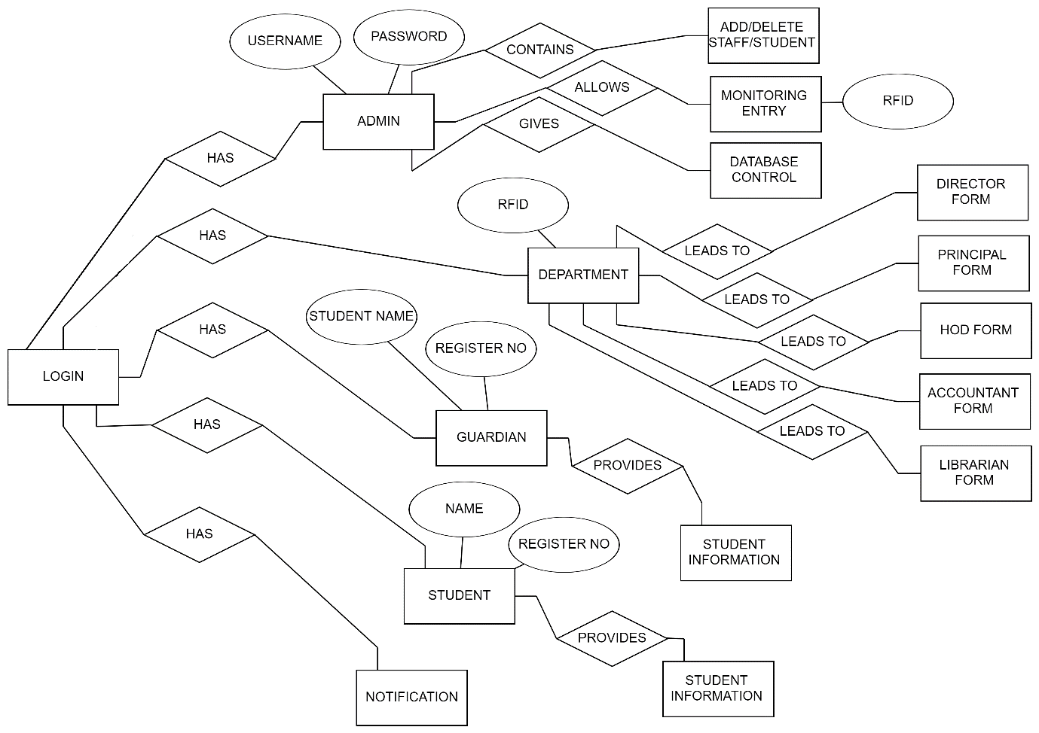

**DATA FLOW DIAGRAM**

**DATAFLOW DIAGRAMS:**

A data flow diagram is graphical tool used to describe and analyze movement of data through a system. These are the central tool and the basis from which the other components are developed. The transformation of data from input to output, through processed, may be described logically and independently of physical components associated with the system. These are known as the logical data flow diagrams. The physical data flow diagrams show the actual implements and movement of data between people, departments, and workstations. A full description of a system consists of a set of data flow diagrams. Using two familiar notations Yourdon, Gane and Sarson notation develops the data flow diagrams. Each component in a DFD is labeled with a descriptive name. Process is further identified with a number that will be used for identification purpose. The development of DFD'S is done in several levels. Each. process in lower-level diagrams can be broken down into a more detailed DFD in the next level.

The lop-level diagram is often called context diagram. It consists of a single process bit, which plays vital role in studying the current system. The process in the context level diagram is exploded into other process at the first level DFD.

The idea behind the explosion of a process into more process is that understanding at one level of detail is exploded into greater detail at the next level. This is done until further explosion is necessary, and an adequate amount of detail is described for analyst to understand the process. Larry Constantine first developed the DFD as a way of expressing system requirements in a graphical from, this led to the modular design. A DFD is also known as a "bubble Chart" has the purpose of clarifying system requirements and identifying major transformations that will become programs in system design.

So, it is the starting point of the design to the lowest level of detail. A DFD consists of a series of bubbles joined by data flows in the system.

**DFD SYMBOLS:**

In the DFD, there are four symbols

1. A square defines a source(originator) or destination of system data

2. An arrow identifies data flow. It is the pipeline through which the information flows

3. A circle or a bubble represents a process that transforms incoming data flow into outgoing data flows.

4. An open rectangle is a data store, data at rest or a temporary repository of data.

Process that transforms data flow

Source or destination of data

Data flow

Data store

**CONSTRUCTING A DED:**

Several rules of thumb are used in drawing DFD'S:

1. Process should be named and numbered for an easy reference. Each name should be representative of the process.

2. The direction of flow is from top to bottom and from left to right. Data traditionally flow from source to the destination although they may flow back to the source. One way to indicate this is to draw long flow line back to a source. An alternative way is to repeat the source symbol as a destination.

Since it is used more than once in the DFD it is marked with a short diagonal. 3. When a process is exploded into lower-level details, they are numbered.

4. The names of data stores and destinations are written in capital letters. Process and data flow names have the first letter of each work capitalized.

A DFD typically shows the minimum contents of data store. Each data store should contain all the data elements that flow in d out. Questionnaires should contain all the data elements that flow in and out. Missing interfaces redundancies and like is then accounted for often through interviews.

**SAILENT FEATURES OF DED'S:**

1. The DFD shows flow of data, not of control loops and decision are controlled considerations do not appear on a DFD.
2. The DFD does not indicate the time factor involved in any process whether the dataflow take place daily, weekly, monthly, or yearly.

3. The sequence of events is not brought out on the DFD.

**RULES GOVERNING THE DED'S:**

**PROCESS**

1) No process can have only outputs.

2) No process can have only inputs. If an object has only inputs than it must be a sink.

3) A process has a verb phrase label.

**DATA STORE:**

1) Data cannot move directly from one data store to another data store, a process must move data.

2) Data cannot move directly from an outside source to a data store, a process, which receives, must move data from the source and place the data into data store

3) A data store has a noun phrase label.

**SOURCE OR SINK:**

The origin and /or destination of data.

1) Data cannot move direly from a source to sink it must be moved by a process

2) A source and /or sink has a noun phrase land

**DATA FLOW:**

1) A Data Flow has only one direction of flow between symbols. It may flow in both directions between a process and a data store to show a read before an update. The latter is usually indicated however by two separate arrows since these happen at different type.

2) A join in DFD means that the same data comes from any of o or more different processes data store or sink to a common to location.

3) A data flow cannot go directly back to the same process it leads. There must be at least one other process that handles the data flow produce some other data flow returns the original data into the beginning process.

4) A Data flow to a data store means update (delete or change).

5) A data flow from a data store means retrieves or use.

A data flow has a noun phrase label more than one data flow noun phrase can appear on a single arrow if all the flows on the same arrow move together as one package

**DATA FLOW DIAGRAM:**

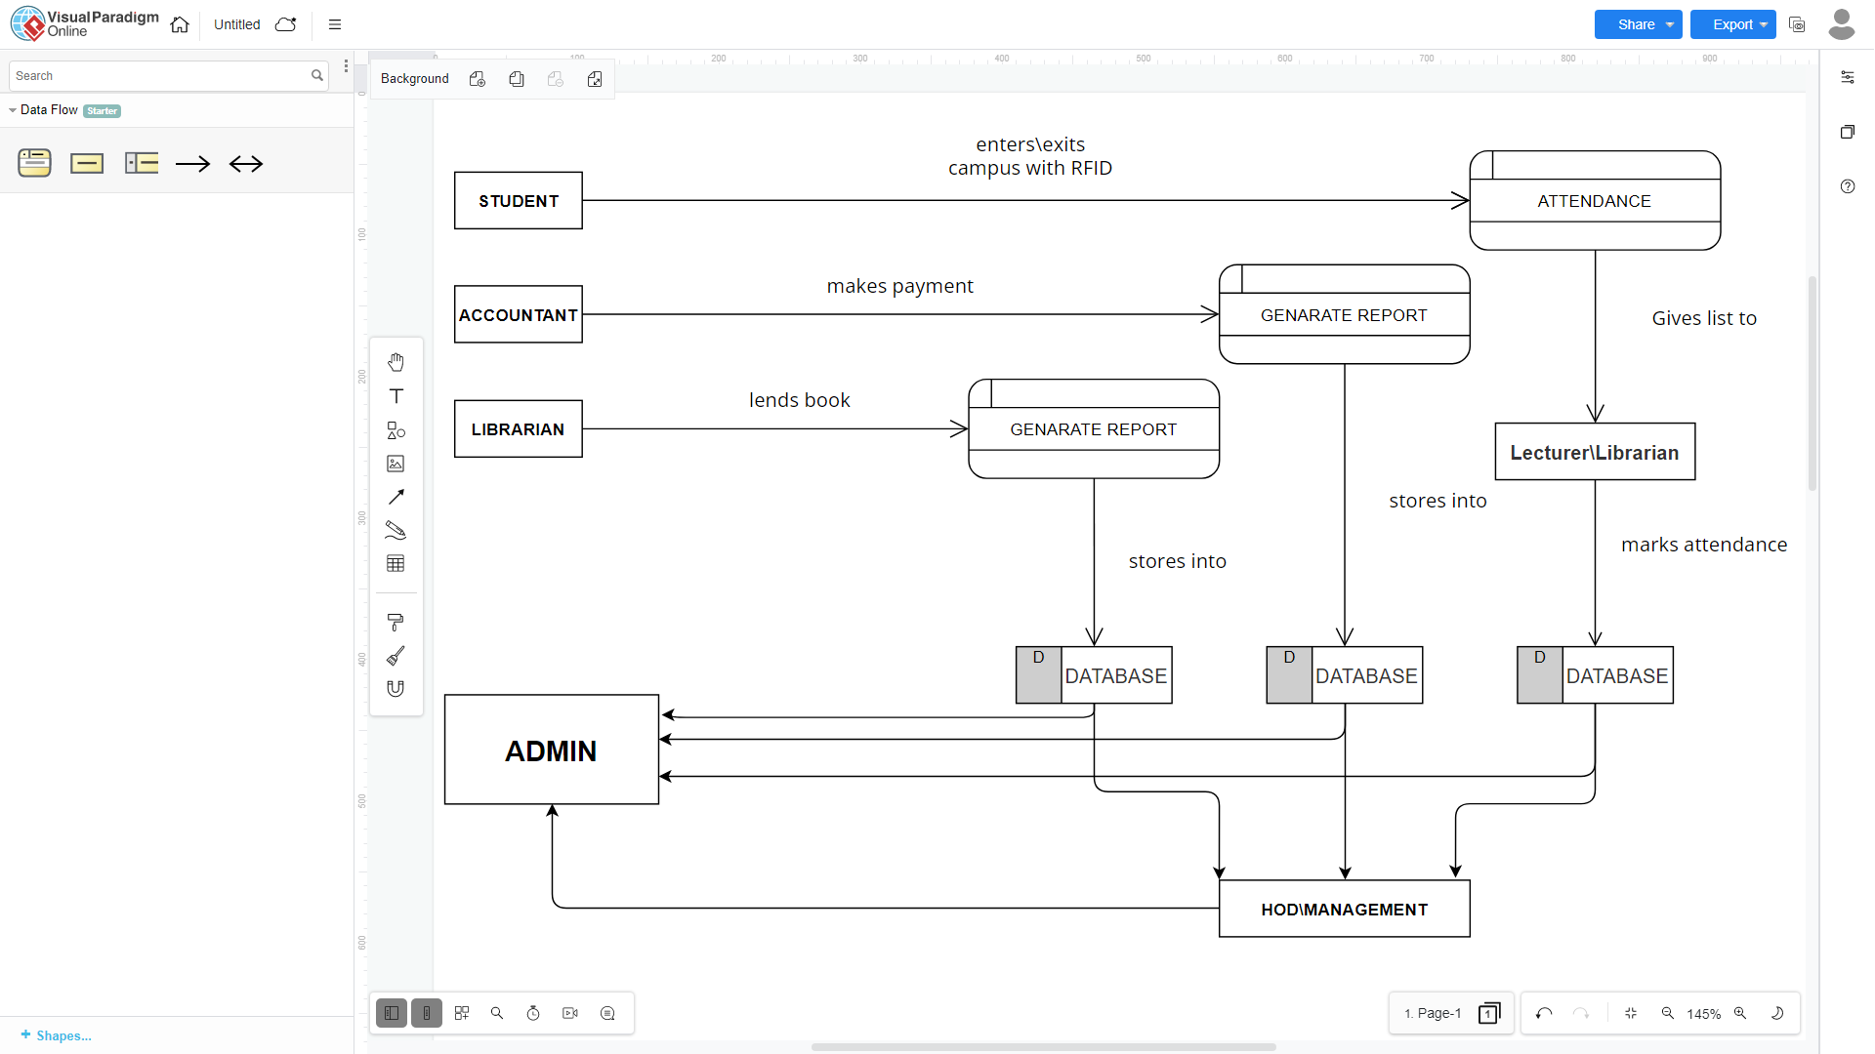

**INTRODUCTION TO**

**VISUAL BASIC .NET**

**Front End:**

**Visual Studio 2019:**

Microsoft Visual Studio is an integrated development environment (IDE) from Microsoft. It is used to develop console and graphical user interface applications. NET is a set of Web development tools offered by Microsoft. Programs like Visual Studio .NET and Visual Web Developer allow Web developers to create dynamic websites using a visual interface. Of course, programmers can write their own code and scripts and incorporate it into VB.NET websites as well. Though it often seen as a successor to Microsoft's VB programming technology, VB.NET also supports Visual Basic.NET, JScript NET and open-source languages like Python and Perl.

Windows Application is built on the NET framework, which provides a programming VB for software programmers. The NET development tools can be used to create applications for both the Windows operating system and the Web. Programs like Visual Studio NET provide a visual interface for developers to create their applications, which makes NET a reasonable choice for designing Web-based interfaces as well.

For an VB.NET website to function correctly, it must be published to a Web server that Supports VB.NET applications. There are some open-source options available for Linux-based systems, these alternatives often provide less than full support for VB.NET applications.

**Language name:**

**VISUAL BASIC**

Visual Basic can serve as an ideal front-end tool for the clients to interact. It has got connectivity mechanisms, or all types of databases situated far and wide in a network and so it can cater to the needs of large body of clients. Using the latest ActiveX technologies, it can integrate the functionalities provided by other applications like Word, Excel, and other windows. Its internet capabilities provide easy access to documents and applications

across the internet. Above all it embodies the object-oriented Technology, which is the cutting-edge technology for all the present-day developments in the software world.

**Features:**

**Modular programming:**

Visual Basic allows easy modularization via VBX added in, user-defined subroutine and functions. The Visual environment forces a certain amount of modularity. The VBX files provided by various vendors allows easy access to huge pieces of functionality with very little coding.

**Automated Interface:**

Visual Basic support automated interface and argument passing, which allow subroutines and functions to be called via another program.

**Rethinking:**

Visual Basic makes programmer's job less tedious. The visual environment allows concentrating more on the program rather than user interface.

**Graphical User Interface:**

Every computer system consists of three major elements, the hardware, system software, application software such as word-processors, spread sheets, database, packages, language, and operating system, it is a GUI. A GUI acts as friendly 'front-end" making it easier for you to interact with the computer.

**INTRODUCTION TO**

**SQL SERVER**

**BACK END:**

SQL is an ANSI (American National Standards Institute) standard; there are many.

different versions of the SQL. language. An RDBMS database program (i.e., MS Access, SQL. Server, MySQL). A server-side scripting language, like PHP or VB, SQL

**WHAT CAN SQL DO?**

SQL can execute queries against a database, retrieve the data, insert records and update the records in database.

SQL can delete from a database, create new database, and create new tables, create new procedures in a database. SQL can create views in a database. It can set permissions on tables, procedures, and views.

**FEATURES OF SOL SERVER**

Microsoft SQL Server features include:

**1. Internet Integration:**

The SQL Server database engine includes integrated XMI. support. It also has the scalability, availability, and security features required to operate as the data storage component of the largest Web sites. The SQL Server programming model is integrated with the Windows DNA architecture for developing Web applications, and SQL server supports features such as English Query and the Microsoft Search Service to incorporate user-friendly queries and powerful search capabilities in Web applications

**2. Scalability and Availability:**

The same database engine can be used across platforms ranging from laptop, computers running Microsoft Windows Data Center Edition. SQL. Server Enterprise Edition supports features such as federated servers, indexed views, and large memory support that allow scaling to the performance levels required by the largest Web sites.

**3. Enterprise-Level Database Features:**

The SQL Server relational database engine supports the features required to support demanding data processing environments. The database engine protects data integrity while minimizing the overhead of managing thousands of users concurrently modifying the database.

SQL Server distributed queries allow you to reference data from multiple sources as if it were a part of a SQL Server database, while at the same time, the distributed transaction support protects they integrity of any updates of the distributed data. Replication allows you to also maintain multiple copies of data, while ensuring that the separate copies remain synchronized. You can replicate a set of data to multiple, mobile, disconnected users, have them work autonomously, and then merge their modifications back to the publisher.

**4.Ease of installation, deployment, and us:**

SQL Server includes a set of administrative and development tools that improve upon the process of installing, deploying, managing, and using SQL Server across several sites. SQL Server also supports a standards-based programming model integrated with the Windows DNA, making the use of SQL Server databases and data warehouses a seamless part of building powerful and scalable systems.

**5.Data Warehousing:**

SQL Server includes tools for extracting and analyzing summary data for online analytical processing. SQL also includes tools for visually designing databases and analyzing data using English-based questions.

**SYSTEM SOFTWARE**

**INTRODUCTION**

After analyzing the requirements of the task to be performed, the next step is to analyze the problem and understand its context. The first activity in the phase is studying the existing system and other is to understand the requirements and domain of the new system. Both the activities are equally important, but the first activity serves as a basis of giving the functional specifications and then successful design of the proposed system. Understanding the properties and requirements of a new system is more difficult and requires creative thinking and understanding of existing running system is also difficult, improper understanding of present system can lead diversion from solution.

**ANALYSIS MODEL**

The model that is basically being followed is the WATERFALL MODEL, which states that the phases are organized in a linear order. First, the feasibility study is done. Once that part is over the requirement analysis and project planning begins. If system exists one and modification and addition of new module is needed, analysis of present system can be used as basic model.

The design starts after the requirement analysis is complete and the coding begins after

the design is complete. Once the programming is completed, the testing is done. In this

model the sequence of activities performed in a software development project are: -

* Requirement Analysis Project Planning
* System design
* Detail design
* Coding
* Unit testing
* System integration & testing

**WATERFALL MODEL**

Water fall model was being chosen because all requirements were known beforehand, and the objective of our software development is the computerization/automation of an already existing manual working system.

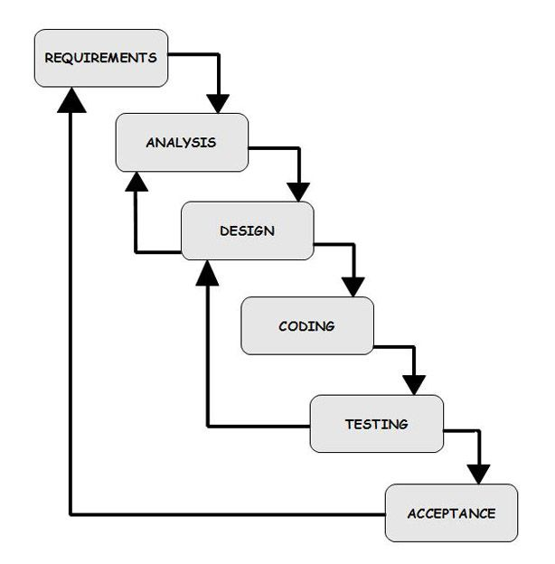

**STUDY OF THE SYSTEM:**

GUI'S

In the flexibility of the uses the interface has been developed a graphics concept in mind, associated through a browser interface. The GUI'S at the top level have been. categorized as

1. Administrative user interface

2. The operational or generic user interface

The administrative user interface concentrates on the consistent information that is practically, part of the organizational activities and which needs proper authentication

for the data collection. The interfaces help the administrations with all the transactional states like Data insertion, Data deletion and Date updating along with the extensive data search capabilities. The operational or generic user interface helps the users upon the system in transactions through the existing data and required services. The operational user interface also helps the ordinary users in managing their own information helps the ordinary users in managing their own information in a customized manner as per the assisted flexibilities.

**NUMBER OF MODULES**

**The project consists of 5 Modules**

1. **Login Module**- lets the user choose where they want to login, namely admin, teacher, librarian, parents, students where admin uses username and password, staff uses RFID this application automatically recognises the staff and will open the form related to them, parents will use students name, students will use register number to login
2. **Admin Module**- lets the admin to add\update\delete staff or students and lets the admin know\make changes to the data which is entered by lecturer and gives full control over the application and its database.
3. **Department Module**- As RFID recognises the staff, application automatically opens appropriate form and provides appropriate control respectively

* Principal module
* Head of the department module
* Lecturer module
* Librarian module
* Accountant module

1. **Parent Module**- it lets them see attendance and other basic information about the students and they will be able to see notices sent by department
2. **Student Module**- it gives the information of attendance, their fees details, library details and other related information

**Entities Involved in the Project:**

1. Admin

2. Staff

3. Students’

4. Guardians’

Admin: An entity responsible for managing users, roles, and roles privileges. Staff: A person (entity) responsible for managing Student’s information respective to their job in the institution.

Students’ and guardians’: entities who can see their activity in the institution

**PROJECT INSTRUCTIONS:**

Based on the given requirements, conceptualize the Solution Architecture. Choose the domain of your interest otherwise develop the application for ultimatedotnet.com. Depict the various architectural components, show interactions and connectedness, and show internal and external elements. Design the web services, web methods and database infrastructure needed both and client and server.

• Provide an environment for upgradation of application for newer versions that are available in the same domain as web service target.

**INPUT AND OUTPUT:**

The Main inputs, outputs, and major functions are as follows

**INPUTS:**

* Admin adds students’ data into database linking it with the unique RFID
* Admin adds staffs’ data into database linking it with the unique RFID
* Staff taps their RFID on to scanner to Log-in
* Student\Guardian enter register number to log-in

**Outputs:**

* If RFID of a staff is recognized as Director or principal, The control will take the user to Director\principal form
* If RFID of a staff is recognized as H.O.D., the control will take the user to H.O.D. form of their department respectively
* If RFID of a staff is recognized as lecturer, the control will take the user to lecturer form of their department and class respectively
* If RFID of a staff is recognized as librarian, the control will take the user to librarian form
* If RFID of a staff is recognized as Accountant, the control will take the user to Accountant form
* The correct register number will give the student\Guardian information about the respective student

**PROPOSED SYSTEM**

To debug the existing system, remove procedures those cause data redundancy, make navigational sequence proper. To provide information about student on different level and to reflect the status.

**NEED FOR COMPUTERIZATION**

We all know the importance of computerization. The world is moving ahead at lightning speed, and everyone is running short of time. One always wants to get the information and perform a task he/she/they desire(s) within a short period of time and too with amount of efficiency and accuracy. The application areas for the computerization have been selected based on following factors:

* Minimizing the manual records kept at different locations.
* There will be more data integrity.
* Facilitating desired information display, very quickly, by retrieving information from users.
* Facilitating various statistical information which helps in decision-making
* To reduce manual efforts in activities that involved repetitive work.
* Updating and deletion of such a huge amount of data will become easier.

**FUNCTIONAL FEATURES OF THE MODEL**

As far as the project is developed the functionality is simple, the objective of the proposal is to strengthen the functioning of institution and make them effective and better. The entire scope has been classified into five streams knows as Admin Level, management Level. H.O.D. Level, Lecturer Level and Student Level. The proposed software will cover the information needs with respect to each request of the user group viz. accepting the request, providing data, report, and the status of the student.

**DATABASE TABLES**

**STUDENTS:**

|  |  |
| --- | --- |
| NAME | DATATYPE |
| RFID | bigint |
| REGNO | nchar(30) |
| STUDENTNAME | char(50) |
| FATHERSNAME | char(50) |
| MOTHERSNAME | char(50) |
| ADDRESS | nvarchar(MAX) |
| PINCODE | bigint |
| AADHAARNO | bigint |
| STDPHONE | bigint |
| PARENTPHN | bigint |
| COURSE | nchar(10) |
| SEM | nchar(10) |
| GENDER | nchar(10) |
| DATEOFBIRTH | nvarchar(50) |
| DATEOFJOINING | nvarchar(50) |
| EMAIL | nvarchar(50) |
| ADDNO | nchar(20) |
| GUARDIAN | char(50) |
| PHOTO | image |
| PAID1 | nvarchar(50) |
| PAYDATE1 | nvarchar(50) |
| PAID2 | nvarchar(50) |
| PAYDATE2 | nvarchar(50) |
| PAID3 | nvarchar(50) |
| PAYDATE3 | nvarchar(50) |
| PAID4 | nvarchar(50) |
| PAYDATE4 | nvarchar(50) |

**STAFF:**

|  |  |
| --- | --- |
| NAME | DATATYPE |
| RFID | bigint |
| NAME | nvarchar(50) |
| ADDRESS | nvarchar(MAX) |
| PINCODE | bigint |
| AADHAAR | bigint |
| PHONENO | bigint |
| ALTPHONE | bigint |
| EMAIL | nvarchar(MAX) |
| GENDER | nchar(10) |
| POST | nchar(50) |
| DEPARTMENT | nchar(50) |
| SUB1 | nvarchar(MAX) |
| SUB2 | nvarchar(MAX) |
| DATEOFJOINING | nvarchar(50) |
| PHOTO | image |
| class1 | nvarchar(50) |
| class2 | nvarchar(50) |

**NOTIFBCOM:**

|  |  |
| --- | --- |
| NAME | DATATYPE |
| from | nvarchar(50) |
| to | nvarchar(50) |
| body | nvarchar(MAX) |
| date | nvarchar(50) |
| time | nvarchar(50) |

**NOTIFBBA:**

|  |  |
| --- | --- |
| NAME | DATATYPE |
| from | nvarchar(50) |
| to | nvarchar(50) |
| body | nvarchar(MAX) |
| date | nvarchar(50) |
| time | nvarchar(50) |

**NOTIFBCA:**

|  |  |
| --- | --- |
| NAME | DATATYPE |
| from | nvarchar(50) |
| to | nvarchar(50) |
| body | nvarchar(MAX) |
| date | nvarchar(50) |
| time | nvarchar(50) |

**NOTIFACC:**

|  |  |
| --- | --- |
| NAME | DATATYPE |
| from | nvarchar(50) |
| to | nvarchar(50) |
| body | nvarchar(MAX) |
| date | nvarchar(50) |
| time | nvarchar(50) |

|  |  |
| --- | --- |
| NAME | DATATYPE |
| from | nvarchar(50) |
| to | nvarchar(50) |
| body | nvarchar(MAX) |
| date | nvarchar(50) |
| time | nvarchar(50) |

**NOTIF:**

**MAILBCOM:**

|  |  |
| --- | --- |
| NAME | DATATYPE |
| TO | nvarchar(MAX) |
| SUBJECT | nvarchar(MAX) |
| BODY | nvarchar(MAX) |
| DATE | nvarchar(50) |
| TIME | nvarchar(50) |

**MAILBCA:**

|  |  |
| --- | --- |
| NAME | DATATYPE |
| TO | nvarchar(MAX) |
| SUBJECT | nvarchar(MAX) |
| BODY | nvarchar(MAX) |
| DATE | nvarchar(50) |
| TIME | nvarchar(50) |

**MAILBBA:**

|  |  |
| --- | --- |
| NAME | DATATYPE |
| TO | nvarchar(MAX) |
| SUBJECT | nvarchar(MAX) |
| BODY | nvarchar(MAX) |
| DATE | nvarchar(50) |
| TIME | nvarchar(50) |

**MAIL:**

|  |  |
| --- | --- |
| NAME | DATATYPE |
| TO | nvarchar(MAX) |
| SUBJECT | nvarchar(MAX) |
| BODY | nvarchar(MAX) |
| DATE | nvarchar(50) |
| TIME | nvarchar(50) |

**LIBRARY:**

|  |  |
| --- | --- |
| NAME | DATATYPE |
| bookid | nvarchar(50) |
| title | nvarchar(50) |
| publishyear | nvarchar(50) |
| Author | nvarchar(50) |
| publisherdetails | nvarchar(50) |
| price | nvarchar(50) |
| purchasedate | nvarchar(50) |
| purchasesource | nvarchar(50) |
| priliminarypagecount | nvarchar(50) |
| mainpagecount | nvarchar(50) |
| postpagecount | nvarchar(50) |
| extracontent | nvarchar(50) |
| bookcategory | nvarchar(50) |
| faultdiscription | nvarchar(50) |
| givento | nvarchar(50) |
| duedate | nvarchar(50) |
| givendate | nvarchar(50) |

**ATTEND:**

|  |  |
| --- | --- |
| NAME | DATATYPE |
| rfid | nvarchar(50) |
| name | nvarchar(50) |
| course | nvarchar(50) |
| intime | nvarchar(50) |
| date | nvarchar(50) |
| sem | nvarchar(50) |
| regno | nvarchar(50) |
| hour1 | nvarchar(50) |
| hour2 | nvarchar(50) |
| hour3 | nvarchar(50) |
| hour4 | nvarchar(50) |
| hour5 | nvarchar(50) |
| hour6 | nvarchar(50) |
| outtime | nvarchar(50) |
| libin | nvarchar(50) |
| libout | nvarchar(50) |

**VALIDATION**

**Password validation for admin while logging in**

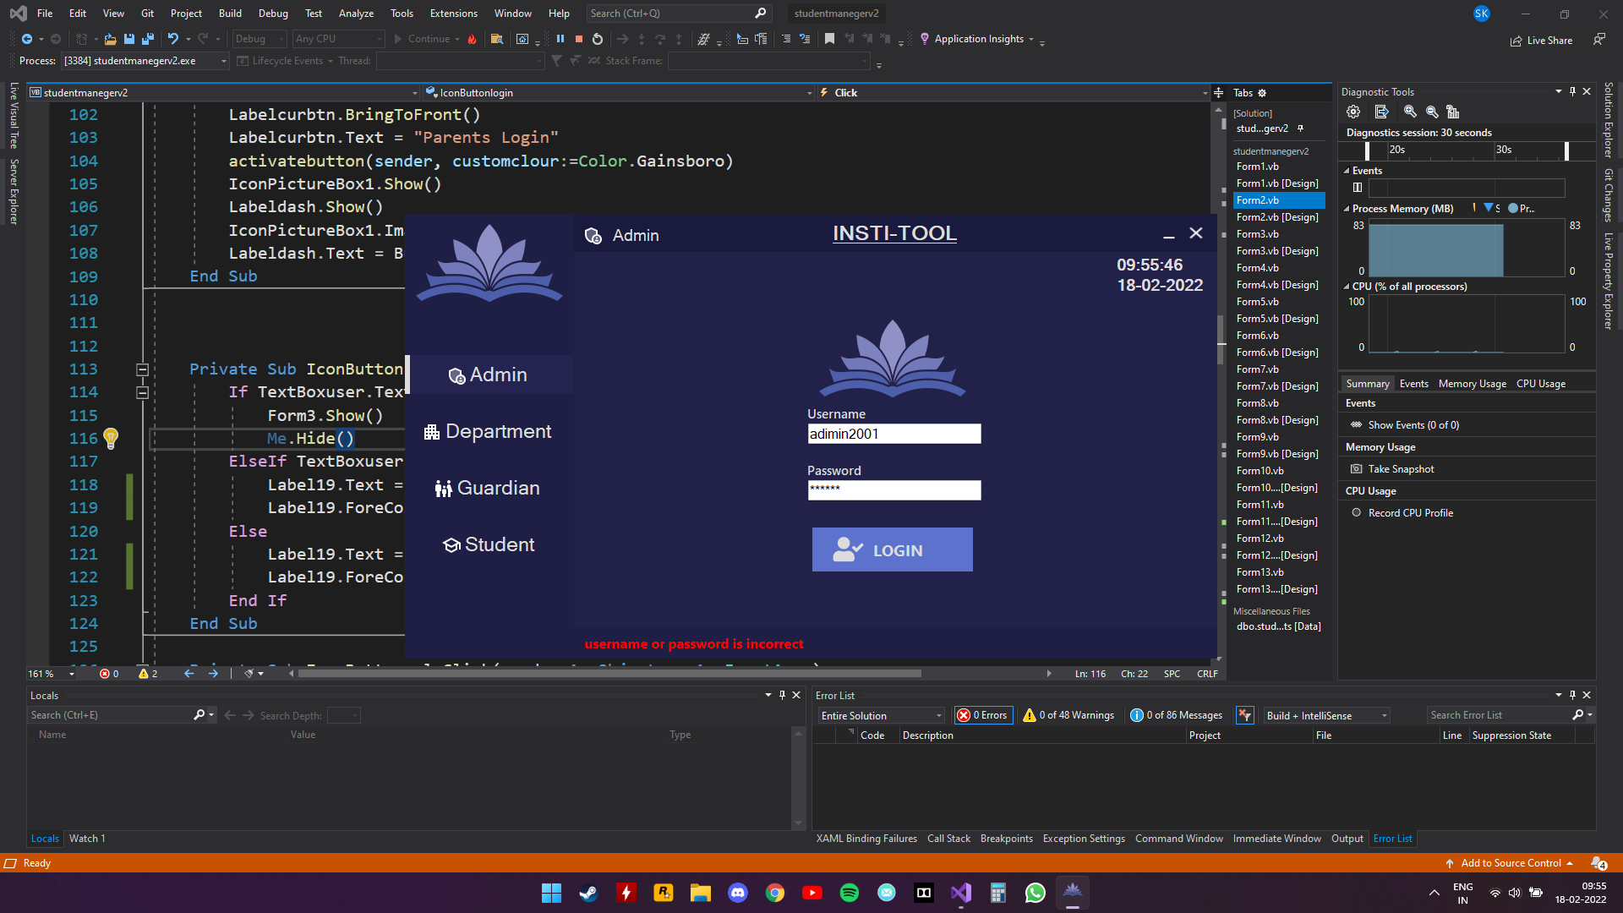

**Code used**

Private Sub IconButtonlogin_Click(sender As Object, e As EventArgs) Handles IconButtonlogin.Click

If TextBoxuser.Text.ToLower = "admin2001" And TextBoxpass.Text = "shs1234" Then

Form3.Show()

Me.Hide()

ElseIf TextBoxuser.Text.ToLower = "" And TextBoxpass.Text = "" Then

Label19.Text = "please enter username and password"

Label19.ForeColor = Color.Red

Else

Label19.Text = "username or password is incorrect "

Label19.ForeColor = Color.Red

End If

End Sub

**AADHAR validation while adding student**

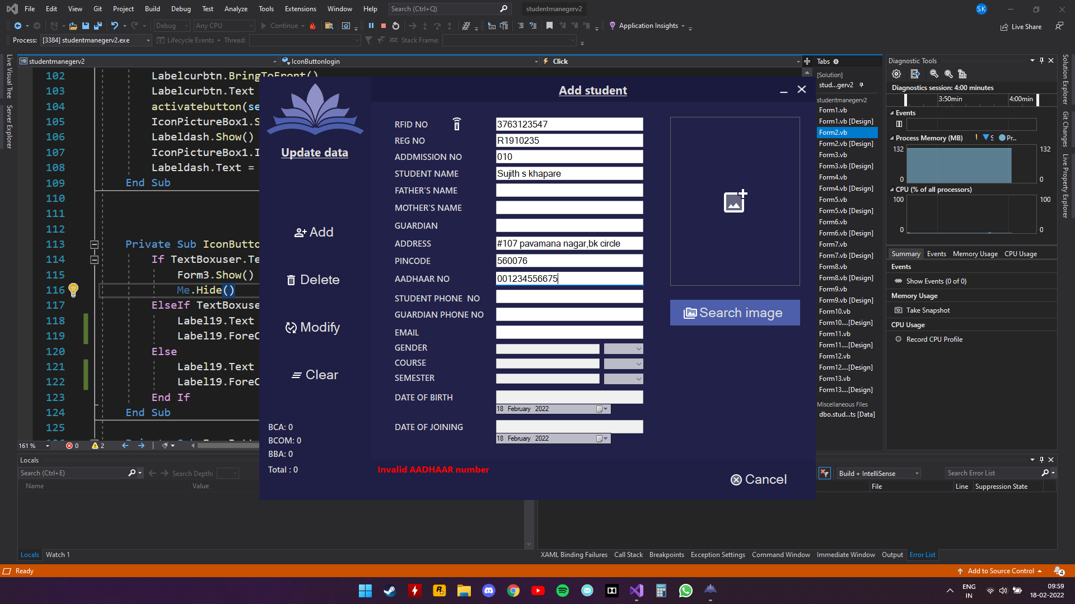

**Code used**

If aadhaar.TextLength < 12 Then

Return 1

ElseIf aadhaar.Text.StartsWith("0") Or aadhaar.Text.StartsWith("1") Then

Return 1

Else

Return 0

End If

**Email validation while adding a student**

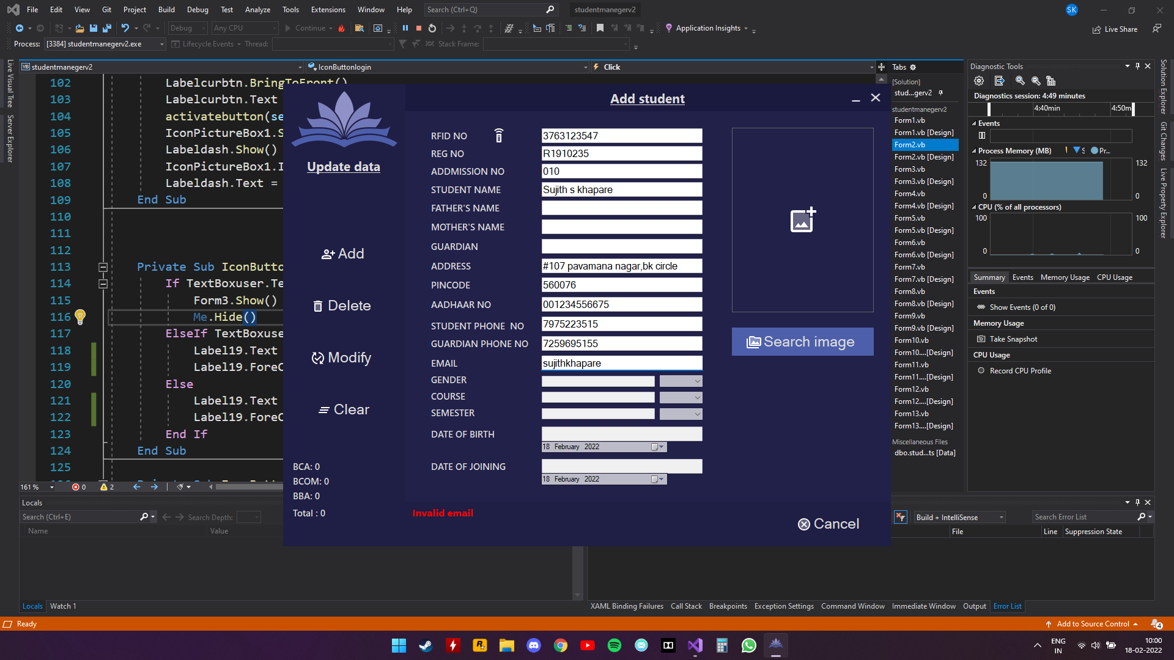

**Code used**

Function mailtest()

If email.Text.Trim <> "" Then

Try

Dim testAddress = New MailAddress(email.Text)

Catch ex As FormatException

Return 1

End Try

End If

End Function

**Calculating student age to fall under joining criteria**

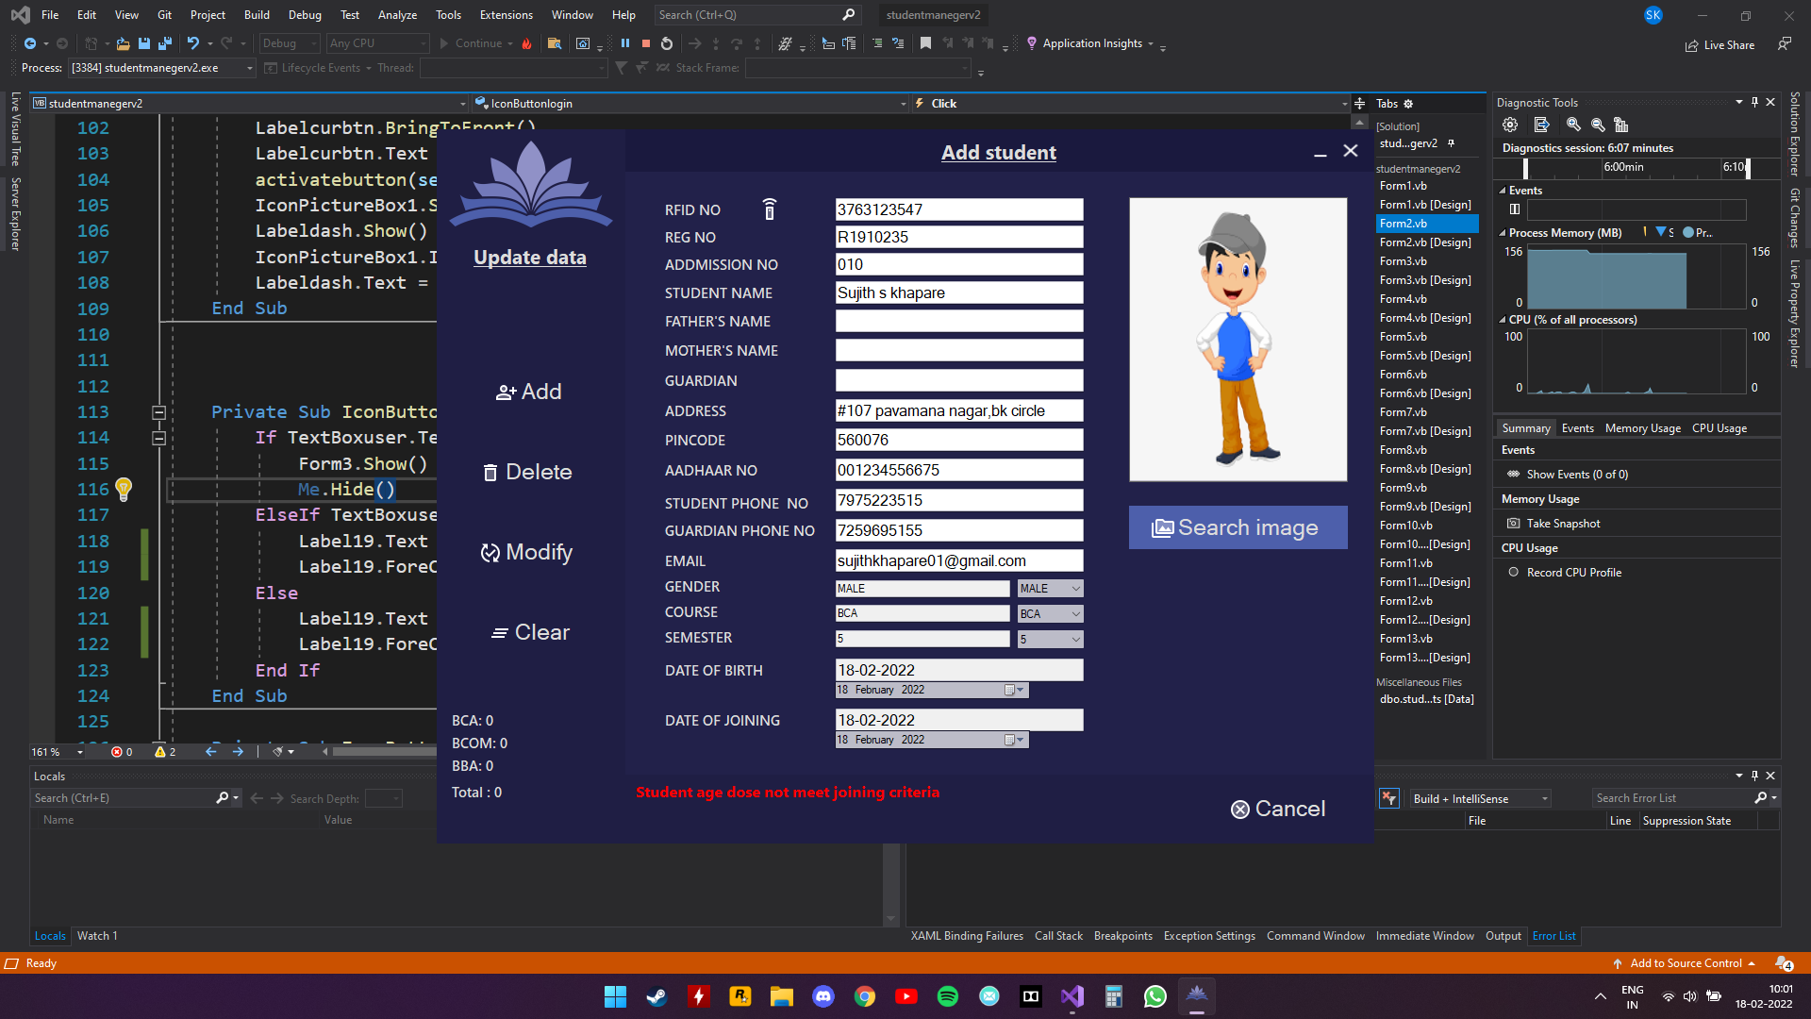

**Code used**

Function age()

Dim a As Integer = DateTimePicker1.Value.Year

Dim b As Integer = DateTimePicker2.Value.Year

Dim c As Integer = b - a

If c >= 17 And c < 35 Then

Label19.Text = ""

Return 0

Else

Return 1

End If

End Function

**Avoiding null inputs**

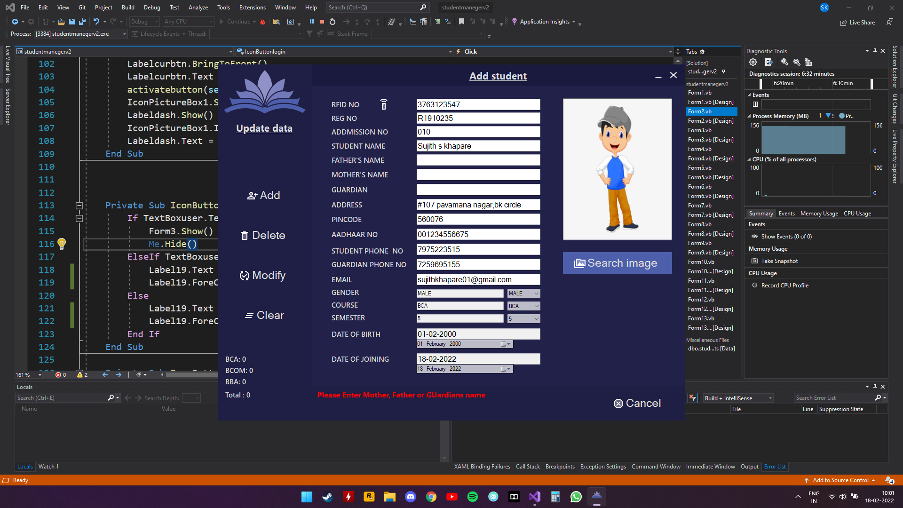

**Code used**

Function prt()

If fathersname.Text.Trim <> "" Or mothersname.Text.Trim <> "" Or guardian.Text.Trim <> "" Then

Label19.Text = ""

Return 0

Else

Return 1

End If

End Function

**Avoiding same phone number for parents and student**

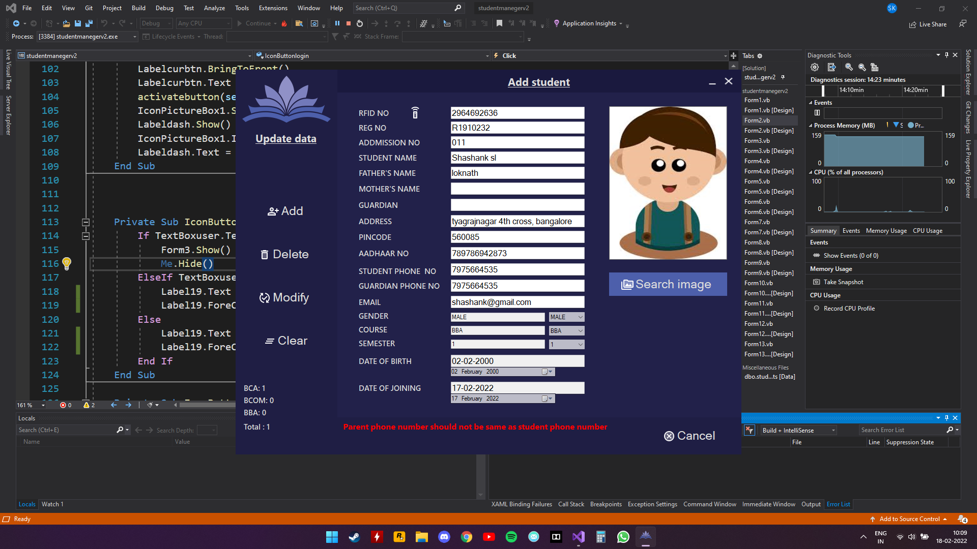

**Code used**

Function num()

If parentphn.Text <> studentphn.Text Then

Label19.Text = ""

Return 0

Else

Return 1

End If

End Function

**Making sure RFID is unique**

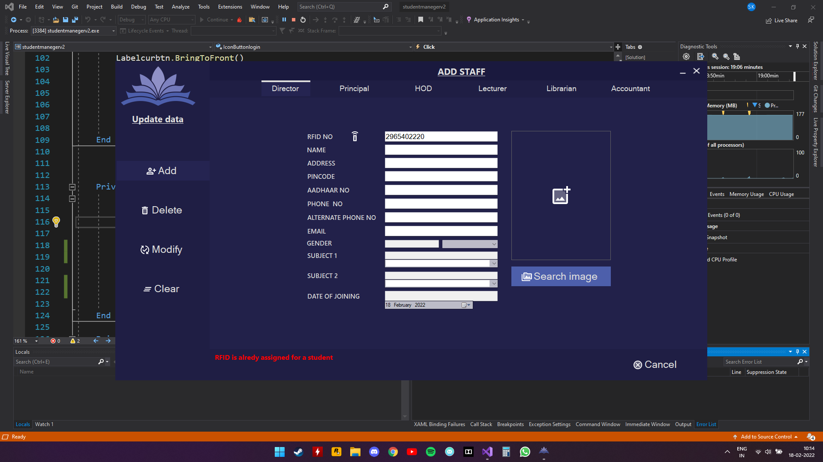

**Code used**

Function datacheck2()

If buttonhp.Location = Director.Location Or buttonhp.Location = Principal.Location Then

Try

Dim r As String

con.Open()

Dim cmd3 As New SqlCommand

cmd3.Connection = con

cmd3.CommandText = "select * from students where RFID=('" + pdrfid.Text + "')"

cmd3.CommandType = CommandType.Text

Dim sdr As SqlDataReader = cmd3.ExecuteReader

sdr.Read()

r = sdr("RFID").ToString

If r IsNot Nothing Then

Return 1

Else

Return 0

End If

Catch ex As Exception

con.Close()

End Try

ElseIf buttonhp.Location = HOD.Location Or buttonhp.Location = Lecturer.Location Then

Try

Dim r As String

con.Open()

Dim cmd3 As New SqlCommand

cmd3.Connection = con

cmd3.CommandText = "select * from students where RFID=('" + hlrfid.Text + "')"

cmd3.CommandType = CommandType.Text

Dim sdr As SqlDataReader = cmd3.ExecuteReader

sdr.Read()

r = sdr("RFID").ToString

If r IsNot Nothing Then

Return 1

Else

Return 0

End If

Catch ex As Exception

con.Close()

End Try

ElseIf buttonhp.Location = Accountant.Location Or buttonhp.Location = Librarian.Location Then

Try

Dim r As String

con.Open()

Dim cmd3 As New SqlCommand

cmd3.Connection = con

cmd3.CommandText = "select * from students where RFID=('" + alrfid.Text + "')"

cmd3.CommandType = CommandType.Text

Dim sdr As SqlDataReader = cmd3.ExecuteReader

sdr.Read()

r = sdr("RFID").ToString

If r IsNot Nothing Then

Return 1

Else

Return 0

End If

Catch ex As Exception

con.Close()

End Try

End If

End Function

**CODING**

**SPLASH SCREEN:**

Public Class Form1

Private Sub Timer1_Tick(sender As Object, e As EventArgs) Handles Timer1.Tick

ProgressBar1.Value = ProgressBar1.Value + 1

If ProgressBar1.Value = 100 Then

Timer1.Enabled = False

Form2.Show()

End If

End Sub

Private Sub PictureBox1_Click(sender As Object, e As EventArgs) Handles PictureBox1.Click

End Sub

End Class

**LOGIN PAGE:**

Imports System.Data.SqlClient

Public Class Form2

Dim buttonhp As Panel

Dim cb2 As String = Nothing

Dim currbtn As Button

Dim con As New SqlConnection("Data Source=(LocalDB)\MSSQLLocalDB;AttachDbFilename=G:\V'th sem project\studentmanegerv2\students007.mdf;Integrated Security=True")

Private Sub Form2_Load(sender As Object, e As EventArgs) Handles MyBase.Load

Form1.Hide()

IconPictureBox1.Hide()

Labeldash.Hide()

Paneladmin.Hide()

PictureBox2.BringToFront()

lbltime.Text = TimeOfDay

Lbldate.Text = Date.Today

student.Visible = False

Department.Visible = False

Paneladmin.Visible = False

End Sub

Private Sub Button1_Click(sender As Object, e As EventArgs) Handles Button1.Click

Application.Exit()

End Sub

Private Sub Button2_Click(sender As Object, e As EventArgs) Handles Button2.Click

Me.WindowState = FormWindowState.Minimized

End Sub

Private Sub Form2_Resize(sender As Object, e As EventArgs) Handles MyBase.Resize

If Me.WindowState = FormWindowState.Maximized Then

Me.MaximizedBounds = Screen.PrimaryScreen.WorkingArea

End If

End Sub

Public Sub New()

InitializeComponent()

buttonhp = New Panel

buttonhp.Size = New Size(6, 46)

Panelmenu.Controls.Add(buttonhp)

End Sub

Private Sub activatebutton(senderbtn As Object, customclour As Color)

If senderbtn IsNot Nothing Then

desablebtn()

currbtn = CType(senderbtn, Button)

currbtn.BackColor = Color.FromArgb(37, 36, 81)

currbtn.ForeColor = customclour

buttonhp.BackColor = customclour

currbtn.TextAlign = ContentAlignment.MiddleCenter

currbtn.ImageAlign = ContentAlignment.MiddleRight

currbtn.TextImageRelation = TextImageRelation.ImageBeforeText

buttonhp.Location = New Point(0, currbtn.Location.Y)

buttonhp.Visible = True

buttonhp.BringToFront()

End If

End Sub

Private Sub desablebtn()

If currbtn IsNot Nothing Then

currbtn.BackColor = Color.FromArgb(31, 30, 68)

currbtn.ForeColor = Color.Gainsboro

currbtn.TextAlign = ContentAlignment.MiddleCenter

currbtn.ImageAlign = ContentAlignment.MiddleRight

currbtn.TextImageRelation = TextImageRelation.ImageBeforeText

End If

End Sub

Private Sub Buttonadmin_Click(sender As Object, e As EventArgs) Handles Buttonadmin.Click

activatebutton(sender, customclour:=Color.Gainsboro)

student.Visible = False

Department.Visible = False

Paneladmin.Visible = True

IconPictureBox1.Show()

Labeldash.Show()

Labelcurbtn.Text = "Aministrator Login"

IconPictureBox1.Image = Buttonadmin.Image

Labeldash.Text = Buttonadmin.Text

PictureBox2.Hide()

End Sub

Private Sub Buttonparnt_Click(sender As Object, e As EventArgs) Handles Buttonparnt.Click

student.Visible = True

Department.Visible = False

PictureBox2.Hide()

Paneladmin.Visible = True

Labelcurbtn.BringToFront()

Labelcurbtn.Text = "Parents Login"

activatebutton(sender, customclour:=Color.Gainsboro)

IconPictureBox1.Show()

Labeldash.Show()

IconPictureBox1.Image = Buttonparnt.Image

Labeldash.Text = Buttonparnt.Text

End Su

Private Sub IconButtonlogin_Click(sender As Object, e As EventArgs) Handles IconButtonlogin.Click

If TextBoxuser.Text.ToLower = "admin2001" And TextBoxpass.Text = "shs1234" Then

Form3.Show()

Me.Hide()

ElseIf TextBoxuser.Text.ToLower = "" And TextBoxpass.Text = "" Then

MsgBox("please enter username and password")

Else

MsgBox("username or password is incorrect ")

End If

End Sub

Private Sub IconButtonprl_Click(sender As Object, e As EventArgs)

End Sub

Private Sub Button3_Click(sender As Object, e As EventArgs) Handles Buttondept.Click

activatebutton(sender, customclour:=Color.Gainsboro)

Paneladmin.Visible = True

Department.Visible = True

student.Visible = False

IconPictureBox1.Show()

Labeldash.Show()

Labelcurbtn.Text = "Department Login"

IconPictureBox1.Image = Buttondept.Image

Labeldash.Text = Buttondept.Text

PictureBox2.Hide()

Me.ActiveControl = TextBoxrfid

End Sub

Private Sub Timer1_Tick(sender As Object, e As EventArgs) Handles Timer1.Tick

lbltime.Text = TimeOfDay

End Sub

Private Sub Button3_Click_1(sender As Object, e As EventArgs) Handles Buttonstd.Click

Paneladmin.Visible = True

student.Visible = True

Department.Visible = False

PictureBox2.Hide()

Labelcurbtn.BringToFront()

Labelcurbtn.Text = "Student Login"

activatebutton(sender, customclour:=Color.Gainsboro)

IconPictureBox1.Show()

Labeldash.Show()

IconPictureBox1.Image = Buttonstd.Image

Labeldash.Text = Buttonstd.Text

End Sub

Public Function autorouter()

Try

If TextBoxrfid.Text.Trim <> "" Then

Dim cb As String

con.Open()

Dim cmd3 As New SqlCommand

cmd3.Connection = con

cmd3.CommandText = "select POST from Staff where RFID=('" + TextBoxrfid.Text + "')"

cmd3.CommandType = CommandType.Text

Dim sdr As SqlDataReader = cmd3.ExecuteReader

sdr.Read()

cb = sdr("POST").ToString.Trim

con.Close()

If cb = "Director" Then

Form7.Show()

Me.Hide()

ElseIf cb = "Principal" Then

Form7.Show()

Me.Hide()

ElseIf cb = "HOD" Then

Form8.Show()

Me.Hide()

ElseIf cb = "Lecturer" Then

Form9.Show()

Me.Hide()

ElseIf cb = "Librarian" Then

Form11.Show()

Me.Hide()

ElseIf cb = "Accountant" Then

Form10.Show()

Me.Hide()

Else

Label19.Text = "Unregistered RFID"

Label19.ForeColor = Color.Red

End If

End If

Catch ex As Exception

con.Close()

End Try

End Function

Private Sub IconButton1_Click(sender As Object, e As EventArgs) Handles IconButton1.Click

autorouter()

End Sub

Private Sub TextBoxrfid_KeyDown(sender As Object, e As KeyEventArgs) Handles TextBoxrfid.KeyDown

If e.KeyCode = Keys.Enter Then

IconButton1.PerformClick()

End If

End Sub

Private Sub studentlogin_Click(sender As Object, e As EventArgs) Handles studentlogin.Click

Try

If TextBoxregno.Text.Trim <> "" Then

con.Open()

Dim cmd3 As New SqlCommand

cmd3.Connection = con

cmd3.CommandText = "select rfid from students where Regno=('" + TextBoxregno.Text.Trim + "')"

cmd3.CommandType = CommandType.Text

Dim sdr As SqlDataReader = cmd3.ExecuteReader

sdr.Read()

cb2 = sdr("rfid").ToString.Trim

con.Close()

If cb2 IsNot Nothing Then

Form12.Show()

returnn()

End If

End If

Catch ex As Exception

con.Close()

Label19.Text = "Unregistered RFID"

Label19.ForeColor = Color.Red

End Try

End Sub

Function returnn()

If cb2 IsNot Nothing Then

Return cb2

End If

End Function

End Class

**ADMIN PAGE:**

Public Class Form3

Dim buttonhp As Panel

Dim currbtn As Button

Public Sub New()

InitializeComponent()

buttonhp = New Panel

buttonhp.Size = New Size(6, 46)

Panelmenu.Controls.Add(buttonhp)

End Sub

Private Sub activatebutton(senderbtn As Object, customclour As Color)

If senderbtn IsNot Nothing Then

desablebtn()

currbtn = CType(senderbtn, Button)

currbtn.BackColor = Color.FromArgb(37, 36, 81)

currbtn.ForeColor = customclour

buttonhp.BackColor = customclour

currbtn.TextAlign = ContentAlignment.MiddleCenter

currbtn.ImageAlign = ContentAlignment.MiddleRight

currbtn.TextImageRelation = TextImageRelation.ImageBeforeText

buttonhp.Location = New Point(0, currbtn.Location.Y)

buttonhp.Visible = True

buttonhp.BringToFront()

End If

End Sub

Private Sub desablebtn()

If currbtn IsNot Nothing Then

currbtn.BackColor = Color.FromArgb(31, 30, 68)

currbtn.ForeColor = Color.Gainsboro

currbtn.TextAlign = ContentAlignment.MiddleCenter

currbtn.ImageAlign = ContentAlignment.MiddleRight

currbtn.TextImageRelation = TextImageRelation.ImageBeforeText

End If

End Sub

Private Sub addteach_Click(sender As Object, e As EventArgs) Handles addteach.Click

activatebutton(sender, customclour:=Color.Gainsboro)

IconPictureBox1.Image = addteach.Image

Labeldash.Text = addteach.Text

PictureBox2.Hide()

Form5.Show()

Me.Hide()

End Sub

Private Sub addstudent_Click(sender As Object, e As EventArgs) Handles addstudent.Click

activatebutton(sender, customclour:=Color.Gainsboro)

IconPictureBox1.Image = addstudent.Image

Labeldash.Text = addstudent.Text

PictureBox2.Hide()

Form4.Show()

Me.Hide()

End Sub

Private Sub Button1_Click(sender As Object, e As EventArgs) Handles Button1.Click

Application.Exit()

End Sub

Private Sub Button2_Click(sender As Object, e As EventArgs) Handles Button2.Click

Me.WindowState = FormWindowState.Minimized

End Sub

Private Sub Form3_Load(sender As Object, e As EventArgs) Handles MyBase.Load

PictureBox2.Visible = True

End Sub

Private Sub Button3_Click(sender As Object, e As EventArgs) Handles Button3.Click

Form6.Show()

Me.Hide()

End Sub

Private Sub Button4_Click(sender As Object, e As EventArgs) Handles Buttonhist.Click

activatebutton(sender, customclour:=Color.Gainsboro)

IconPictureBox1.Image = Buttonhist.Image

Labeldash.Text = Buttonhist.Text

PictureBox2.Hide()

Form13.Show()

Me.Hide()

End Sub

End Class

**ADD STUDENTS:**

Imports System.Data.SqlClient

Imports System.Net.Mail

Public Class Form4

Dim con As New SqlConnection("Data Source=(LocalDB)\MSSQLLocalDB;AttachDbFilename=G:\V'th sem project\studentmanegerv2\students007.mdf;Integrated Security=True")

Function clear()

TextBoxrfid.Clear()

TextBoxregno.Clear()

studentname.Clear()

fathersname.Clear()

mothersname.Clear()

TextBoxaddr.Clear()

pincode.Clear()

aadhaar.Clear()

addmissionno.Clear()

studentphn.Clear()

parentphn.Clear()

TextBoxcourse.Clear()

TextBoxgender.Clear()

TextBoxsem.Clear()

course.Text = ""

sem.Text = ""

gender.Text = ""

dateofbirth.Clear()

dateofjoining.Clear()

email.Clear()

Me.ActiveControl = TextBoxrfid

guardian.Clear()

PictureBox2.Image = Nothing

PictureBox2.BackgroundImage = studentmanegerv2.My.Resources.Resources.twotone_add_photo_alternate_white_24dp

End Function

Function collection()

Try

con.Open()

Dim cmd45 As New SqlCommand

cmd45.Connection = con

cmd45.CommandText = "Select RFID from students "

cmd45.CommandType = CommandType.Text

Dim sdr As SqlDataReader = cmd45.ExecuteReader()

sdr.Read()

Dim list As New AutoCompleteStringCollection

While sdr.Read()

list.Add(sdr("RFID").ToString())

End While

TextBoxrfid.AutoCompleteCustomSource = list

con.Close()

Catch ex As Exception

con.Close()

End Try

End Function

Function count()

Try

Dim cnt As Integer = -1

Dim cnt1 As Integer = -1

Dim cnt2 As Integer = -1

con.Open()

Dim cmd As New SqlCommand

cmd.Connection = con

cmd.CommandText = "SELECT Count([RFID]) FROM [students] where Course like '%BCA%'"

cmd.ExecuteNonQuery()

cnt = Convert.ToInt32(cmd.ExecuteScalar())

bcacount.Text = "BCA: " & cnt.ToString

Dim cmd1 As New SqlCommand

cmd1.Connection = con

cmd1.CommandText = "SELECT Count([RFID]) FROM [students] where Course like '%BBA%'"

cmd1.ExecuteNonQuery()

cnt1 = Convert.ToInt32(cmd1.ExecuteScalar())

bbacount.Text = "BBA: " & cnt1.ToString

Dim cmd2 As New SqlCommand

cmd2.Connection = con

cmd2.CommandText = "SELECT Count([RFID]) FROM [students] where Course like '%BCOM%'"

cmd2.ExecuteNonQuery()

cnt2 = Convert.ToInt32(cmd2.ExecuteScalar())

bcomcount.Text = "BCOM: " & cnt2.ToString

stdtotal.Text = "Total : " & (cnt + cnt1 + cnt2).ToString

con.Close()

Catch ex As Exception

con.Close()

End Try

End Function

Function age()

Dim a As Integer = DateTimePicker1.Value.Year

Dim b As Integer = DateTimePicker2.Value.Year

Dim c As Integer = b - a

If c >= 17 And c < 35 Then

Label19.Text = ""

Return 0

Else

Return 1

End If

End Function

Function blank()

If TextBoxregno.Text.Trim <> "" And studentname.Text.Trim <> "" And TextBoxrfid.Text.Trim <> "" And TextBoxaddr.Text.Trim <> "" And pincode.Text.Trim <> "" And aadhaar.Text.Trim <> "" And studentphn.Text.Trim <> "" And parentphn.Text.Trim <> "" And TextBoxcourse.Text.Trim <> "" And TextBoxsem.Text.Trim <> "" And TextBoxgender.Text.Trim <> "" And dateofbirth.Text.Trim <> "" And dateofjoining.Text.Trim <> "" And email.Text.Trim <> "" And addmissionno.Text.Trim <> "" And nullimg() = 0 Then

Label19.Text = ""

Return 0

Else

Return 1

End If

End Function

Function num()

If parentphn.Text <> studentphn.Text Then

Label19.Text = ""

Return 0

Else

Return 1

End If

End Function

Function prt()

If fathersname.Text.Trim <> "" Or mothersname.Text.Trim <> "" Or guardian.Text.Trim <> "" Then

Label19.Text = ""

Return 0

Else

Return 1

End If

End Function

Function mailtest()

If email.Text.Trim <> "" Then

Try

Dim testAddress = New MailAddress(email.Text)

Catch ex As FormatException

Return 1

End Try

End If

End Function

Function phn()

If parentphn.TextLength < 10 Then

Return 1

Else

Return 0

End If

End Function

Function phn1()

If studentphn.TextLength < 10 Then

Return 1

Else

Return 0

End If

End Function

Function phn2()

If aadhaar.TextLength < 12 Then

Return 1

ElseIf aadhaar.Text.StartsWith("0") Or aadhaar.Text.StartsWith("1") Then

Return 1

Else

Return 0

End If

End Function

Function phn3()

If pincode.TextLength < 6 Then

Return 1

Else

Return 0

End If

End Function

Function nullimg()

If PictureBox2.Image Is Nothing Then

Return 1

Else

Return 0

End If

End Function

Private Sub Form4_Load(sender As Object, e As EventArgs) Handles MyBase.Load

clear()

Me.ActiveControl = TextBoxrfid

collection()

DateTimePicker1.MaxDate = Date.Now

DateTimePicker2.MaxDate = Date.Now

Label19.Text = ""

Button3.Visible = False

count()

End Sub

Private Sub Buttonadd_Click(sender As Object, e As EventArgs) Handles Buttonadd.Click

If datacheck() = 0 Then

If blank() = 0 Then

If age() = 0 Then

If num() = 0 Then

If mailtest() = 0 Then

If prt() = 0 Then

If phn() = 0 Then

If phn1() = 0 Then

If phn2() = 0 Then

If phn3() = 0 Then

If nullimg() = 0 Then

Try

Cursor = Cursors.WaitCursor

Application.DoEvents()

Dim picture As Image = PictureBox2.Image

con.Open()

Dim cmd01 As New SqlCommand

cmd01.Connection = con

cmd01.CommandText = "insert into students(RFID,REGNO,STUDENTNAME,FATHERSNAME,MOTHERSNAME,ADDRESS,PINCODE,AADHAARNO,STDPHONE,PARENTPHN,COURSE,SEM,GENDER,DATEOFBIRTH,DATEOFJOINING,EMAIL,ADDNO,GUARDIAN,PHOTO) values('" + TextBoxrfid.Text + "','" + TextBoxregno.Text + "','" + studentname.Text + "','" + fathersname.Text + "','" + mothersname.Text + "','" + TextBoxaddr.Text + "','" + pincode.Text + "','" + aadhaar.Text + "','" + studentphn.Text + "','" + parentphn.Text + "','" + TextBoxcourse.Text + "','" + TextBoxsem.Text + "','" + TextBoxgender.Text + "','" + dateofbirth.Text + "','" + dateofjoining.Text + "','" + email.Text + "','" + addmissionno.Text + "','" + guardian.Text + "',@MyImage)"

Using stream As New IO.MemoryStream

picture.Save(stream, Imaging.ImageFormat.Jpeg)

cmd01.Parameters.Add("@MyImage", SqlDbType.Image).Value = stream.GetBuffer

Debug.WriteLine(cmd01.ExecuteNonQuery())

con.Close()

End Using

MsgBox("Values added Successfully", MsgBoxStyle.Information, "Success")

clear()

count()

collection()

Cursor = Cursors.Default

Catch ex As Exception

MsgBox(ex.Message)

con.Close()

End Try

Else

Label19.Text = "Please upload image"

Label19.ForeColor = Color.Red

End If

Else

Label19.Text = "Invalid PINCODE number"

Label19.ForeColor = Color.Red

End If

Else

Label19.Text = "Invalid AADHAAR number"

Label19.ForeColor = Color.Red

End If

Else

Label19.Text = "Invalid student phone number"

Label19.ForeColor = Color.Red

End If

Else

Label19.Text = "Invalid parent phone number"

Label19.ForeColor = Color.Red

End If

Else

Label19.Text = "Please Enter Mother, Father or GUardians name "

Label19.ForeColor = Color.Red

End If

Else

Label19.Text = "Invalid email"

Label19.ForeColor = Color.Red

End If

Else

Label19.Text = "Parent phone number should not be same as student phone number"

Label19.ForeColor = Color.Red

End If

Else

Label19.Text = "Student age dose not meet joining criteria"

Label19.ForeColor = Color.Red

End If

Else

Label19.Text = "Please Enter All the values"

Label19.ForeColor = Color.Red

End If

Else

Label19.Text = "RFID is alredy assigned for someone other than student"

Label19.ForeColor = Color.Red

End If

End Sub

Private Sub Buttoncancel_Click(sender As Object, e As EventArgs) Handles Buttoncancel.Click

clear()

Form3.Show()

Me.Close()

End Sub

Private Sub Buttondlt_Click(sender As Object, e As EventArgs) Handles Buttondlt.Click

If TextBoxrfid.Text <> "" Then

Dim ans As Integer

ans = MsgBox("Are you sure you want to delete?", vbOKCancel, "?")

If ans = vbOK Then

Try

Cursor = Cursors.WaitCursor

Application.DoEvents()

con.Open()

Dim cmd02 As New SqlCommand

cmd02.Connection = con

cmd02.CommandText = "delete from students where ('" + TextBoxrfid.Text + "')=RFID"

cmd02.ExecuteNonQuery()

Label19.Text = "Values Deleted from database successfully"

Label19.ForeColor = Color.Green

con.Close()

clear()

collection()

count()

Cursor = Cursors.Default

Catch ex As Exception

MsgBox(ex.Message)

con.Close()

End Try

ElseIf ans = vbCancel Then

Label19.Text = "Cancelled"

Label19.ForeColor = Color.Green

End If

Else

Label19.Text = "Select the RFID that is to be deleted"

Label19.ForeColor = Color.Red

End If

End Sub

Private Sub Button2_Click(sender As Object, e As EventArgs) Handles Button2.Click

Me.WindowState = FormWindowState.Minimized

End Sub

Private Sub Button1_Click(sender As Object, e As EventArgs) Handles Button1.Click

Application.Exit()

End Sub

Private Sub DateTimePicker1_TextChanged(sender As Object, e As EventArgs) Handles DateTimePicker1.TextChanged

dateofbirth.Text = DateTimePicker1.Value.Date

End Sub

Private Sub DateTimePicker2_TextChanged(sender As Object, e As EventArgs) Handles DateTimePicker2.TextChanged

dateofjoining.Text = DateTimePicker2.Value.Date

End Sub

Private Sub clearbtn_Click(sender As Object, e As EventArgs) Handles clearbtn.Click

clear()

Label19.Text = ""

End Sub

Private Sub TextBoxrfid_TextChanged(sender As Object, e As EventArgs) Handles TextBoxrfid.TextChanged

TextBoxregno.Clear()

studentname.Clear()

fathersname.Clear()

mothersname.Clear()

TextBoxaddr.Clear()

pincode.Clear()

aadhaar.Clear()

addmissionno.Clear()

studentphn.Clear()

parentphn.Clear()

course.Text = ""

sem.Text = ""

gender.Text = ""

TextBoxcourse.Clear()

TextBoxgender.Clear()

TextBoxsem.Clear()

dateofbirth.Clear()

dateofjoining.Clear()

email.Clear()

guardian.Clear()

DateTimePicker1.MaxDate = Date.Now

DateTimePicker2.MaxDate = Date.Now

Buttonadd.Enabled = True

Label19.Text = ""

PictureBox2.BackgroundImage = studentmanegerv2.My.Resources.Resources.twotone_add_photo_alternate_white_24dp

PictureBox2.Image = Nothing

Button3.Visible = False

End Sub

Private Sub gender_SelectedIndexChanged(sender As Object, e As EventArgs) Handles gender.SelectedIndexChanged

TextBoxgender.Text = gender.Text

End Sub

Private Sub course_SelectedIndexChanged(sender As Object, e As EventArgs) Handles course.SelectedIndexChanged

TextBoxcourse.Text = course.Text

End Sub

Private Sub sem_SelectedIndexChanged(sender As Object, e As EventArgs) Handles sem.SelectedIndexChanged

TextBoxsem.Text = sem.Text

End Sub

Private Sub pincode_KeyPress(sender As Object, e As KeyPressEventArgs) Handles pincode.KeyPress

If e.KeyChar <> ChrW(Keys.Back) Then

If Char.IsNumber(e.KeyChar) Then

Else

e.Handled = True

End If

End If

End Sub

Private Sub parentphn_KeyPress(sender As Object, e As KeyPressEventArgs) Handles parentphn.KeyPress

If e.KeyChar <> ChrW(Keys.Back) Then

If Char.IsNumber(e.KeyChar) Then

Else

e.Handled = True

End If

End If

End Sub

Private Sub studentphn_KeyPress(sender As Object, e As KeyPressEventArgs) Handles studentphn.KeyPress

If e.KeyChar <> ChrW(Keys.Back) Then

If Char.IsNumber(e.KeyChar) Then

Else

e.Handled = True

End If

End If

End Sub

Private Sub aadhaar_KeyPress(sender As Object, e As KeyPressEventArgs) Handles aadhaar.KeyPress

If e.KeyChar <> ChrW(Keys.Back) Then

If Char.IsNumber(e.KeyChar) Then

Else

e.Handled = True

End If

End If

End Sub

Private Sub fathersname_KeyPress(sender As Object, e As KeyPressEventArgs) Handles fathersname.KeyPress

If Not (Asc(e.KeyChar) = 8) Then

Dim allowedChars As String = "abcdefghijklmnopqrstuvwxyzABCDEFGHIJKLMNOPQRSTUVWXYZ "

If Not allowedChars.Contains(e.KeyChar.ToString) Then

e.KeyChar = ChrW(0)

e.Handled = True

End If

End If

End Sub

Private Sub studentname_KeyPress(sender As Object, e As KeyPressEventArgs) Handles studentname.KeyPress

If Not (Asc(e.KeyChar) = 8) Then

Dim allowedChars As String = "abcdefghijklmnopqrstuvwxyzABCDEFGHIJKLMNOPQRSTUVWXYZ "

If Not allowedChars.Contains(e.KeyChar.ToString) Then

e.KeyChar = ChrW(0)

e.Handled = True

End If

End If

End Sub

Private Sub mothersname_KeyPress(sender As Object, e As KeyPressEventArgs) Handles mothersname.KeyPress

If Not (Asc(e.KeyChar) = 8) Then

Dim allowedChars As String = "abcdefghijklmnopqrstuvwxyzABCDEFGHIJKLMNOPQRSTUVWXYZ "

If Not allowedChars.Contains(e.KeyChar.ToString) Then

e.KeyChar = ChrW(0)

e.Handled = True

End If

End If

End Sub

Private Sub TextBoxrfid_KeyPress(sender As Object, e As KeyPressEventArgs) Handles TextBoxrfid.KeyPress

If e.KeyChar <> ChrW(Keys.Back) Then

If Char.IsNumber(e.KeyChar) Then

Else

e.Handled = True

End If

End If

End Sub

Private Sub TextBoxrfid_KeyDown(sender As Object, e As KeyEventArgs) Handles TextBoxrfid.KeyDown

If e.KeyCode = Keys.Enter Then

Me.ActiveControl = TextBoxregno

TextBoxregno.SelectionLength = 0

End If

End Sub

Private Sub addmissionno_KeyDown(sender As Object, e As KeyEventArgs) Handles addmissionno.KeyDown

If e.KeyCode = Keys.Enter Then

Me.ActiveControl = studentname

End If

End Sub

Private Sub TextBoxregno_KeyDown(sender As Object, e As KeyEventArgs) Handles TextBoxregno.KeyDown

If e.KeyCode = Keys.Enter Then

Me.ActiveControl = addmissionno

End If

End Sub

Private Sub studentname_KeyDown(sender As Object, e As KeyEventArgs) Handles studentname.KeyDown

If e.KeyCode = Keys.Enter Then

Me.ActiveControl = fathersname

End If

End Sub

Private Sub fathersname_KeyDown(sender As Object, e As KeyEventArgs) Handles fathersname.KeyDown

If e.KeyCode = Keys.Enter Then

Me.ActiveControl = mothersname

End If

End Sub

Private Sub TextBoxaddr_KeyDown(sender As Object, e As KeyEventArgs) Handles TextBoxaddr.KeyDown

If e.KeyCode = Keys.Enter Then

Me.ActiveControl = pincode

End If

End Sub

Private Sub mothersname_KeyDown(sender As Object, e As KeyEventArgs) Handles mothersname.KeyDown

If e.KeyCode = Keys.Enter Then

Me.ActiveControl = guardian

End If

End Sub

Private Sub pincode_KeyDown(sender As Object, e As KeyEventArgs) Handles pincode.KeyDown

If e.KeyCode = Keys.Enter Then

Me.ActiveControl = aadhaar

End If

End Sub

Private Sub aadhaar_KeyDown(sender As Object, e As KeyEventArgs) Handles aadhaar.KeyDown

If e.KeyCode = Keys.Enter Then

Me.ActiveControl = studentphn

End If

End Sub

Private Sub studentphn_KeyDown(sender As Object, e As KeyEventArgs) Handles studentphn.KeyDown

If e.KeyCode = Keys.Enter Then

Me.ActiveControl = parentphn

End If

End Sub

Private Sub parentphn_KeyDown(sender As Object, e As KeyEventArgs) Handles parentphn.KeyDown

If e.KeyCode = Keys.Enter Then

Me.ActiveControl = email

End If

End Sub

Private Sub TextBoxrfid_LostFocus(sender As Object, e As EventArgs) Handles TextBoxrfid.LostFocus

lf()

pic()

End Sub

Function lf()

Try

Dim r As String

con.Open()

Dim cmd3 As New SqlCommand

cmd3.Connection = con

cmd3.CommandText = "select * from students where RFID=('" + TextBoxrfid.Text + "')"

cmd3.CommandType = CommandType.Text

Dim sdr As SqlDataReader = cmd3.ExecuteReader

sdr.Read()

r = sdr("RFID").ToString

TextBoxregno.Text = sdr("REGNO").ToString.Trim

studentname.Text = sdr("STUDENTNAME").ToString.Trim

fathersname.Text = sdr("FATHERSNAME").ToString.Trim

mothersname.Text = sdr("MOTHERSNAME").ToString.Trim

guardian.Text = sdr("GUARDIAN").ToString.Trim

TextBoxaddr.Text = sdr("ADDRESS").ToString.Trim

pincode.Text = sdr("PINCODE").ToString.Trim

aadhaar.Text = sdr("AADHAARNO").ToString.Trim

addmissionno.Text = sdr("ADDNO").ToString.Trim

studentphn.Text = sdr("STDPHONE").ToString.Trim

parentphn.Text = sdr("PARENTPHN").ToString.Trim

TextBoxcourse.Text = sdr("COURSE").ToString.Trim

TextBoxsem.Text = sdr("SEM").ToString.Trim

TextBoxgender.Text = sdr("GENDER").ToString.Trim

dateofbirth.Text = sdr("DATEOFBIRTH").ToString.Trim

DateTimePicker1.Value = dateofbirth.Text

dateofjoining.Text = sdr("DATEOFJOINING").ToString.Trim

DateTimePicker2.Value = dateofjoining.Text

email.Text = sdr("EMAIL").ToString.Trim

con.Close()

Buttonadd.Enabled = False

Button3.Visible = True

Catch ex As Exception

con.Close()

Buttonadd.Enabled = True

End Try

End Function

Function pic()

Try

Dim picture1 As Image = Nothing

con.Open()

Dim cmd As New SqlCommand

cmd.Connection = con

Dim path As String = OpenFileDialog1.FileName

cmd.CommandText = "select PHOTO from students where RFID=('" + TextBoxrfid.Text + "')"

Dim pictureData As Byte() = DirectCast(cmd.ExecuteScalar(), Byte())

con.Close()

Using stream As New IO.MemoryStream(pictureData)

picture1 = Image.FromStream(stream)

End Using

PictureBox2.Image = picture1

PictureBox2.SizeMode = PictureBoxSizeMode.StretchImage

Return picture1

Catch ex As Exception

con.Close()

End Try

End Function

Private Sub guardian_KeyPress(sender As Object, e As KeyPressEventArgs) Handles guardian.KeyPress

If Not (Asc(e.KeyChar) = 8) Then

Dim allowedChars As String = "abcdefghijklmnopqrstuvwxyzABCDEFGHIJKLMNOPQRSTUVWXYZ "

If Not allowedChars.Contains(e.KeyChar.ToString) Then

e.KeyChar = ChrW(0)

e.Handled = True

End If

End If

End Sub

Private Sub email_TextChanged(sender As Object, e As EventArgs) Handles email.TextChanged

If mailtest() = 1 Then

Label19.Text = "Invalid email"

Label19.ForeColor = Color.Red

Else

Label19.Text = ""

End If

End Sub

Private Sub parentphn_TextChanged(sender As Object, e As EventArgs) Handles parentphn.TextChanged

If phn() = 1 Then

Label19.Text = "Invalid parent phone number"

Label19.ForeColor = Color.Red

Else

Label19.Text = ""

End If

End Sub

Private Sub studentphn_TabIndexChanged(sender As Object, e As EventArgs) Handles studentphn.TabIndexChanged

End Sub

Private Sub aadhaar_TextChanged(sender As Object, e As EventArgs) Handles aadhaar.TextChanged

If phn2() = 1 Then

Label19.Text = "Invalid AADHAAR number"

Label19.ForeColor = Color.Red

Else

Label19.Text = ""

End If

End Sub

Private Sub aadhaar_MouseDown(sender As Object, e As MouseEventArgs) Handles aadhaar.MouseDown

If e.Button = MouseButtons.Right Then

aadhaar.ContextMenu = New ContextMenu()

Label19.Text = "copy paste not allowed"

Label19.ForeColor = Color.Red

End If

End Sub

Private Sub parentphn_MouseDown(sender As Object, e As MouseEventArgs) Handles parentphn.MouseDown

If e.Button = MouseButtons.Right Then

parentphn.ContextMenu = New ContextMenu()

Label19.Text = "copy paste not allowed"

Label19.ForeColor = Color.Red

End If

End Sub

Private Sub studentphn_MouseDown(sender As Object, e As MouseEventArgs) Handles studentphn.MouseDown

If e.Button = MouseButtons.Right Then

studentphn.ContextMenu = New ContextMenu()

Label19.Text = "copy paste not allowed"

Label19.ForeColor = Color.Red

End If

End Sub

Private Sub TextBoxrfid_MouseDown(sender As Object, e As MouseEventArgs) Handles TextBoxrfid.MouseDown

If e.Button = MouseButtons.Right Then

TextBoxrfid.ContextMenu = New ContextMenu()

Label19.Text = "copy paste not allowed"

Label19.ForeColor = Color.Red

End If

End Sub

Private Sub pincode_MouseDown(sender As Object, e As MouseEventArgs) Handles pincode.MouseDown

If e.Button = MouseButtons.Right Then

pincode.ContextMenu = New ContextMenu()

Label19.Text = "copy paste not allowed"

Label19.ForeColor = Color.Red

End If

End Sub

Private Sub studentphn_TextChanged(sender As Object, e As EventArgs) Handles studentphn.TextChanged

If phn1() = 1 Then

Label19.Text = "Invalid student phone number"

Label19.ForeColor = Color.Red

Else

Label19.Text = ""

End If

End Sub

Private Sub guardian_KeyDown(sender As Object, e As KeyEventArgs) Handles guardian.KeyDown

If e.KeyCode = Keys.Enter Then

TextBoxaddr.Focus()

End If

End Sub

Private Sub studentname_MouseDown(sender As Object, e As MouseEventArgs) Handles studentname.MouseDown

If e.Button = MouseButtons.Right Then

studentname.ContextMenu = New ContextMenu()

Label19.Text = "copy paste not allowed"

Label19.ForeColor = Color.Red

End If

End Sub

Private Sub fathersname_MouseDown(sender As Object, e As MouseEventArgs) Handles fathersname.MouseDown

If e.Button = MouseButtons.Right Then

fathersname.ContextMenu = New ContextMenu()

Label19.Text = "copy paste not allowed"

Label19.ForeColor = Color.Red

End If

End Sub

Private Sub mothersname_MouseDown(sender As Object, e As MouseEventArgs) Handles mothersname.MouseDown

If e.Button = MouseButtons.Right Then

mothersname.ContextMenu = New ContextMenu()

Label19.Text = "copy paste not allowed"

Label19.ForeColor = Color.Red

End If

End Sub

Private Sub guardian_MouseDown(sender As Object, e As MouseEventArgs) Handles guardian.MouseDown

If e.Button = MouseButtons.Right Then

guardian.ContextMenu = New ContextMenu()

Label19.Text = "copy paste not allowed"

Label19.ForeColor = Color.Red

End If

End Sub

Private Sub addimg_Click(sender As Object, e As EventArgs) Handles addimg.Click

OpenFileDialog1.ShowDialog()

End Sub

Private Sub OpenFileDialog1_FileOk(sender As Object, e As System.ComponentModel.CancelEventArgs) Handles OpenFileDialog1.FileOk

Try

PictureBox2.ImageLocation = OpenFileDialog1.FileName

PictureBox2.SizeMode = PictureBoxSizeMode.StretchImage

Catch ex As Exception

End Try

End Sub

Function datacheck()

Try

Dim r As String

con.Open()

Dim cmd3 As New SqlCommand

cmd3.Connection = con

cmd3.CommandText = "select * from staff where RFID=('" + TextBoxrfid.Text + "')"

cmd3.CommandType = CommandType.Text

Dim sdr As SqlDataReader = cmd3.ExecuteReader

sdr.Read()

r = sdr("RFID").ToString

If r IsNot Nothing Then

Return 1

Else

Return 0

End If

Catch ex As Exception

con.Close()

End Try

End Function

Private Sub Buttonmod_Click(sender As Object, e As EventArgs) Handles Buttonmod.Click

If blank() = 0 Then

If age() = 0 Then

If num() = 0 Then

If mailtest() = 0 Then

If prt() = 0 Then

If phn() = 0 Then

If phn1() = 0 Then

If phn2() = 0 Then

If phn3() = 0 Then

If nullimg() = 0 Then

Try

Cursor = Cursors.WaitCursor

Application.DoEvents()

Dim picture As Image = PictureBox2.Image

con.Open()

Dim cmd01 As New SqlCommand

cmd01.Connection = con

cmd01.CommandText = "update students set REGNO=('" + TextBoxregno.Text + "'),STUDENTNAME=('" + studentname.Text + "'),FATHERSNAME=('" + fathersname.Text + "'),MOTHERSNAME=('" + mothersname.Text + "'),ADDRESS=('" + TextBoxaddr.Text + "'),PINCODE=('" + pincode.Text + "'),AADHAARNO=('" + aadhaar.Text + "'),STDPHONE=('" + studentphn.Text + "'),PARENTPHN=('" + parentphn.Text + "'),COURSE=('" + TextBoxcourse.Text + "'),SEM=('" + TextBoxsem.Text + "'),GENDER=('" + TextBoxgender.Text + "'),DATEOFBIRTH=('" + dateofbirth.Text + "'),DATEOFJOINING=('" + dateofjoining.Text + "'),EMAIL=('" + email.Text + "'),ADDNO=('" + addmissionno.Text + "'),GUARDIAN=('" + guardian.Text + "') where RFID=('" + TextBoxrfid.Text + "')"

cmd01.ExecuteNonQuery()

con.Close()

MsgBox("Values updated Successfully", MsgBoxStyle.Information, "Success")

clear()

Cursor = Cursors.Default

Catch ex As Exception

MsgBox(ex.Message)

con.Close()

End Try

Else

Label19.Text = "Please upload image"

Label19.ForeColor = Color.Red

End If

Else

Label19.Text = "Invalid PINCODE number"

Label19.ForeColor = Color.Red

End If

Else

Label19.Text = "Invalid AADHAAR number"

Label19.ForeColor = Color.Red

End If

Else

Label19.Text = "Invalid student phone number"

Label19.ForeColor = Color.Red

End If

Else

Label19.Text = "Invalid parent phone number"

Label19.ForeColor = Color.Red

End If

Else

Label19.Text = "Please Enter Mother, Father or GUardians name "

Label19.ForeColor = Color.Red

End If

Else

Label19.Text = "Invalid email"

Label19.ForeColor = Color.Red

End If

Else

Label19.Text = "Parent phone number should not be same as student phone number"

Label19.ForeColor = Color.Red

End If

Else

Label19.Text = "Student age dose not meet joining criteria"

Label19.ForeColor = Color.Red

End If

Else

Label19.Text = "Please Enter All the values"

Label19.ForeColor = Color.Red

End If

End Sub

Private Sub Button3_Click(sender As Object, e As EventArgs) Handles Button3.Click

If blank() = 0 Then

If age() = 0 Then

If num() = 0 Then

If mailtest() = 0 Then

If prt() = 0 Then

If phn() = 0 Then

If phn1() = 0 Then

If phn2() = 0 Then

If phn3() = 0 Then

If nullimg() = 0 Then

Try

Cursor = Cursors.WaitCursor

Application.DoEvents()

Dim picture As Image

picture = PictureBox2.Image

con.Open()

Dim cmd01 As New SqlCommand

cmd01.Connection = con

cmd01.CommandText = "update students set PHOTO=(@MyImage) where RFID=('" + TextBoxrfid.Text + "')"

Using stream As New IO.MemoryStream

picture.Save(stream, Imaging.ImageFormat.Jpeg)

cmd01.Parameters.Add("@MyImage", SqlDbType.Image).Value = stream.GetBuffer

Debug.WriteLine(cmd01.ExecuteNonQuery())

con.Close()

End Using

MsgBox("Values updated Successfully", MsgBoxStyle.Information, "Success")

Cursor = Cursors.Default

Catch ex As Exception

Label19.Text = "Please select a different image"

Label19.ForeColor = Color.Red

con.Close()

End Try

Else

Label19.Text = "Please upload image"

Label19.ForeColor = Color.Red

End If

Else

Label19.Text = "Invalid PINCODE number"

Label19.ForeColor = Color.Red

End If

Else

Label19.Text = "Invalid AADHAAR number"

Label19.ForeColor = Color.Red

End If

Else

Label19.Text = "Invalid student phone number"

Label19.ForeColor = Color.Red

End If

Else

Label19.Text = "Invalid parent phone number"

Label19.ForeColor = Color.Red

End If

Else

Label19.Text = "Please Enter Mother, Father or GUardians name "

Label19.ForeColor = Color.Red

End If

Else

Label19.Text = "Invalid email"

Label19.ForeColor = Color.Red

End If

Else

Label19.Text = "Parent phone number should not be same as student phone number"

Label19.ForeColor = Color.Red

End If

Else

Label19.Text = "Student age does not meet joining criteria"

Label19.ForeColor = Color.Red

End If

Else

Label19.Text = "Please Enter All the values"

Label19.ForeColor = Color.Red

End If

End Sub

End Class

**SNAPSHOTS**

**SPLASH SCREEN:**

It loads login form

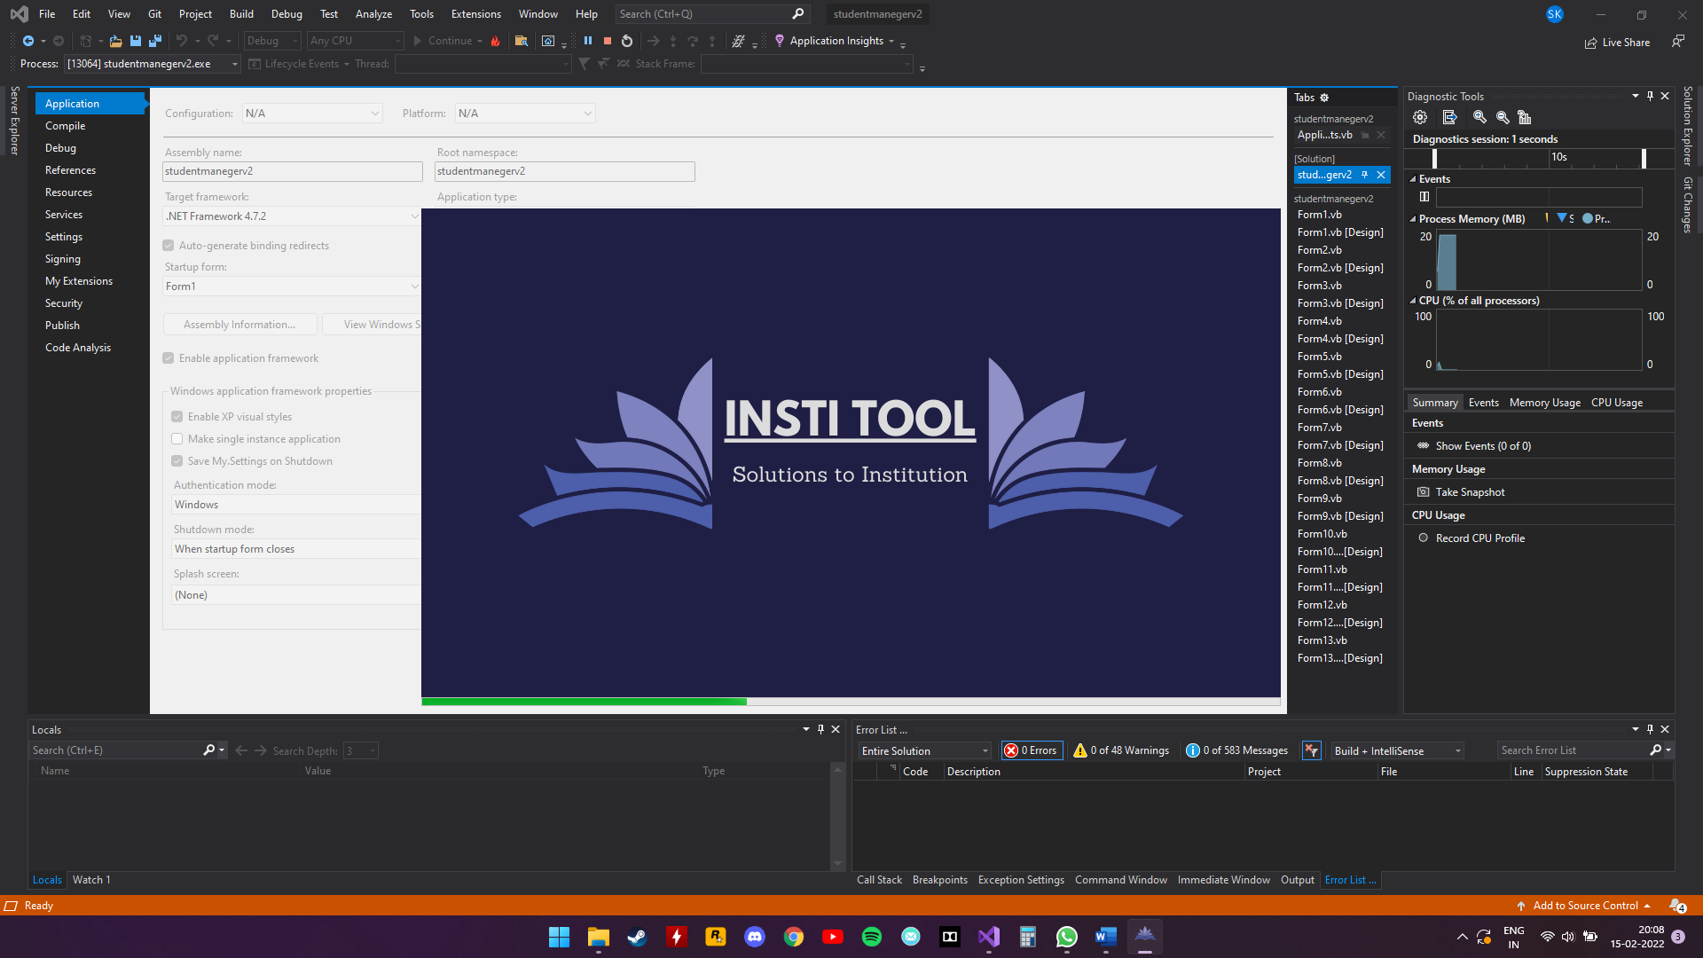

**LOGIN PAGE:**

this form is used by users to log into their form

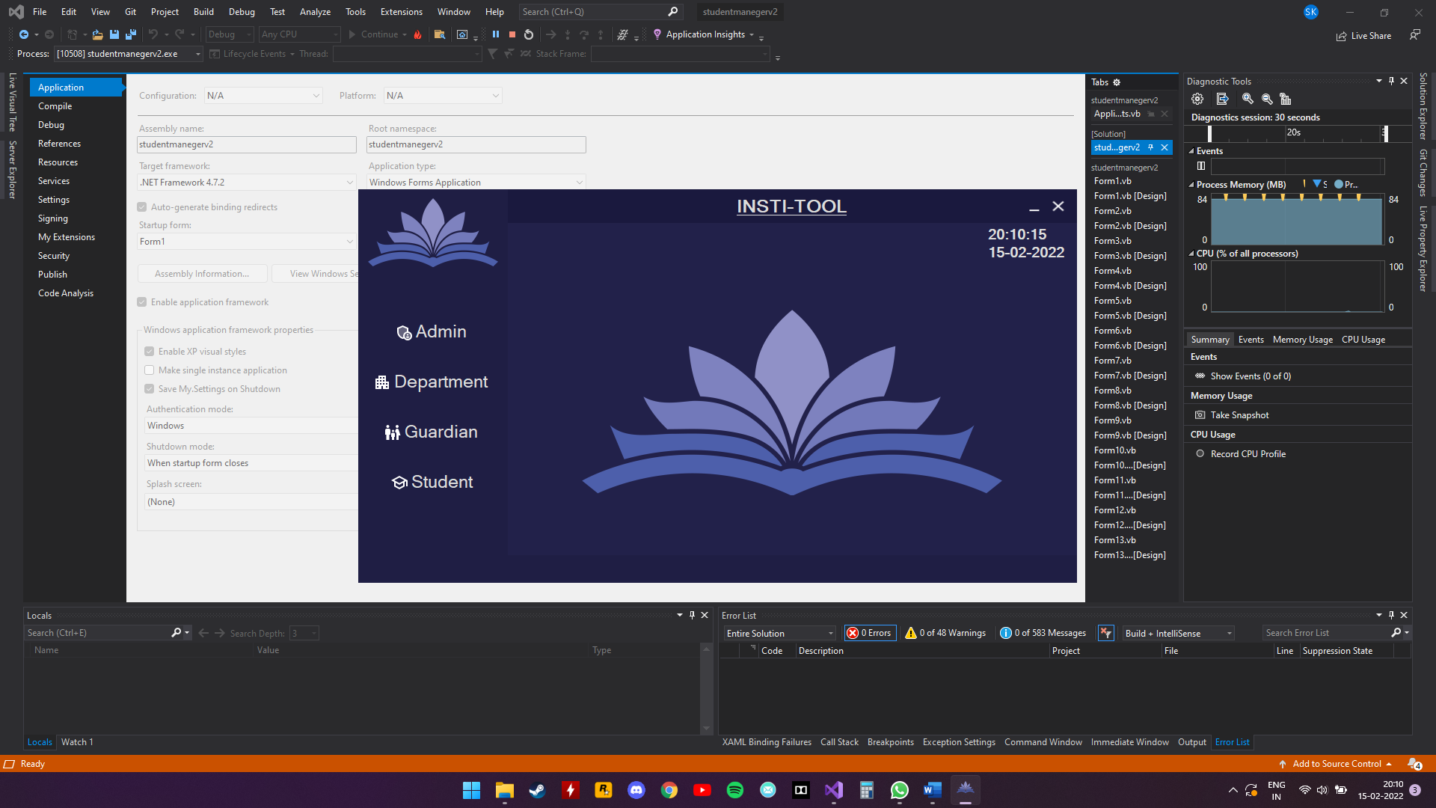

**ADMIN LOGIN:**

Admin will enter the valid username and password to log in

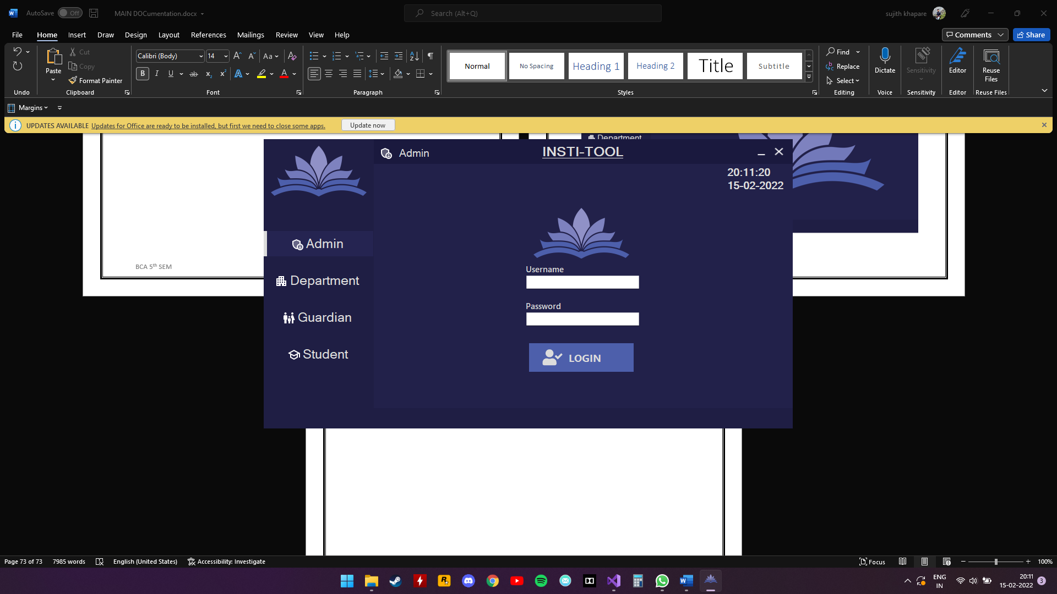

**DEPARTMENT LOGIN:**

Staff will use the given RFID to log into their forms

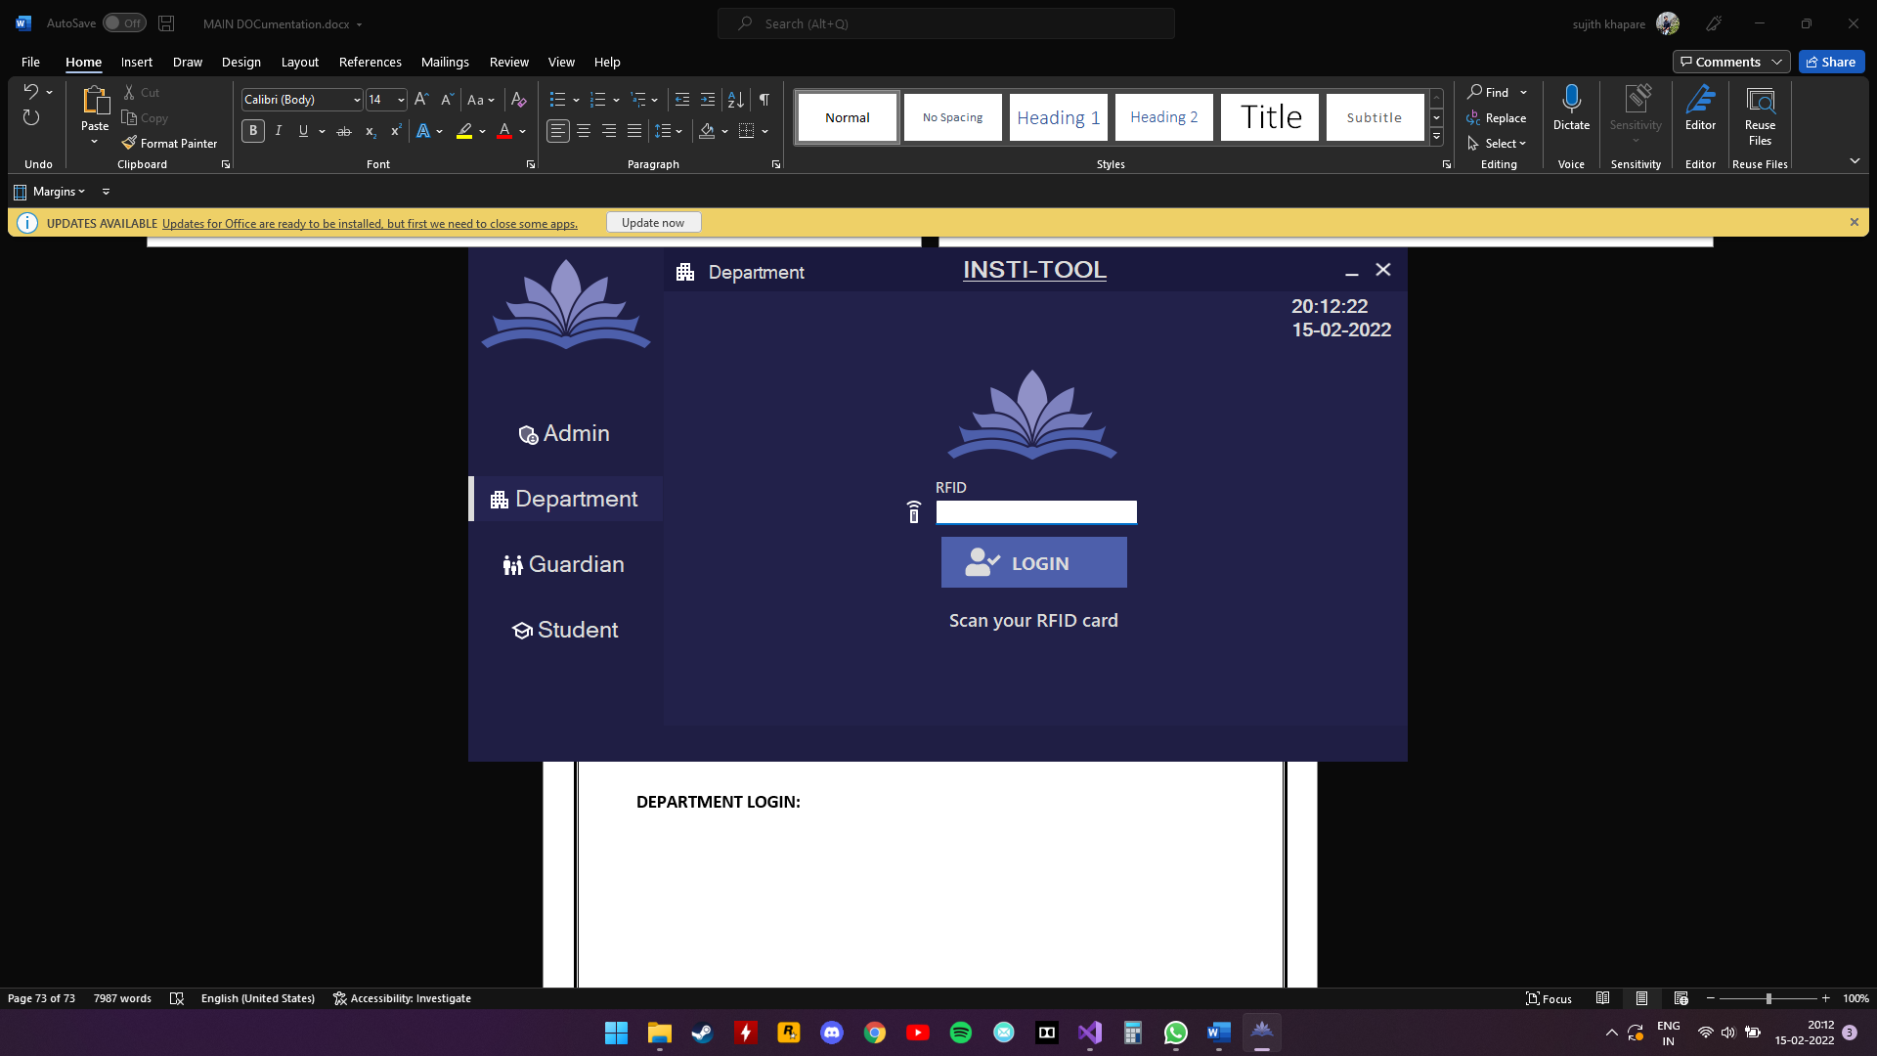

**GUARDIAN LOGIN:**

Guardian will use students’ register number to log in

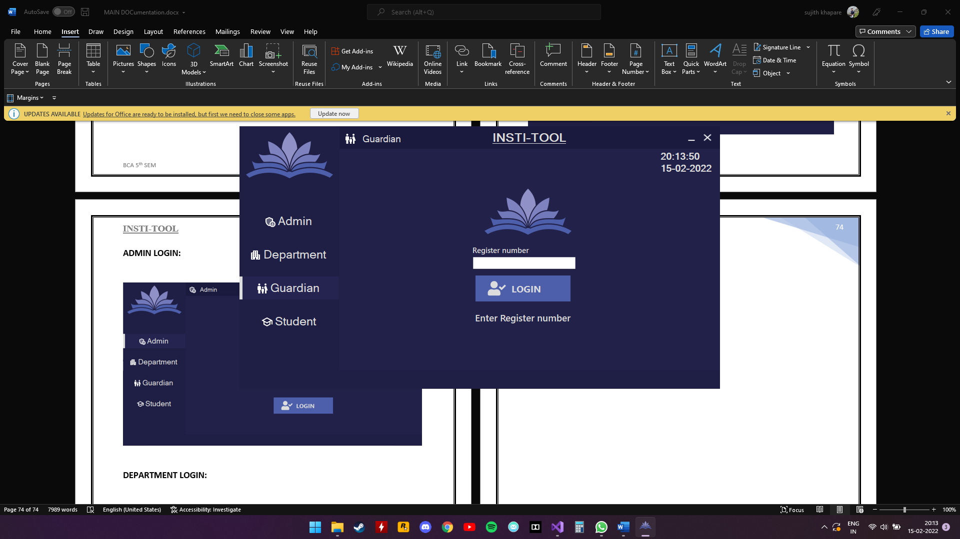

**STUDENT LOGIN:**

Students’ will use their register number to log in

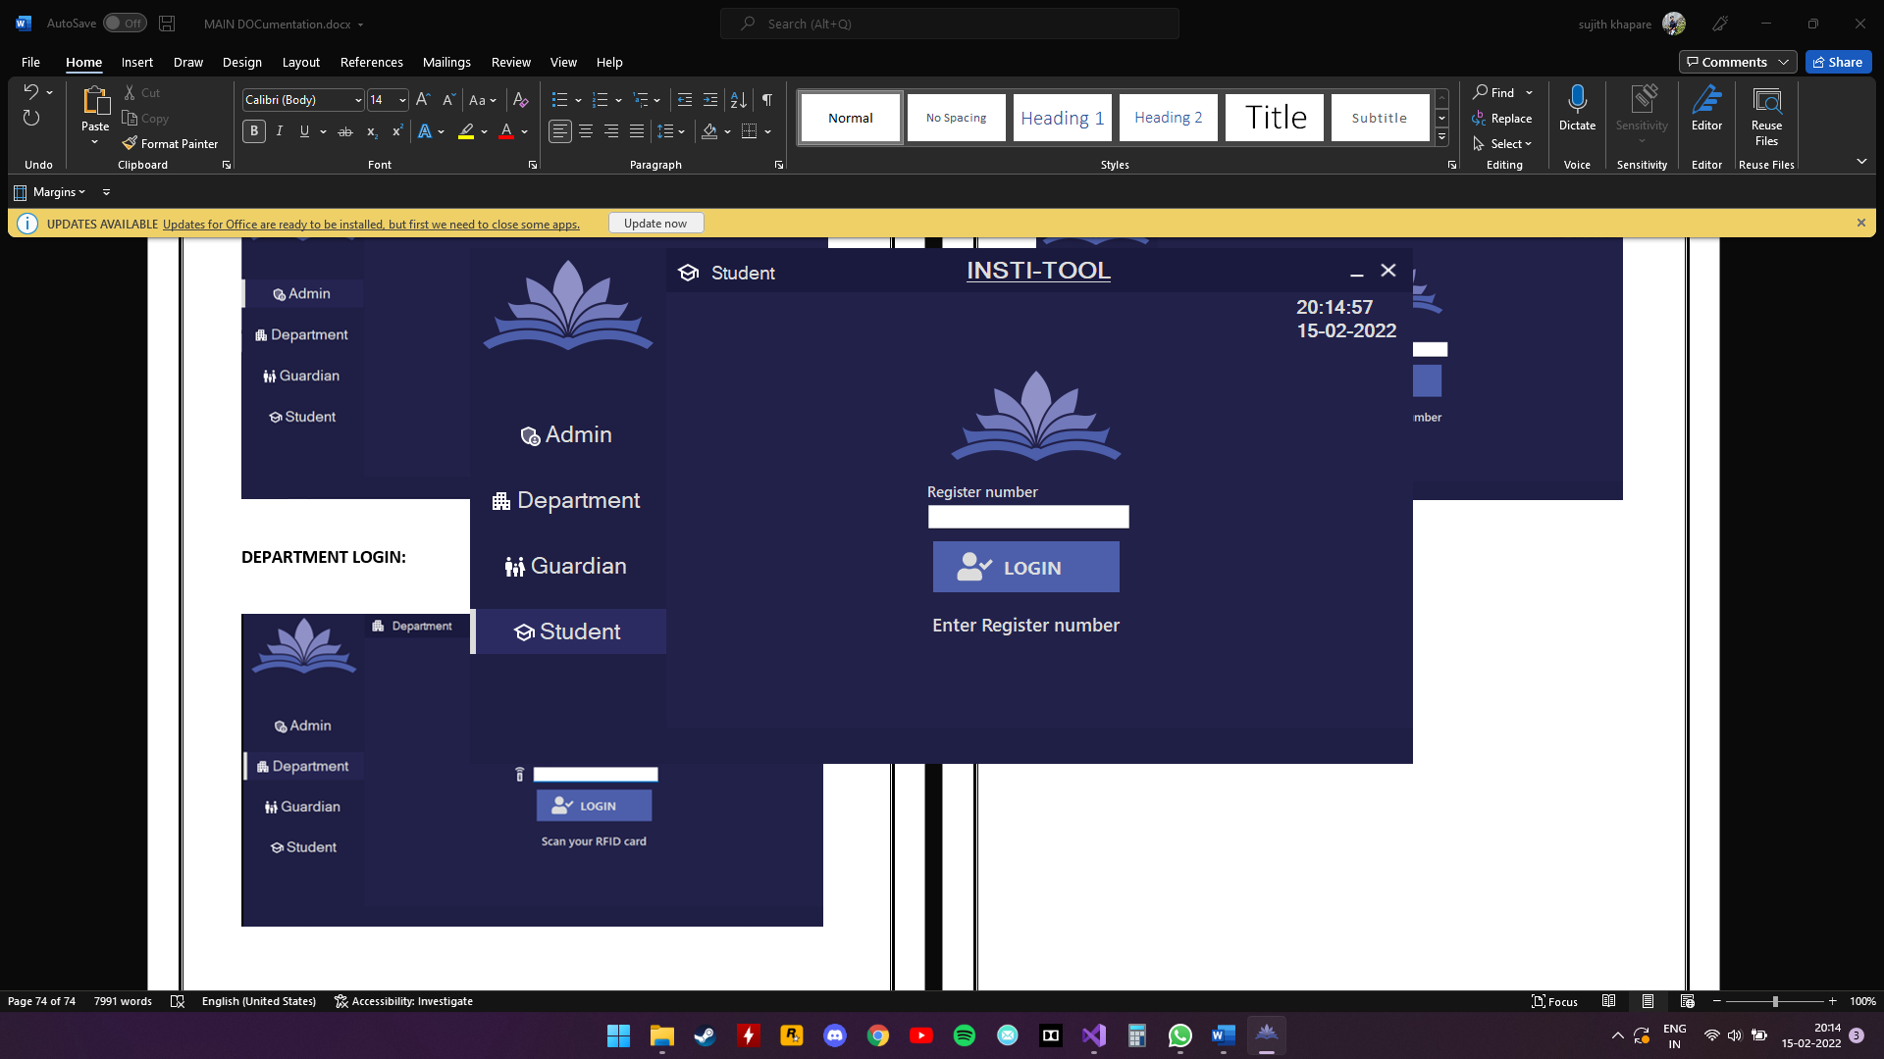

**ADMIN PAGE:**

This is admins dashboard where he can add students\staff, access control, and view all the tables in database

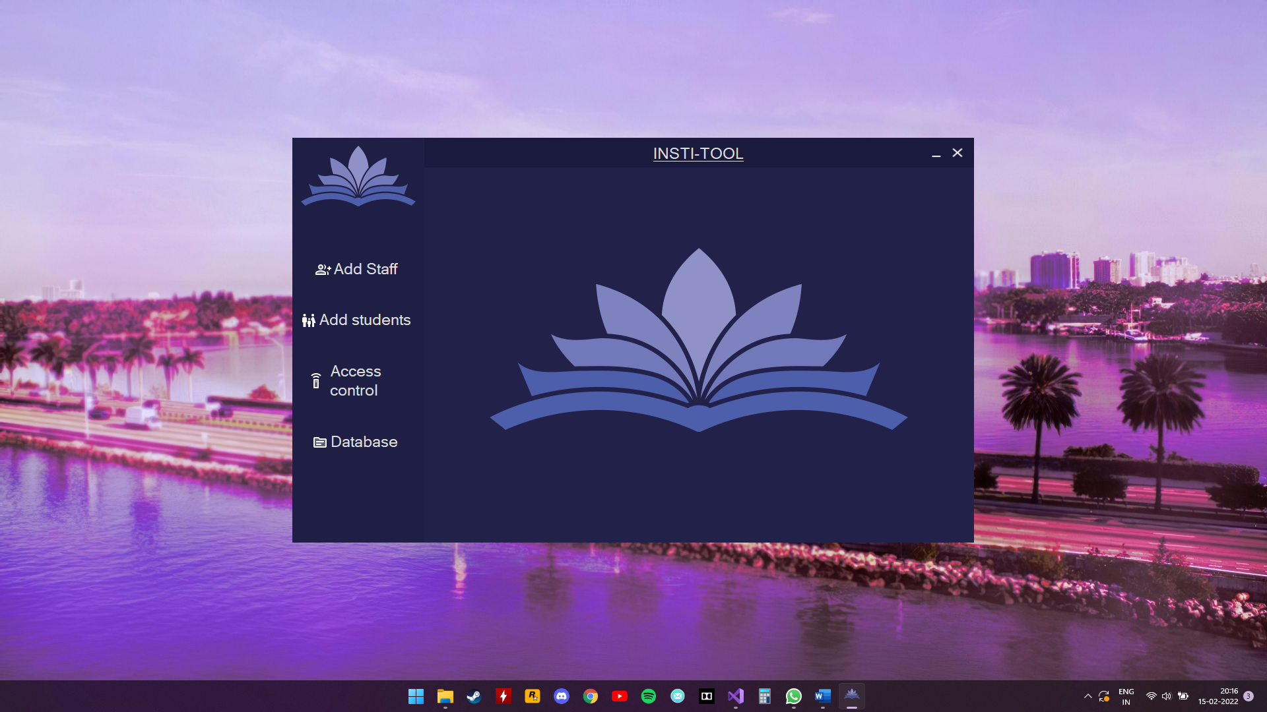

**ADD STUDENTS:**

Admin adding a student

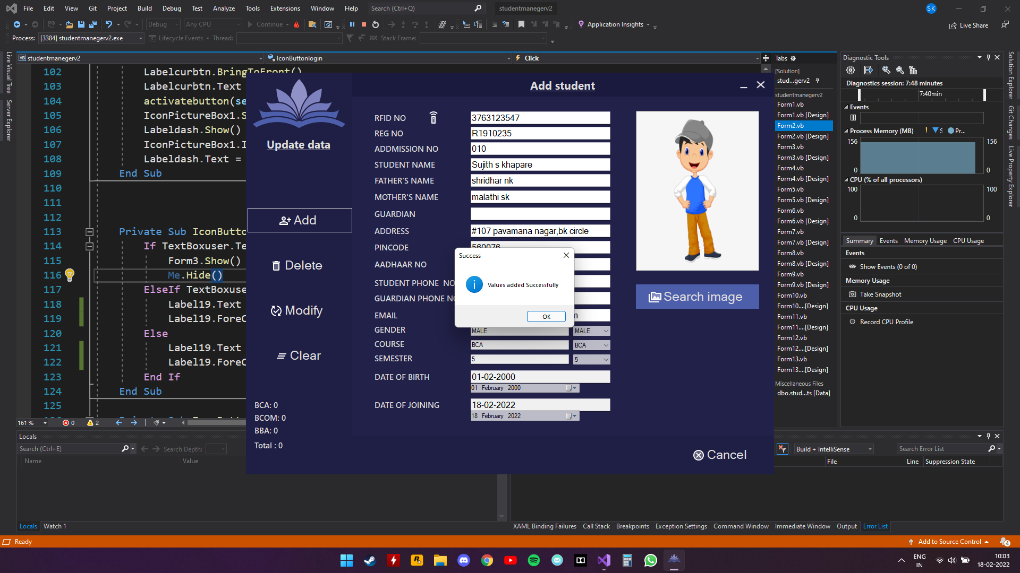

**ADD STAFF:**

**Director**

admin adding a director

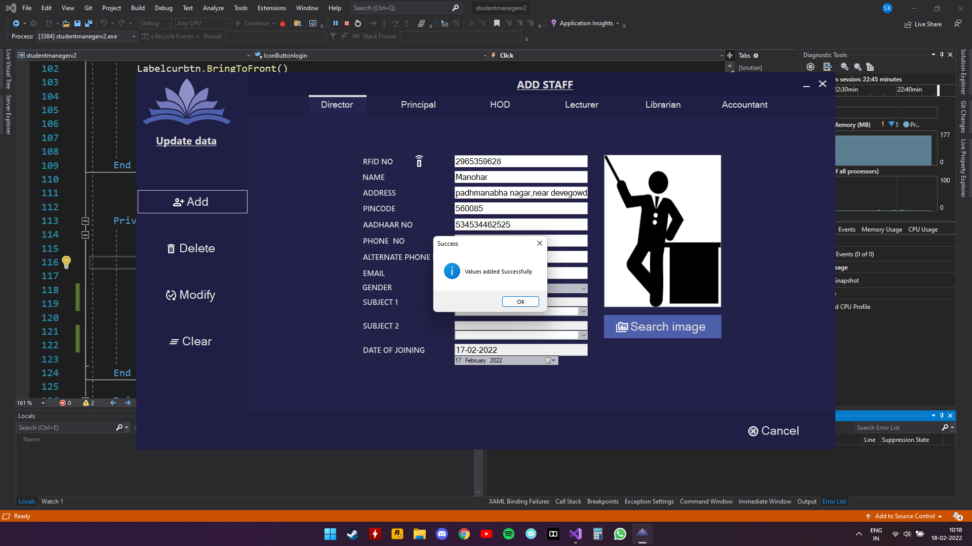

**Principal**

Admin adding a principal

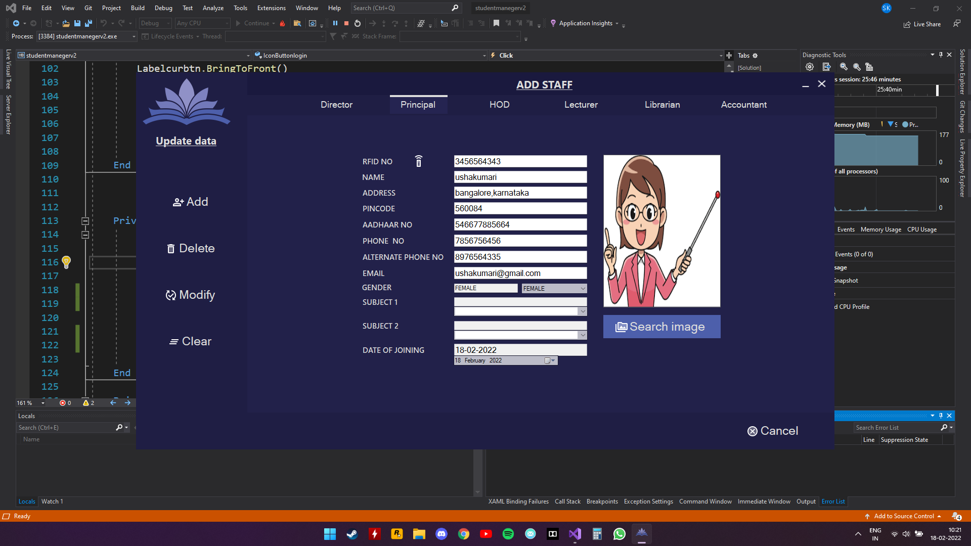

**HOD**

Admin adding head of the department

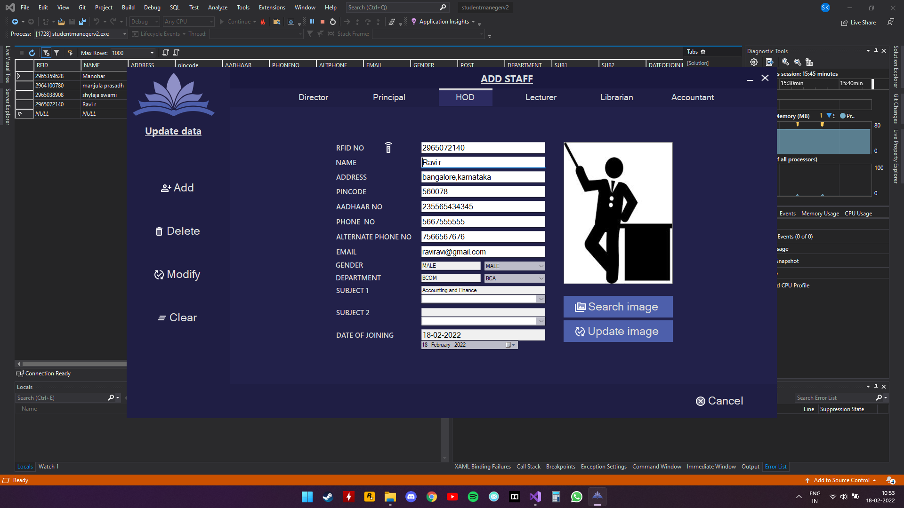

**LECTURER**

Admin adding a lecturer

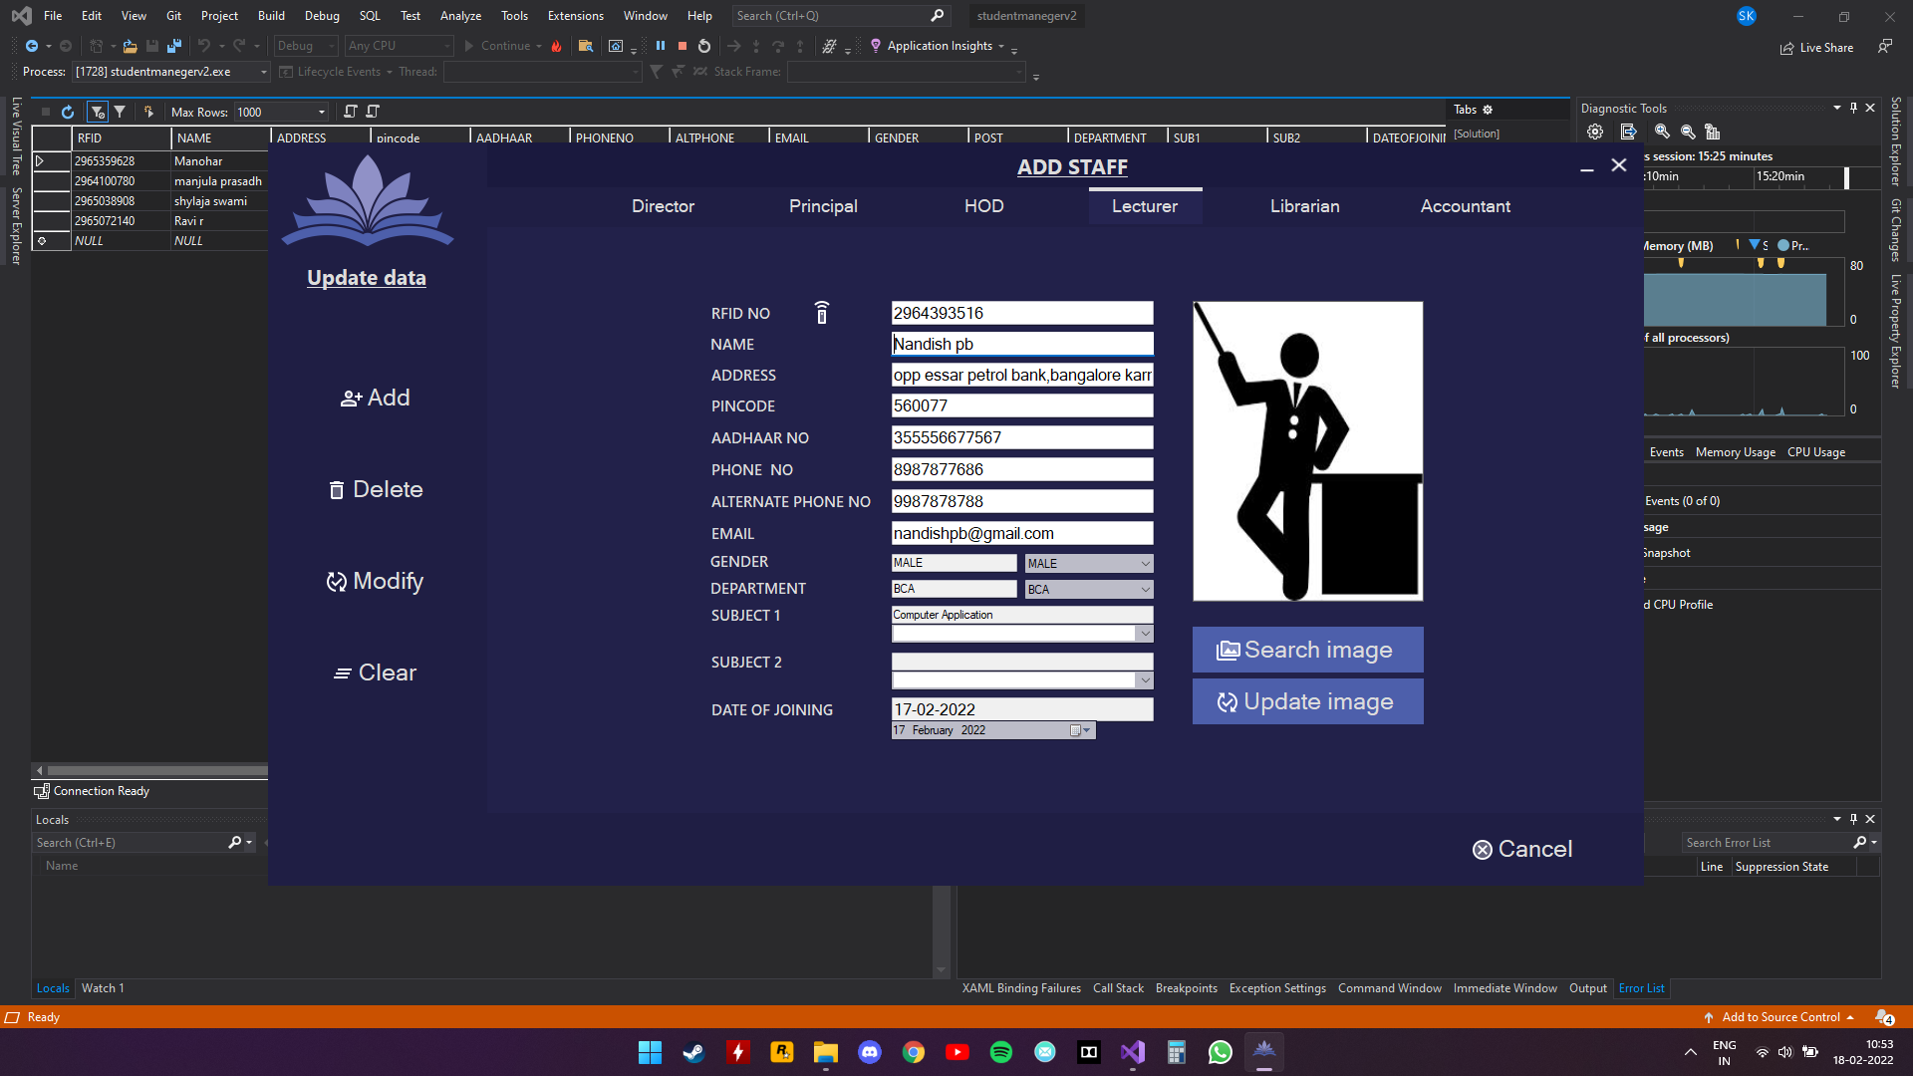

**LIBRARIAN**

Admin adding a librarian

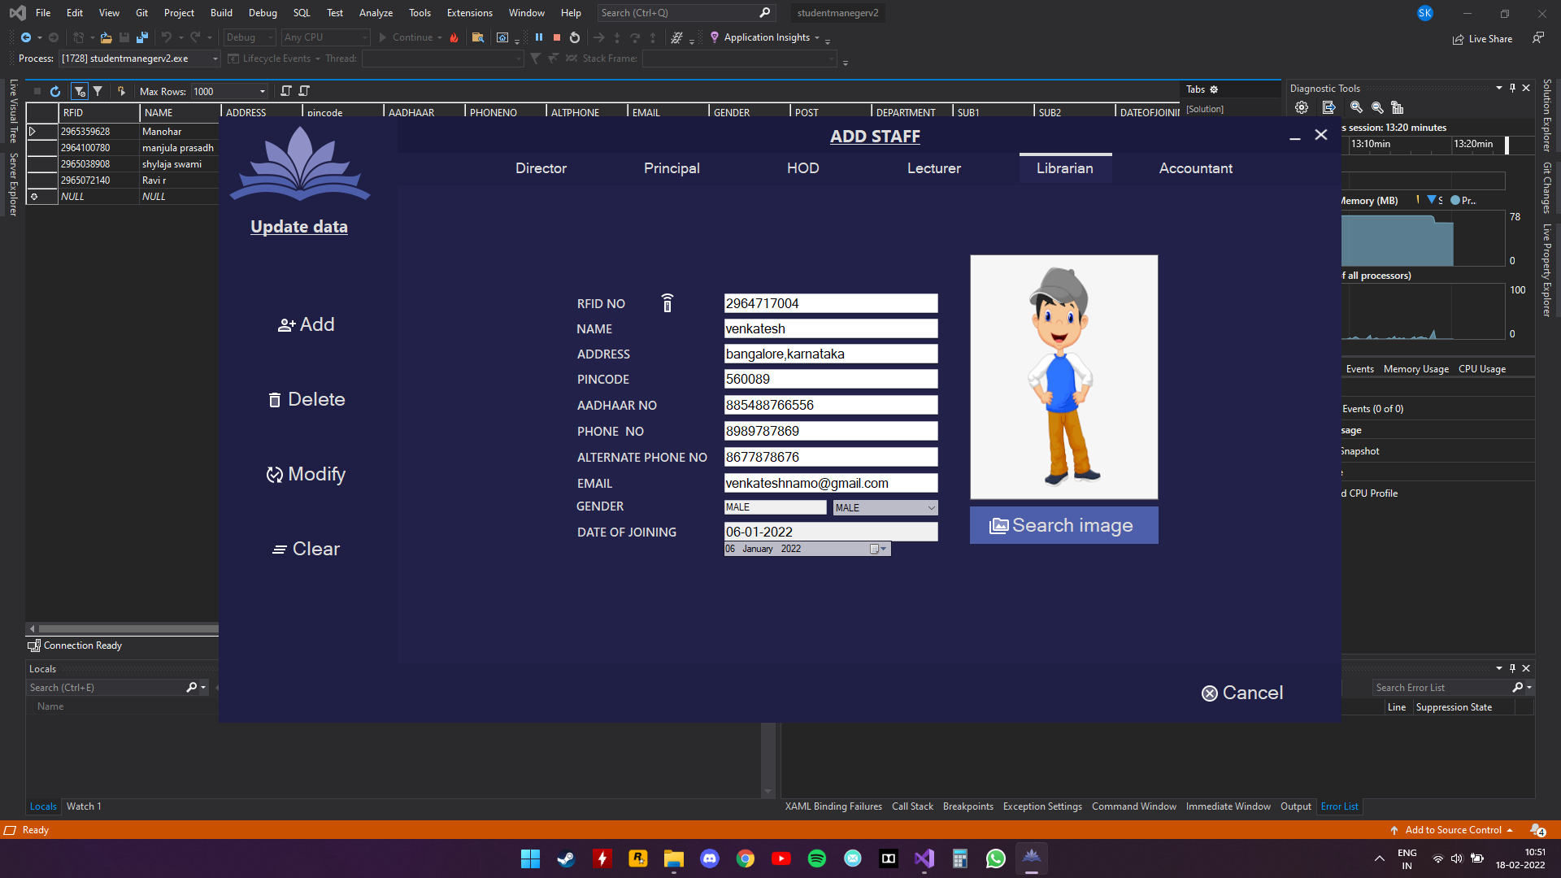

**ACCOUNTANT**

Admin adding a librarian

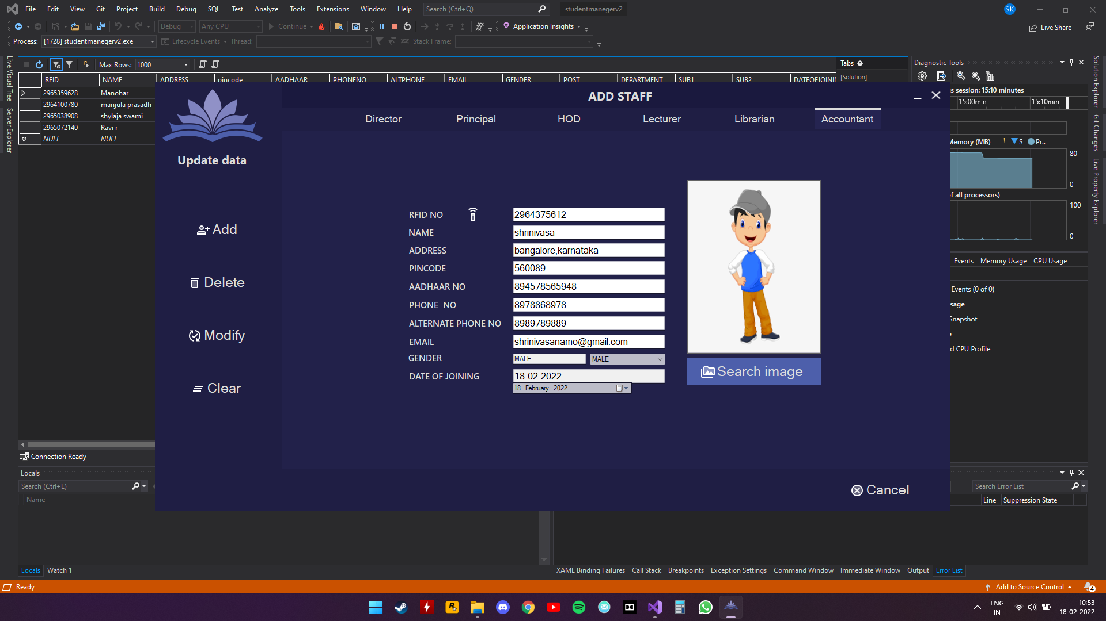

**ACCESS CONTROL:**

This form will be put up at the entrance of institution for security purpose and to record the entry/exit time

Wrong RFID Correct RFID

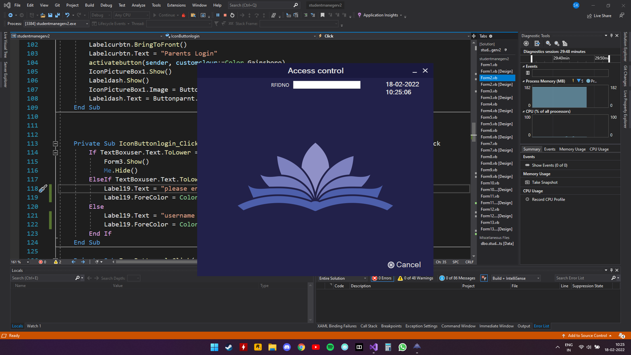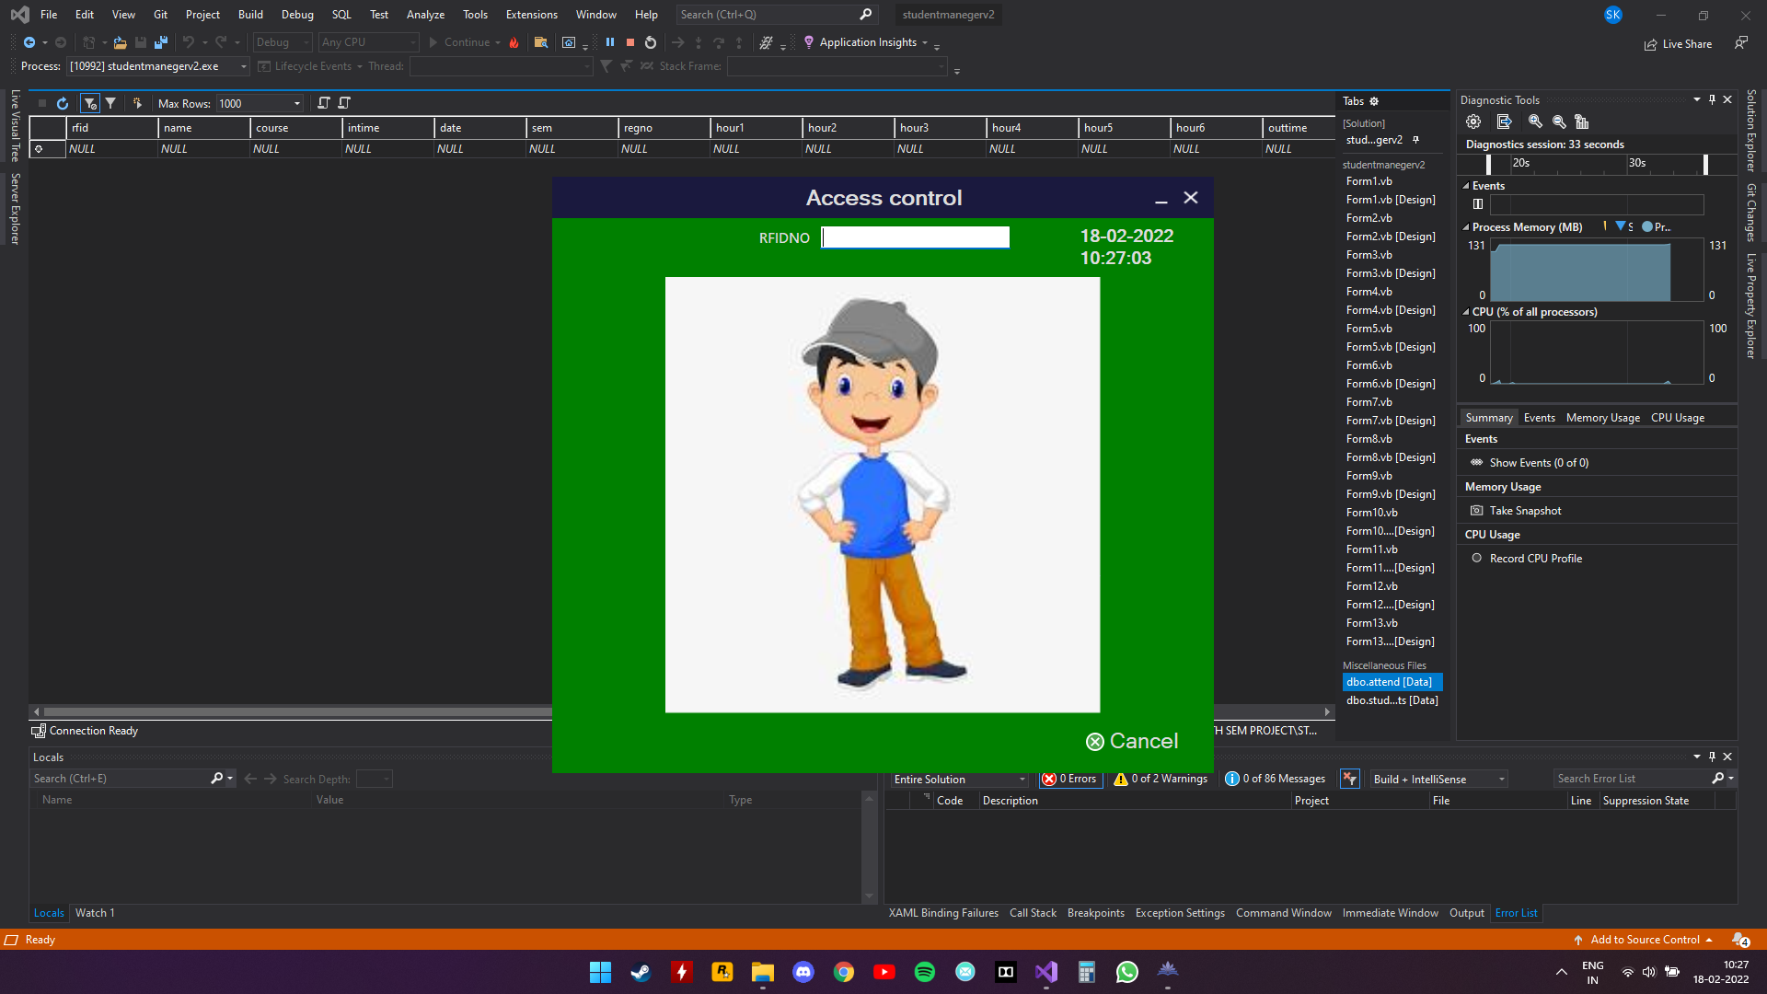

**DATABASE:**

Admin can view all the tables in the database

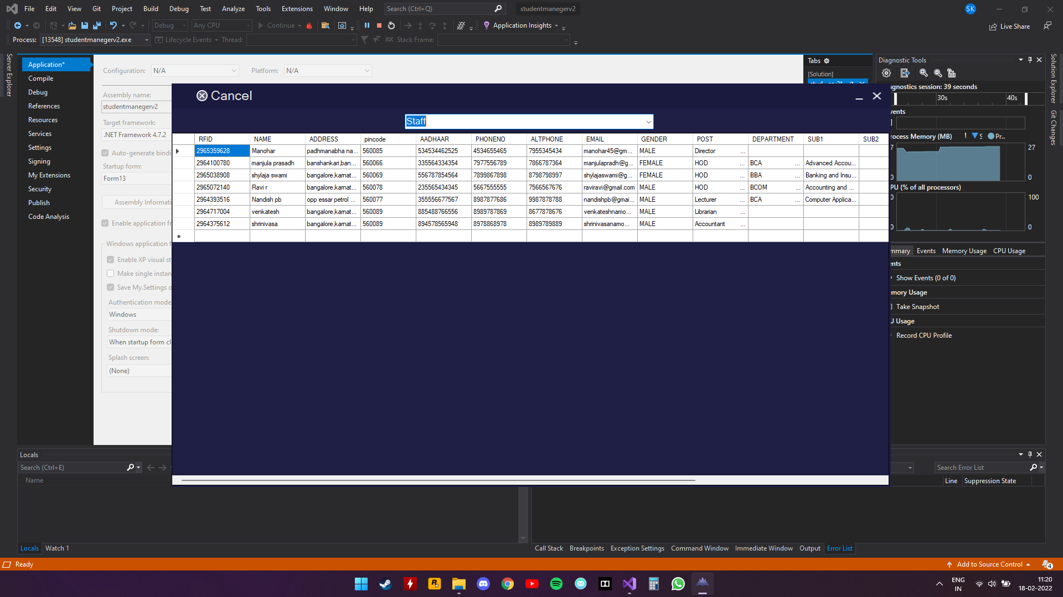

**DIRECTOR\PRINCIPAL FORM:**

Director\Principal can view Hod information

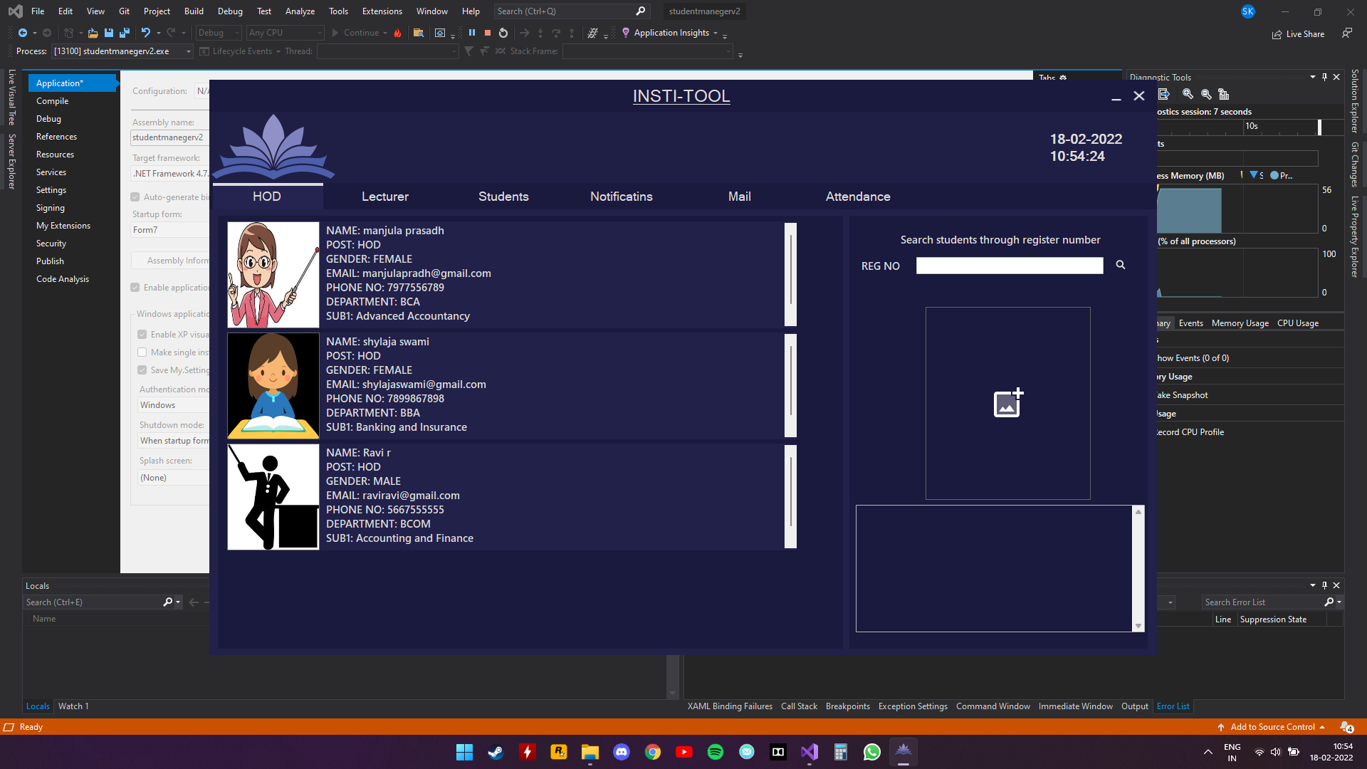

**Lecturer**

Director can view lecturer information

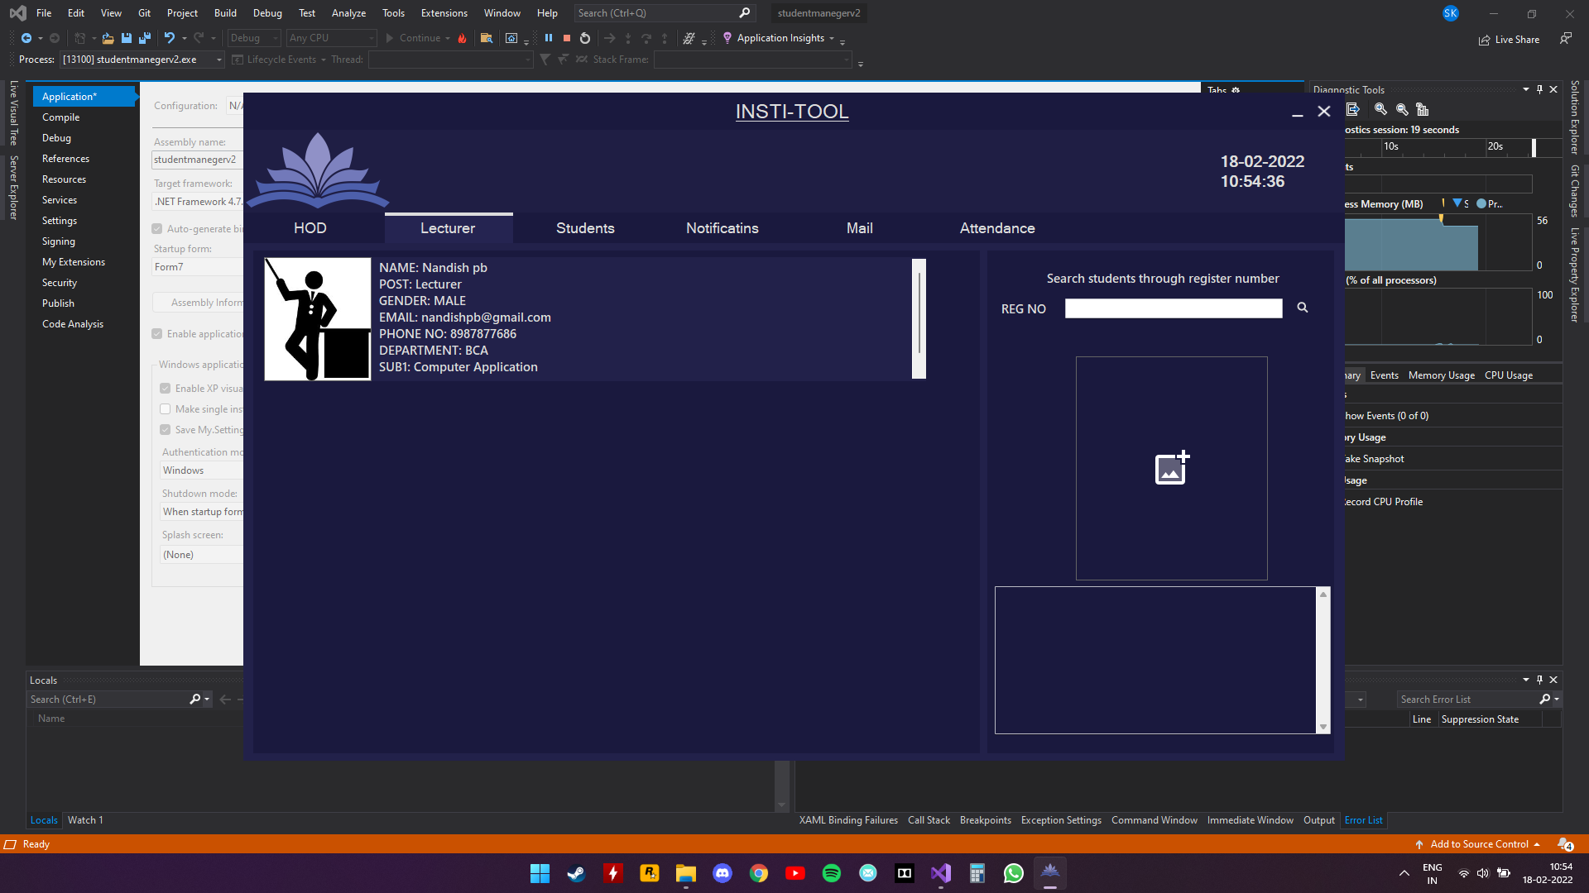

**students**

Director\Principal can view Students’ information - all

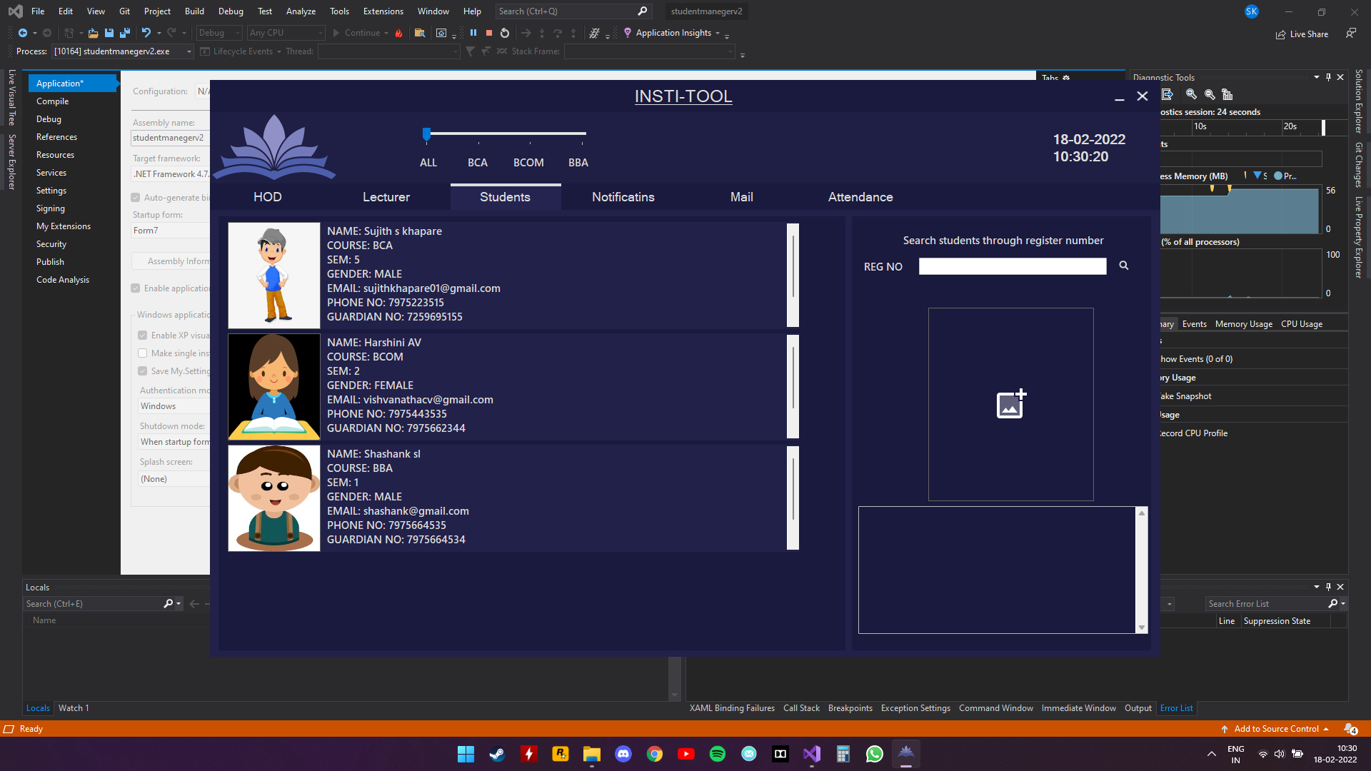

Director\Principal can view Students’ information - BCA

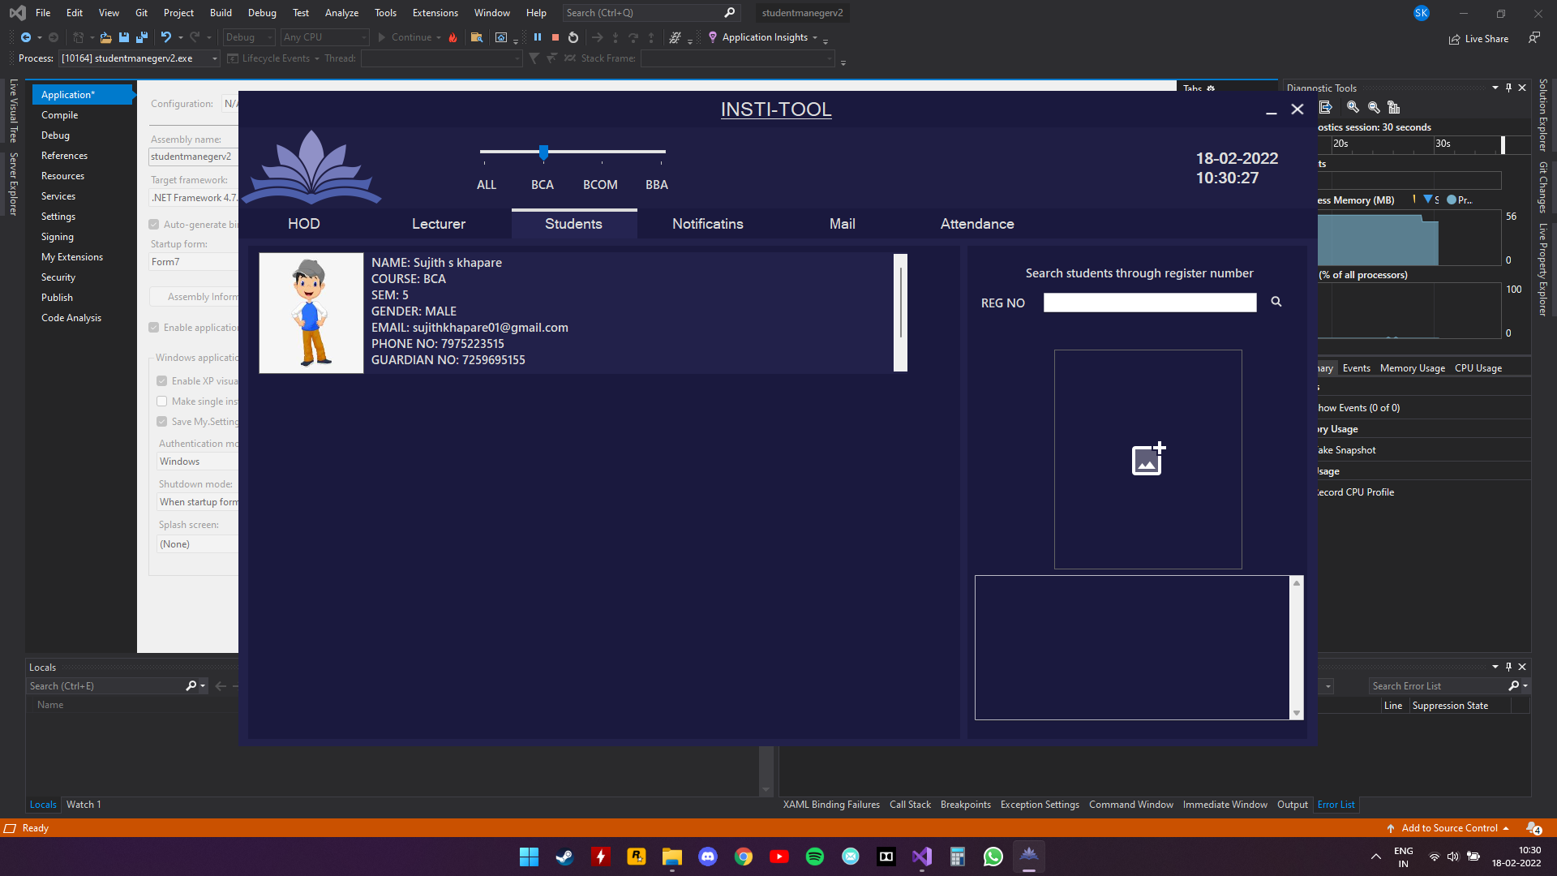

Director\Principal can view Students’ information – BCOM

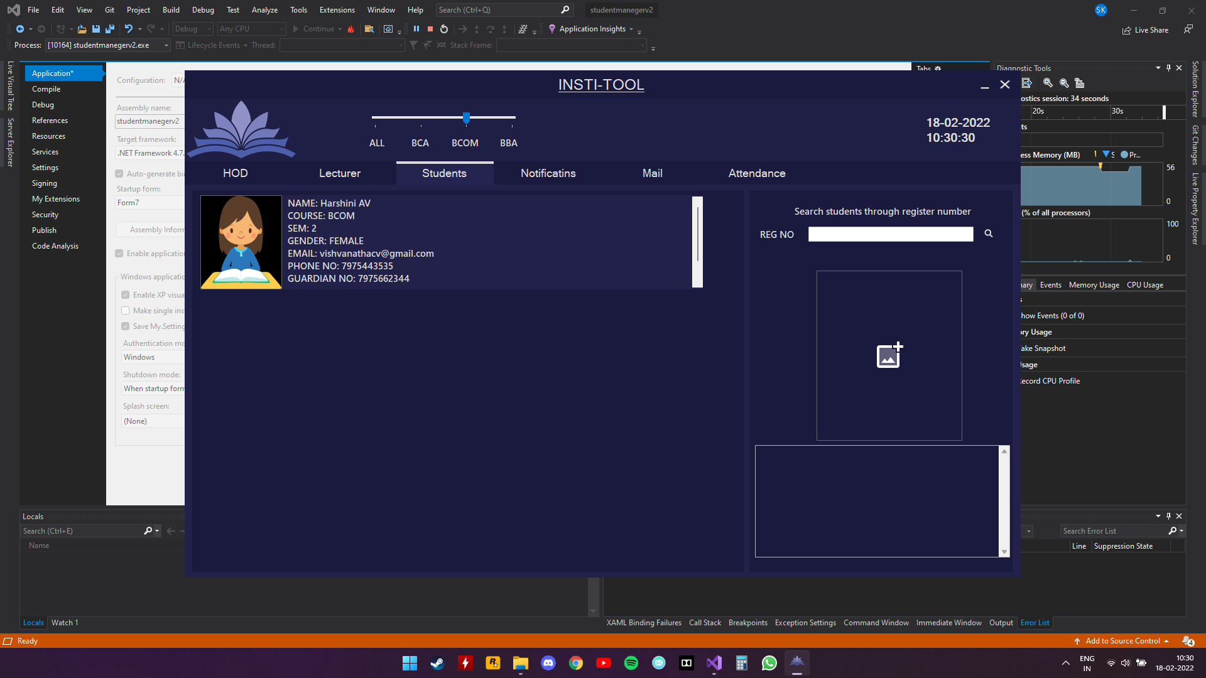

Director\Principal can view Students’ information – BCOM

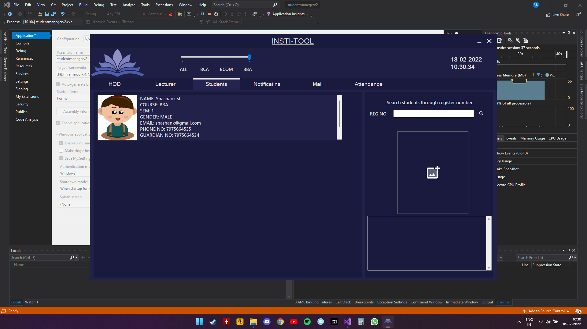

**Notification**

Director\Principal can send notifications

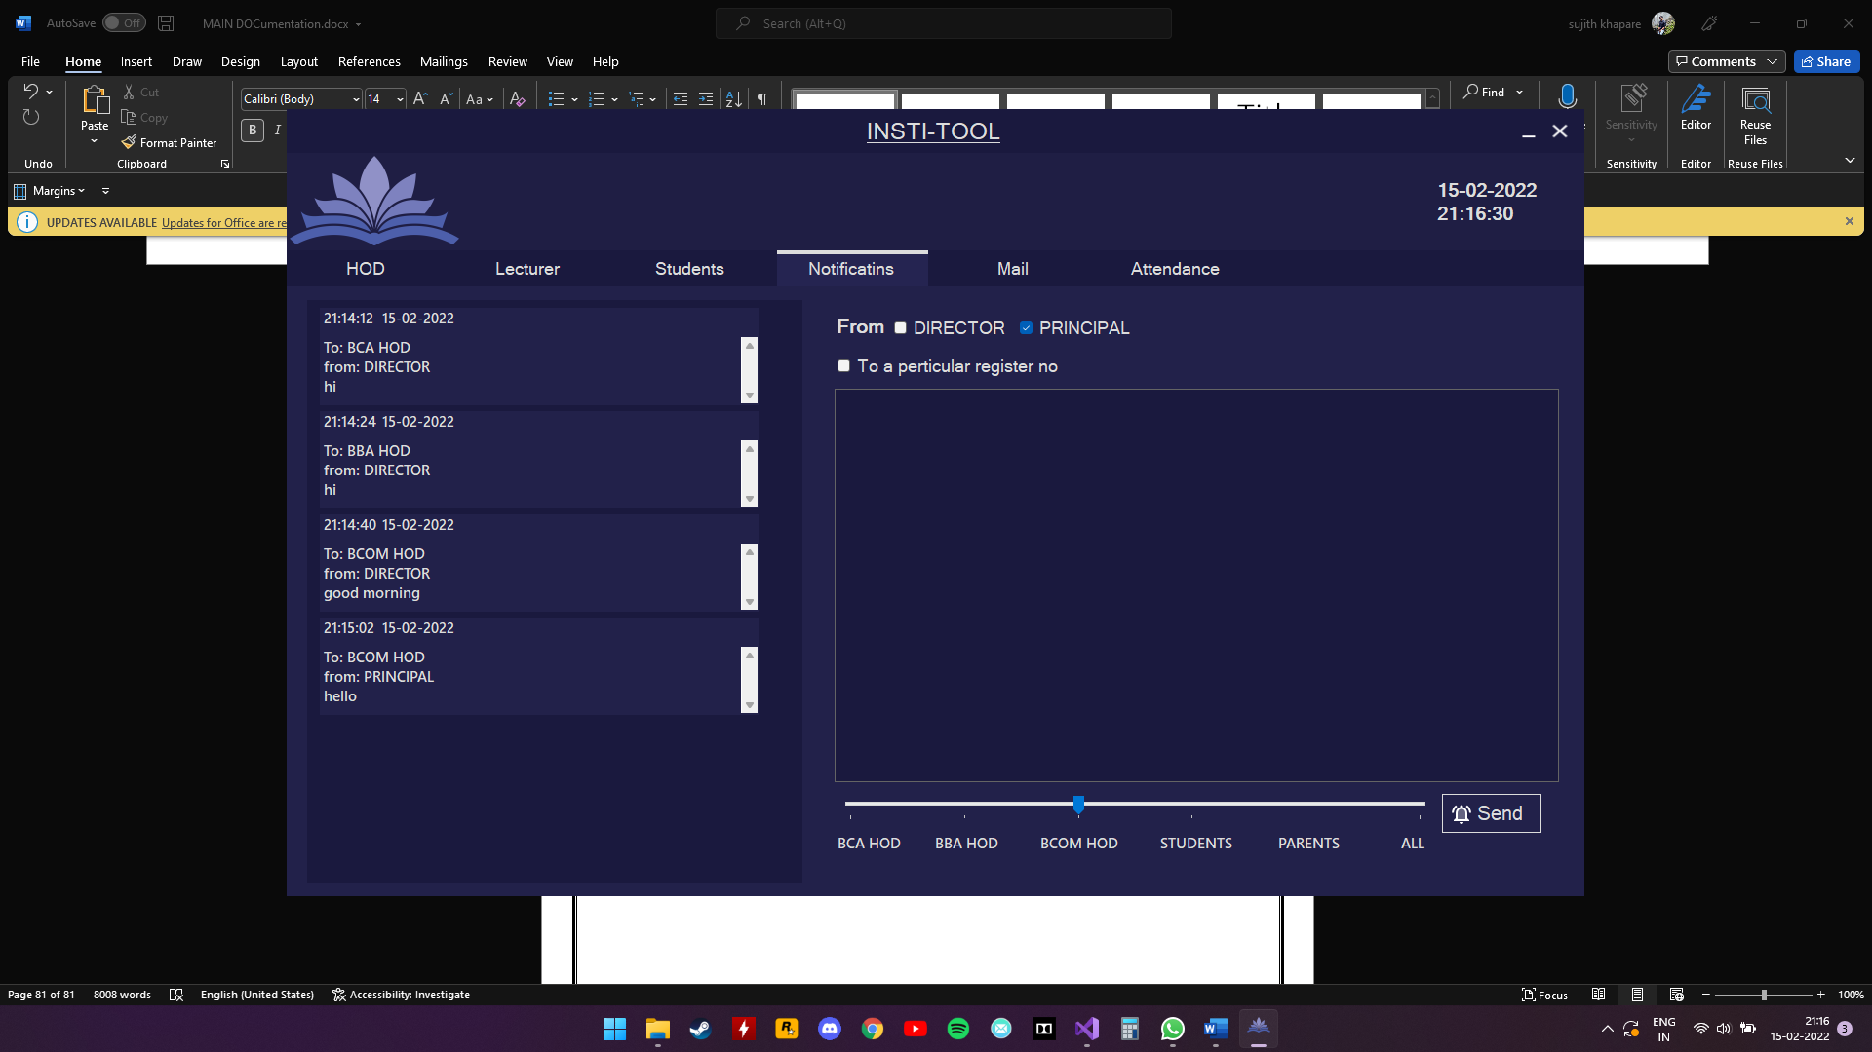

**Mail**

Director\Principal can send e-mail

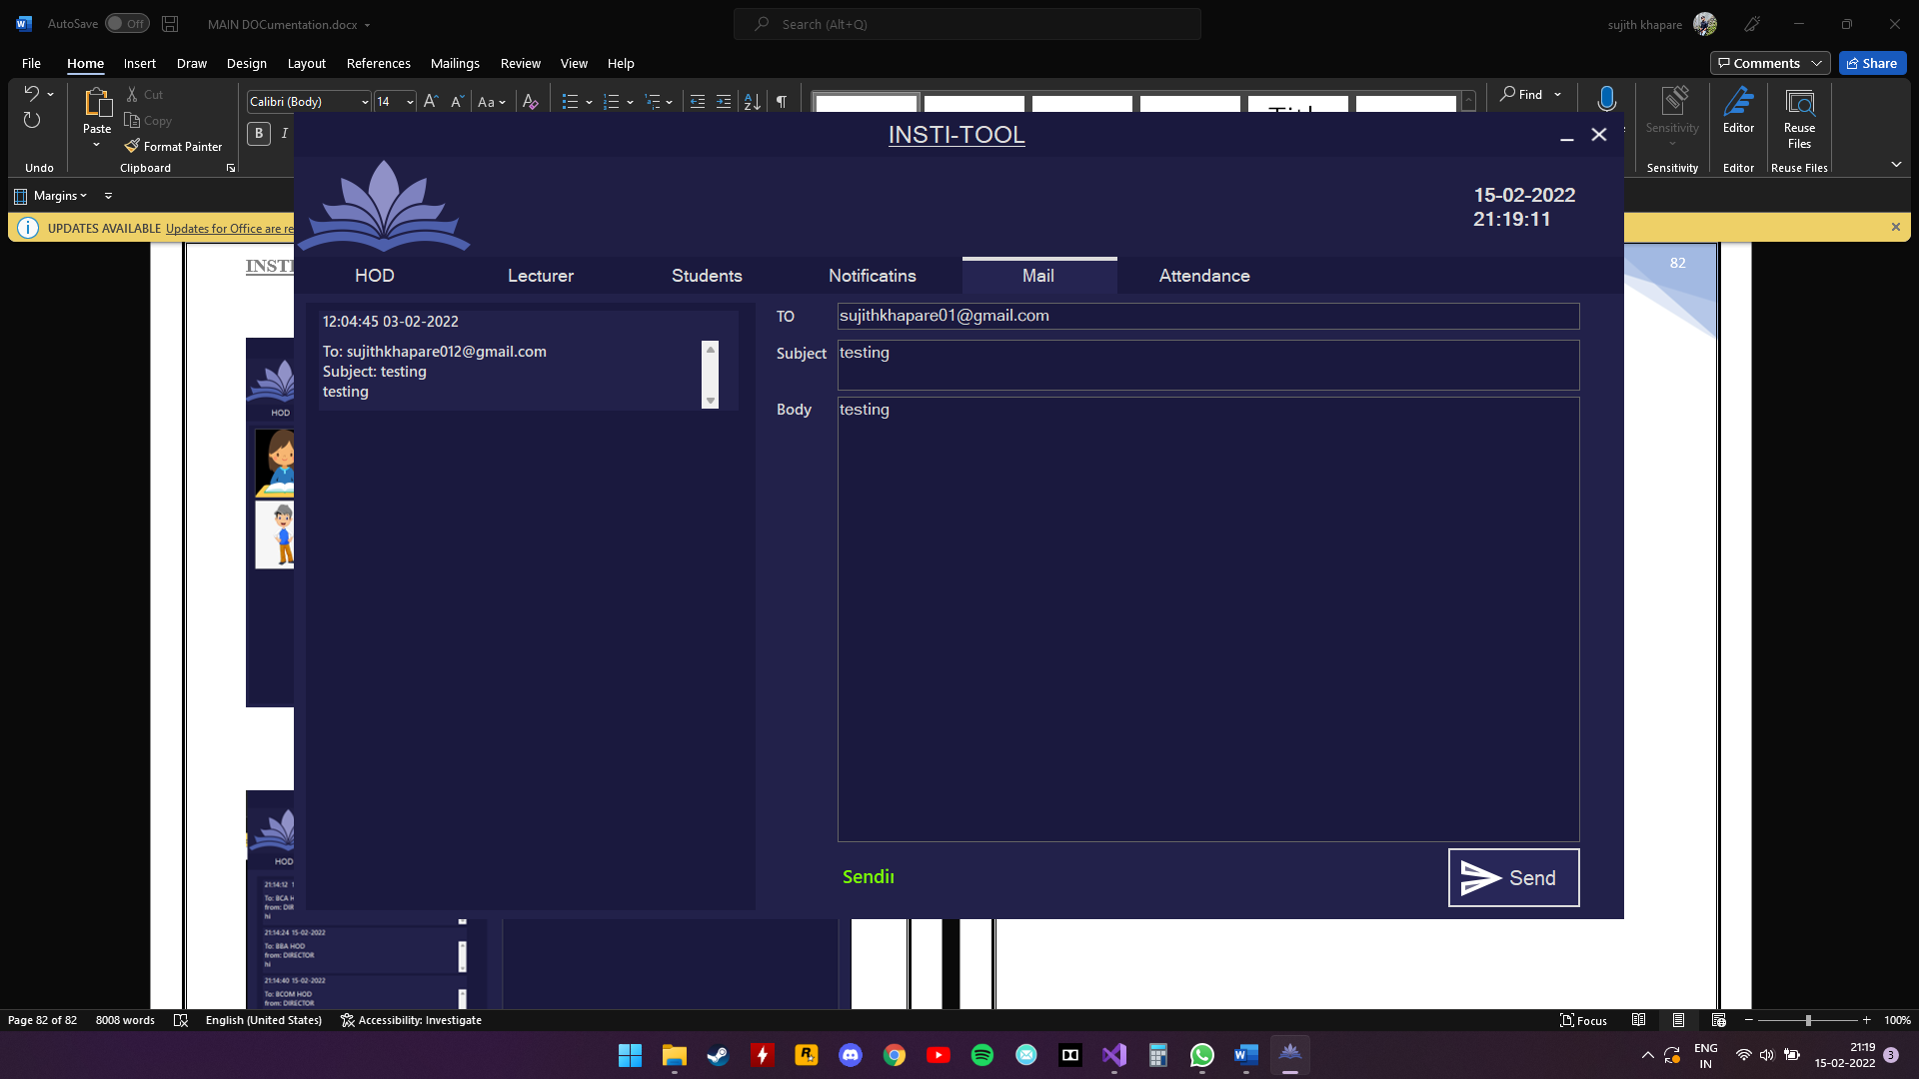

**Attendance**

Director\Principal can view\mark students’ attendance

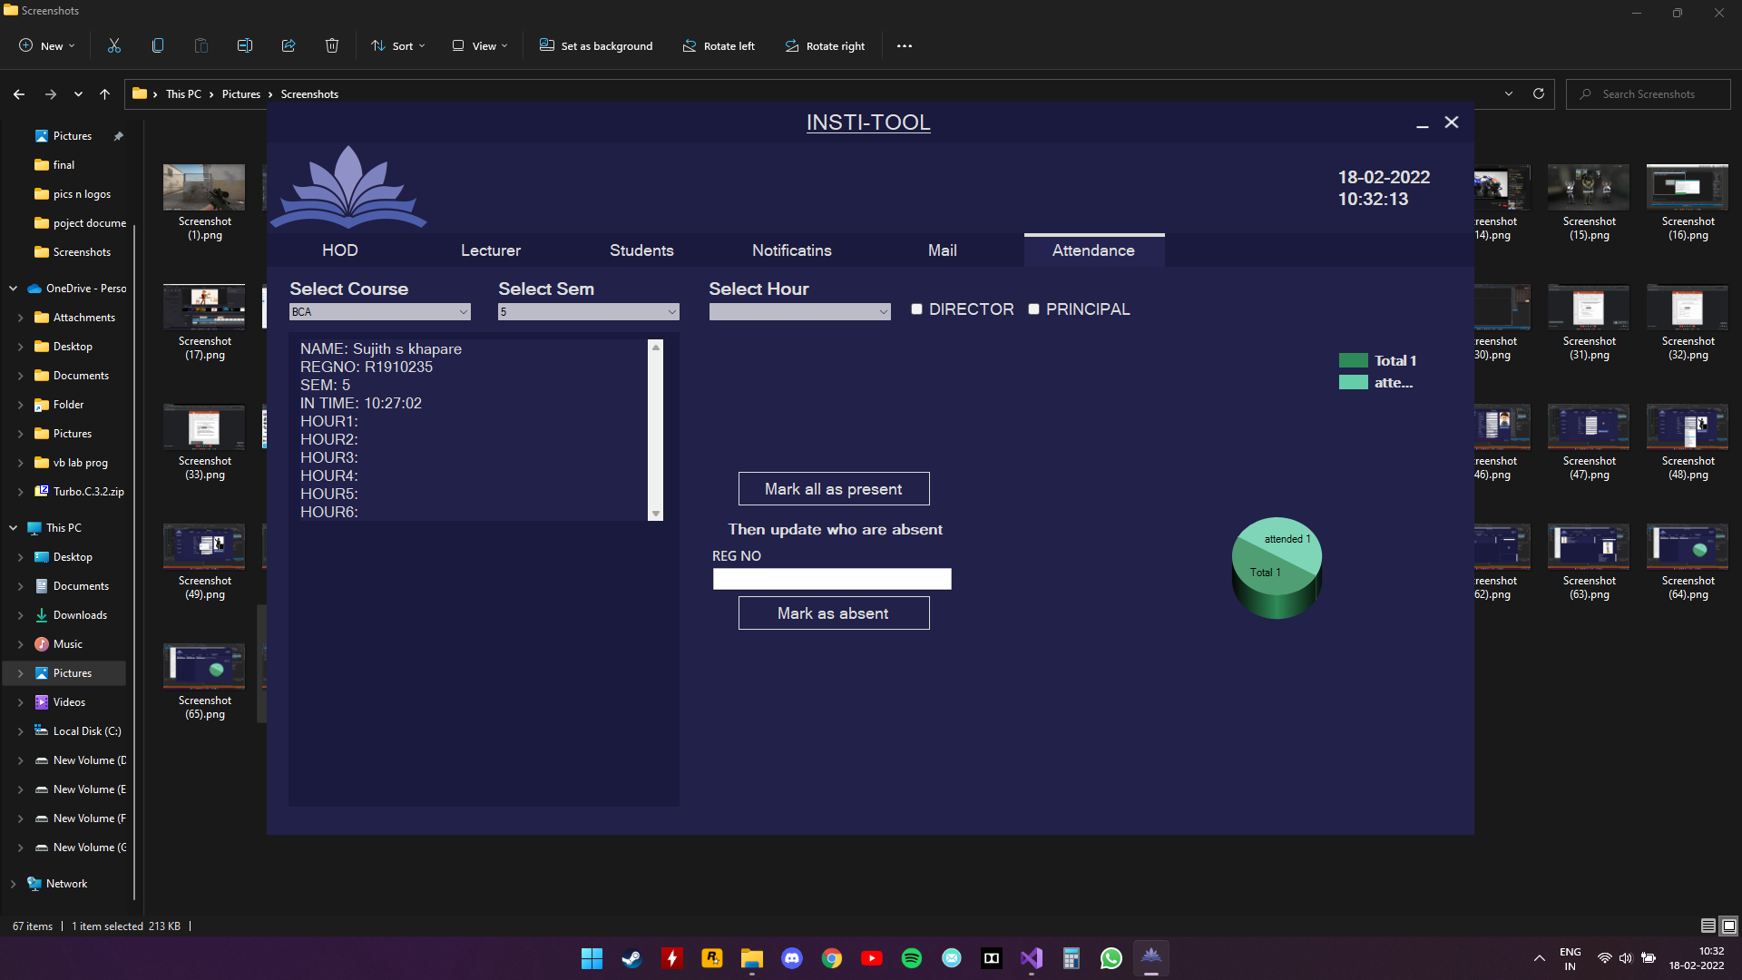

pie chart

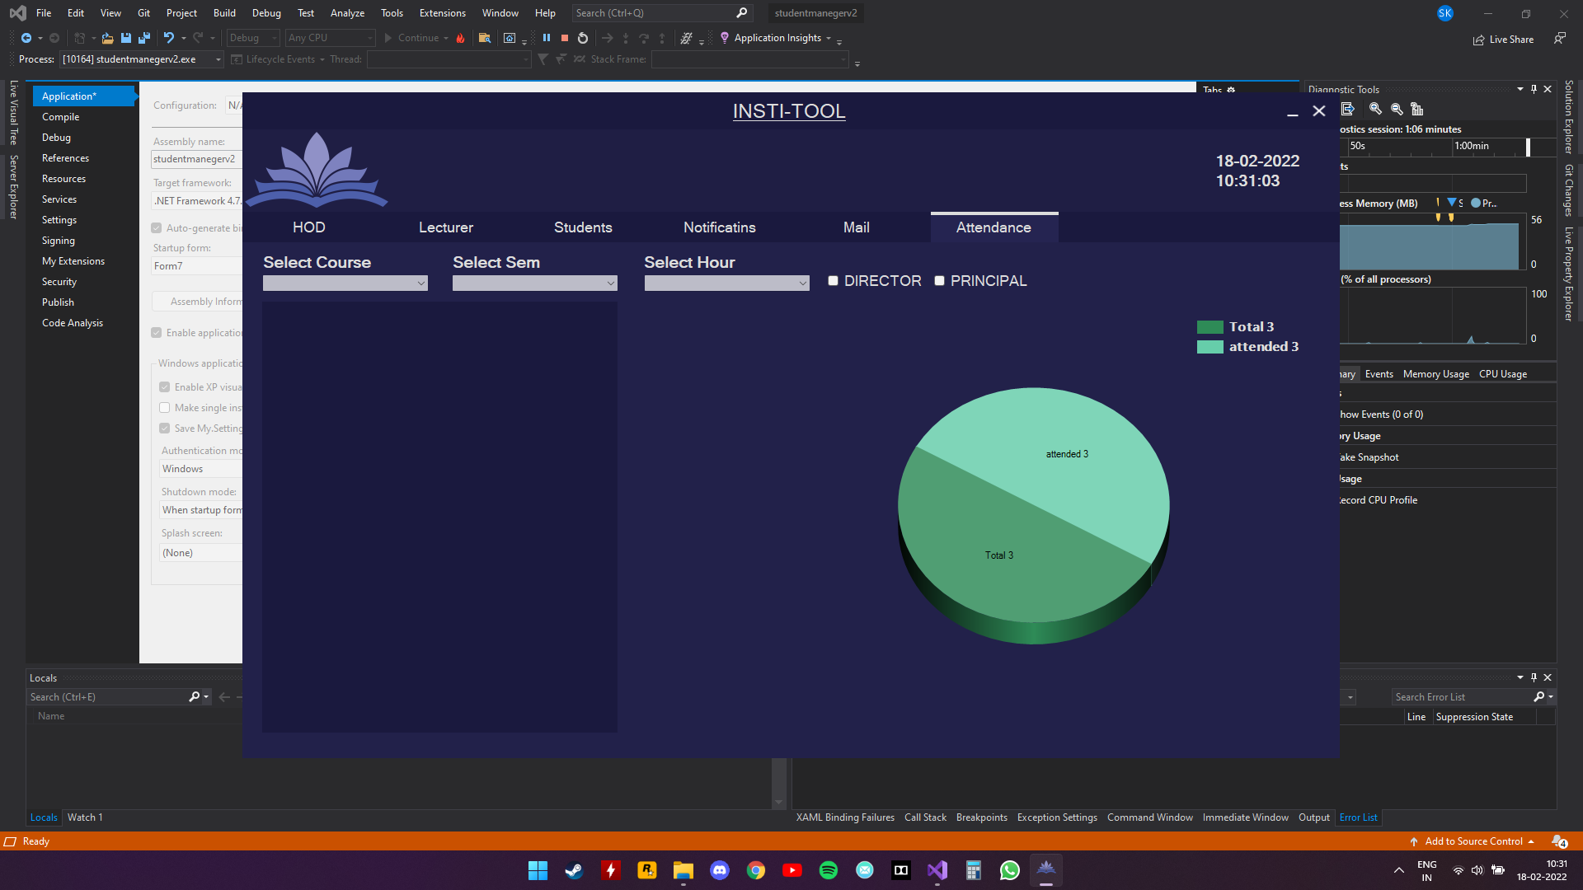

**HOD FORM(BCA):**

HOD can view lecturer details of their department and assign class

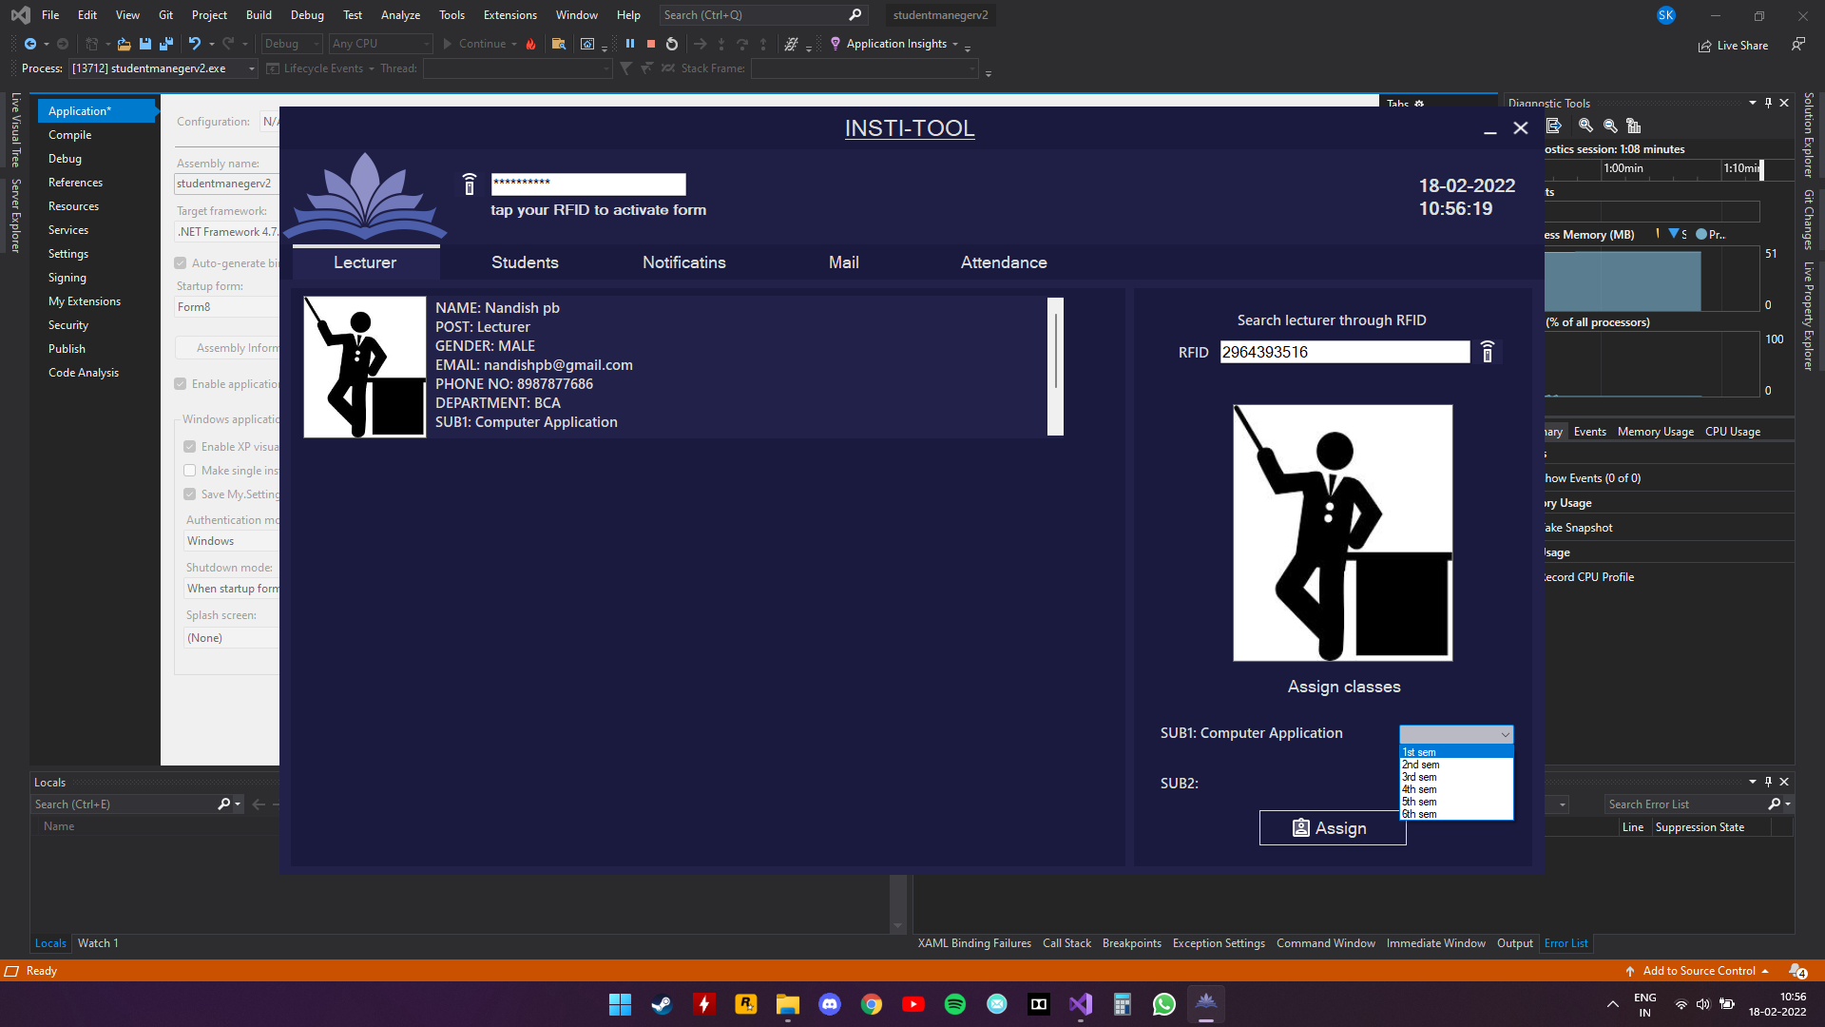

HOD can view students details of their department

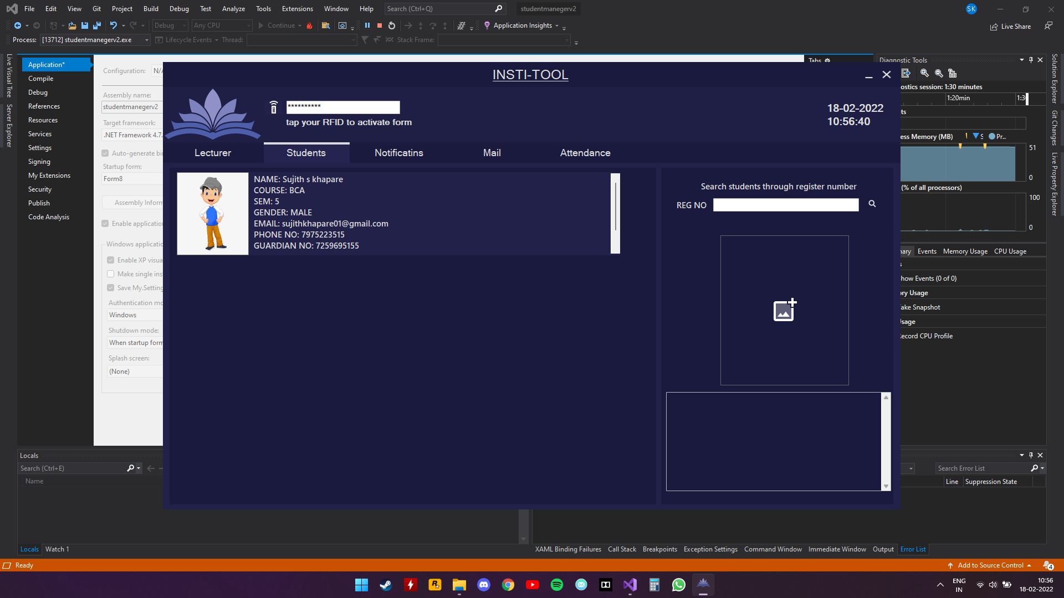

HOD can send notifications to their department

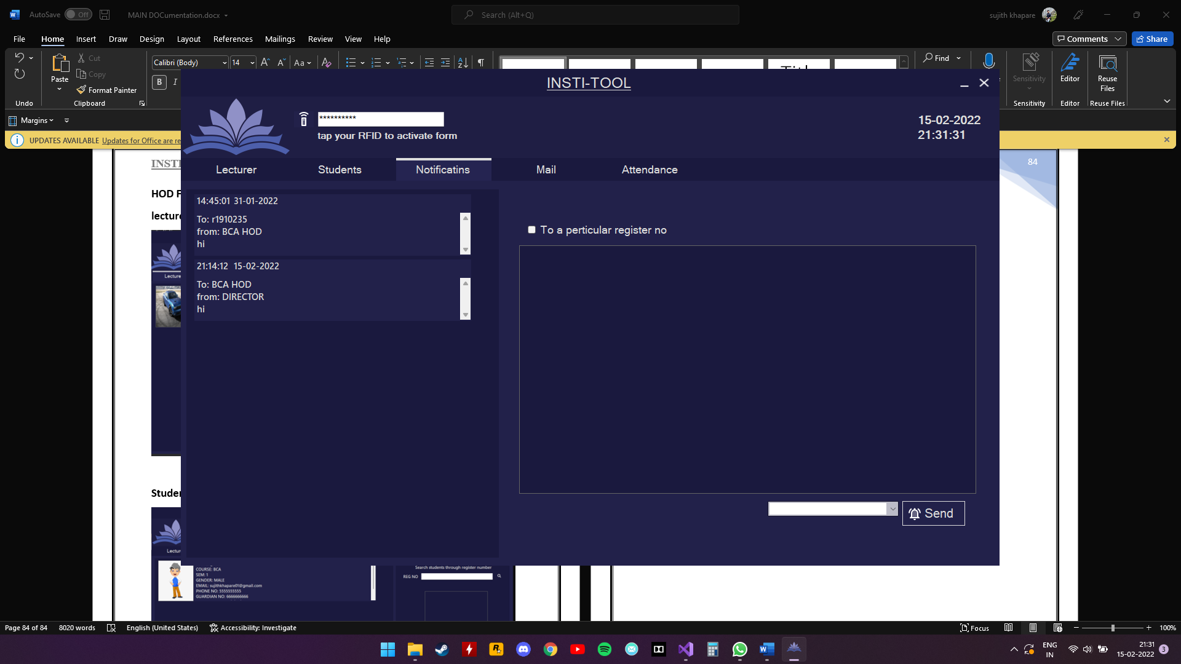

HOD can send mail to their department

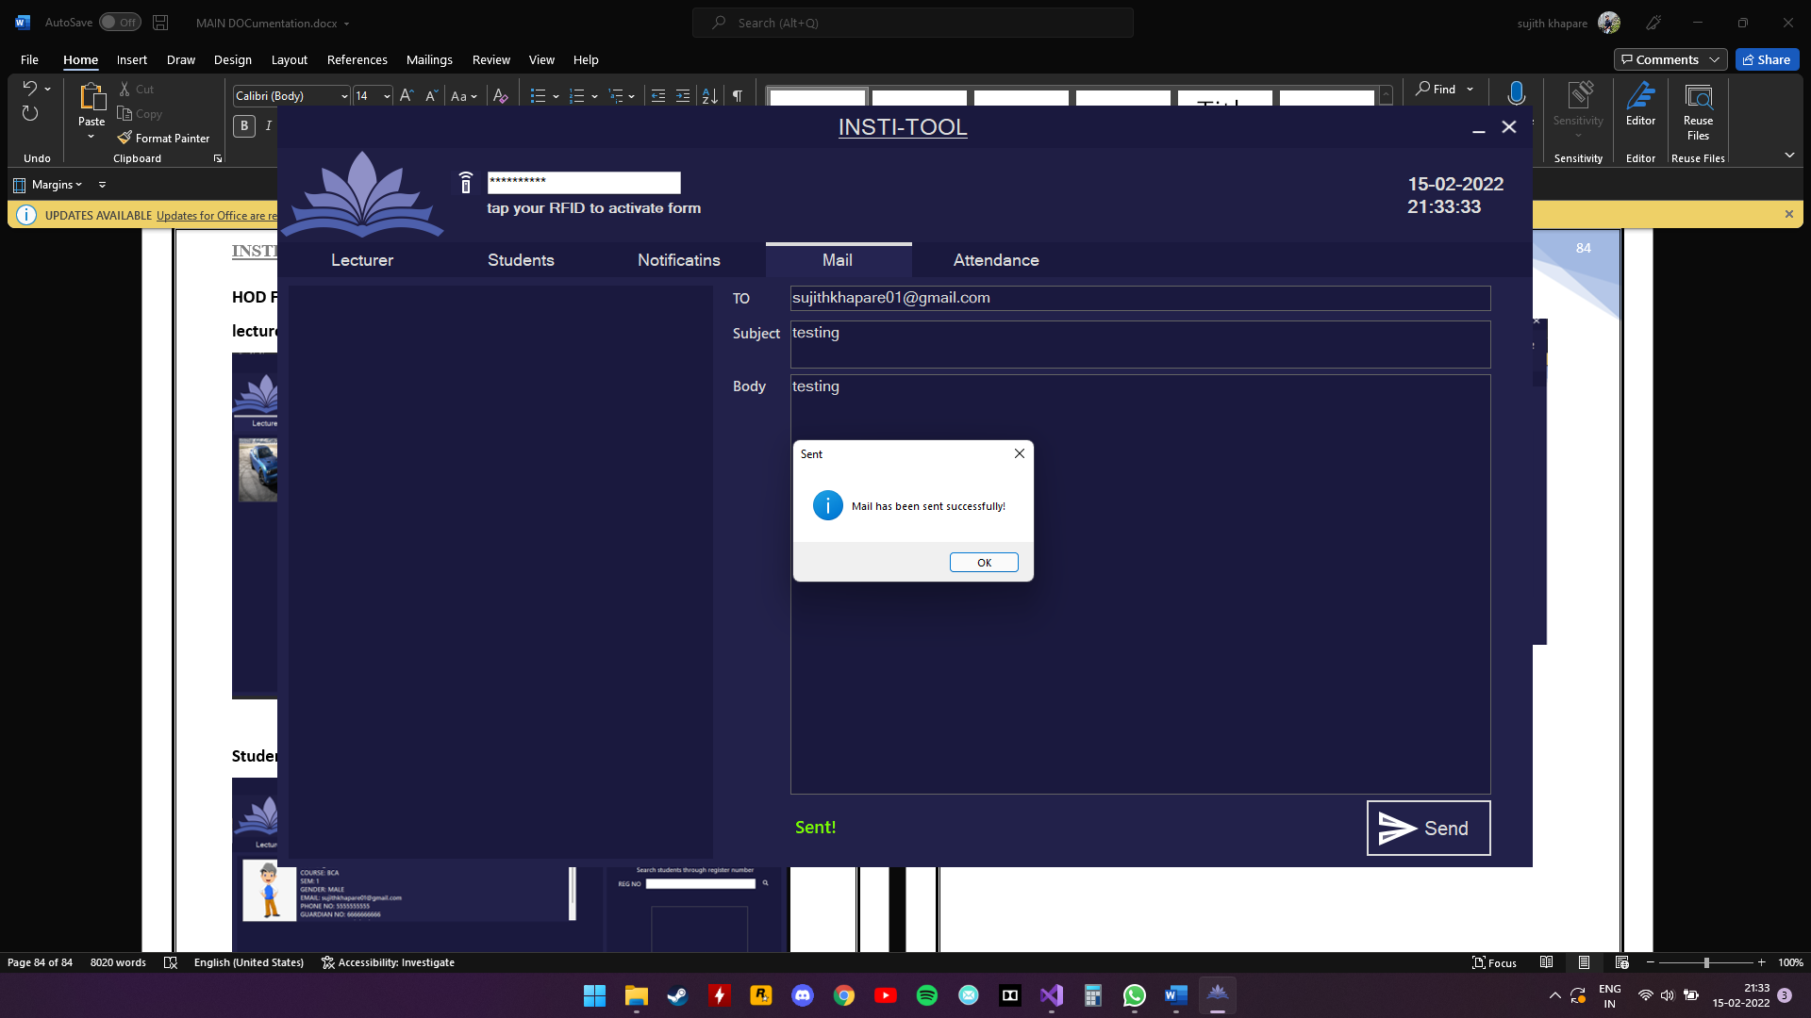

Sent mail appear on the left panel

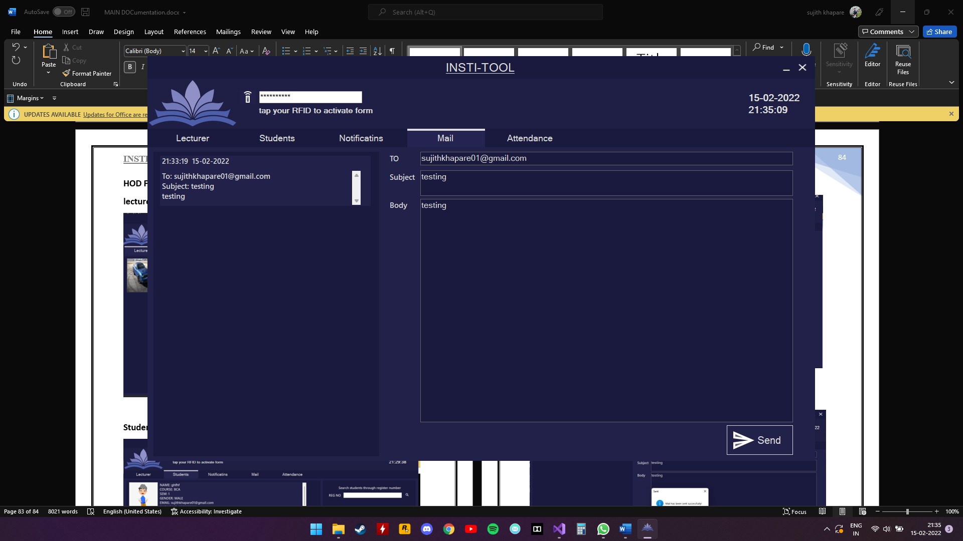

HOD can view\mark attendance

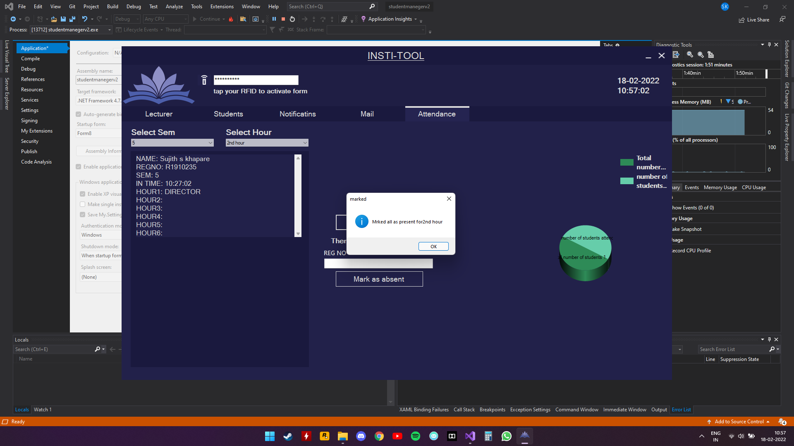

**LECTURER FORM:**

Lecturer can view students details of their department and class

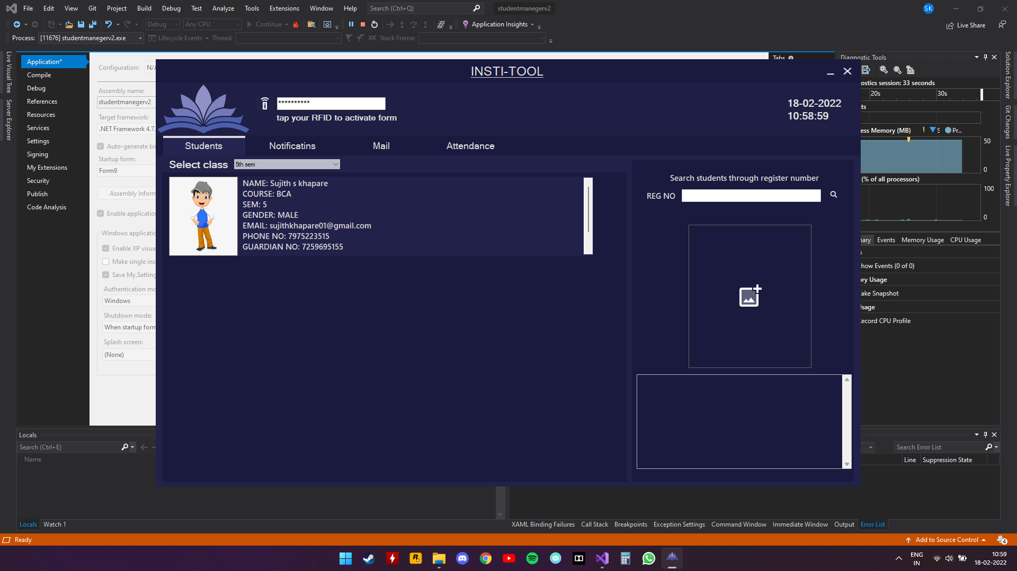

lecturer can send notifications to their department

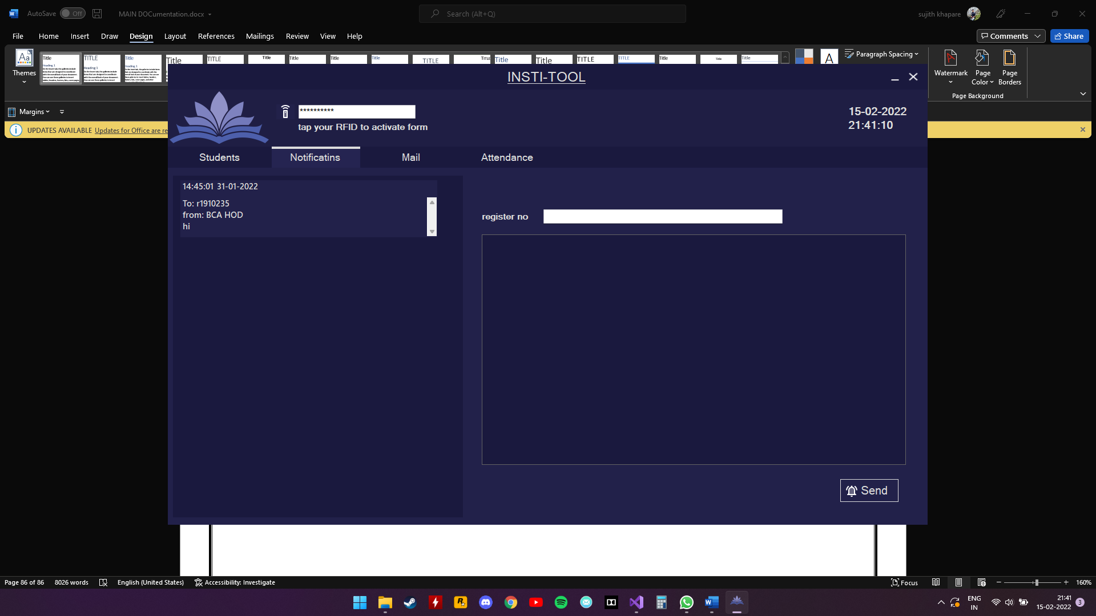

lecturer can send e-mail to their department

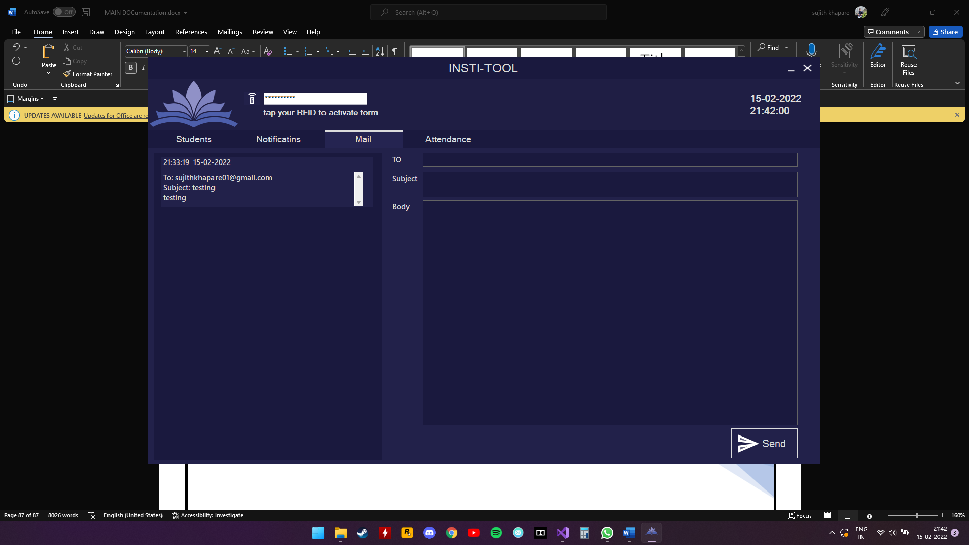

Lecturer can view\mark attendance only for class they are assigned for

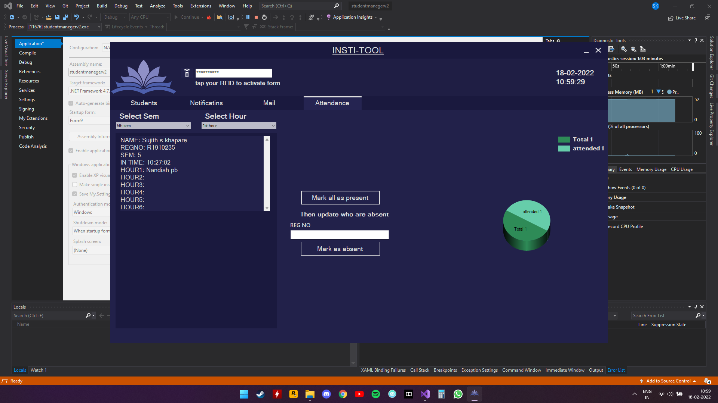

**LIBRARIAN FORM:**

Librarian adding books to inventory

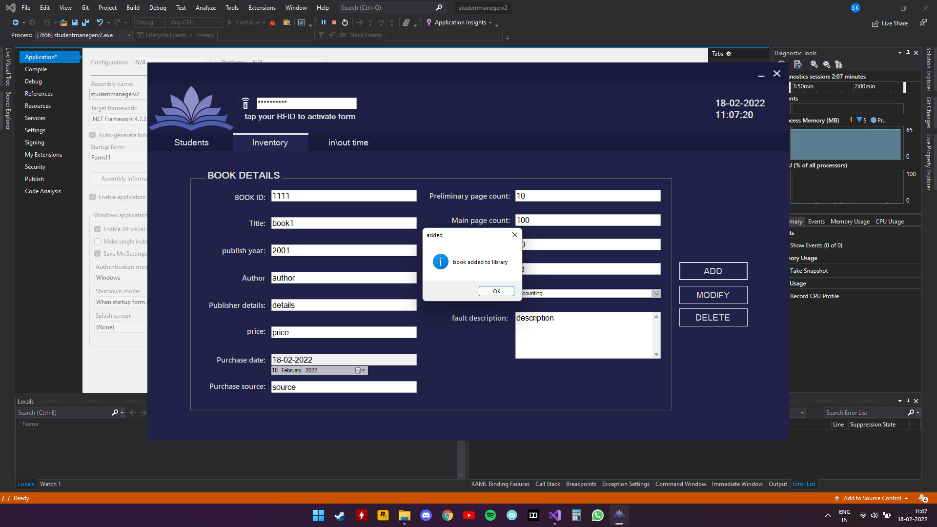

Library attendance

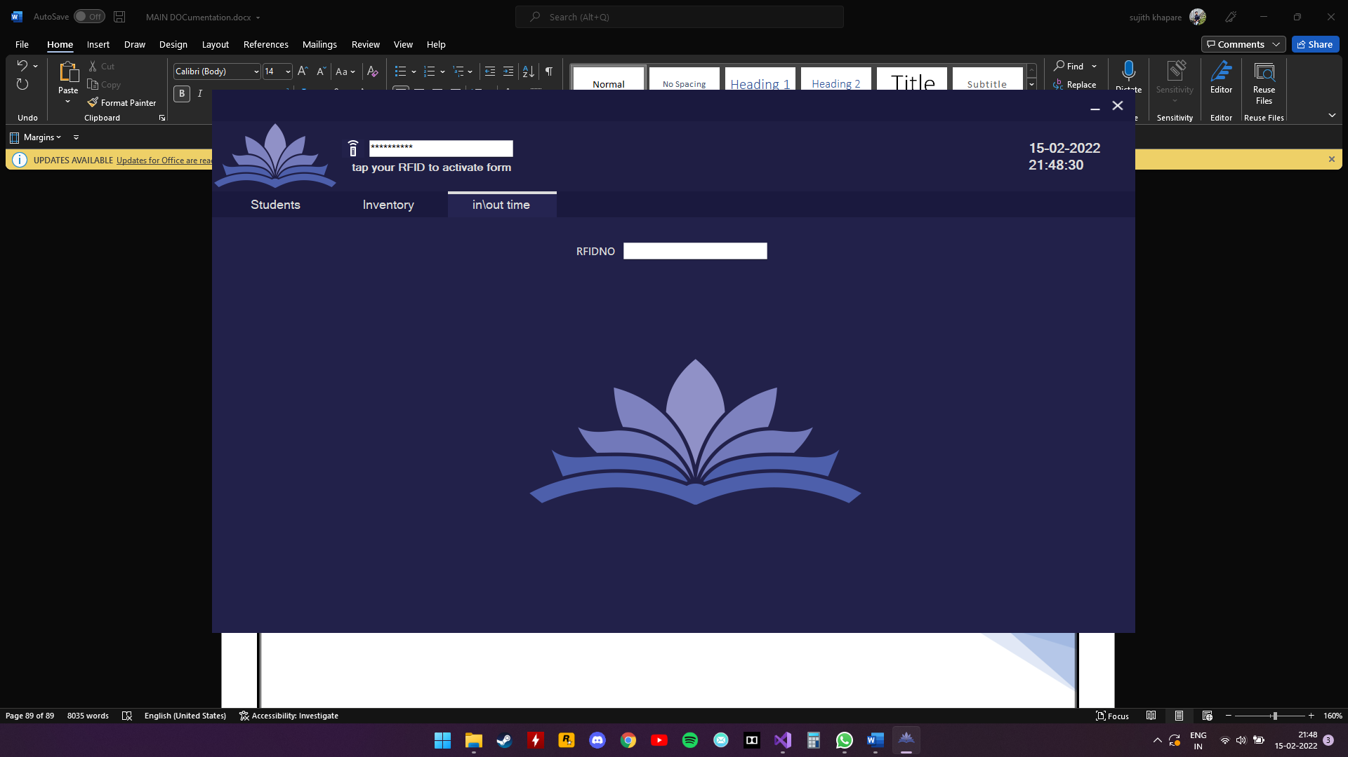

Valid RFID

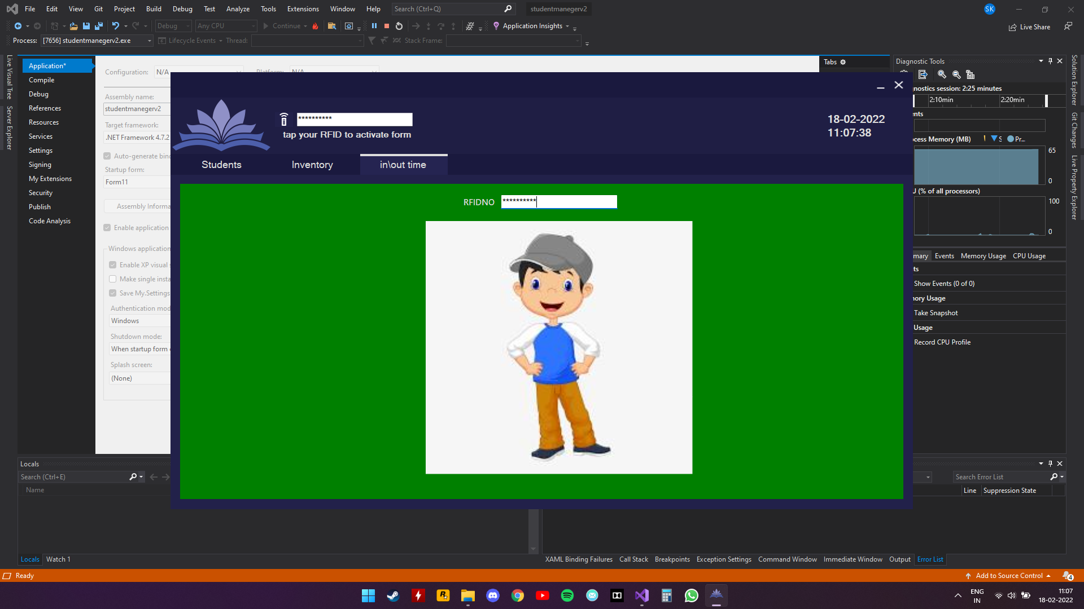

**ACCOUNTANT FORM:**

Finding student from RFID or register number

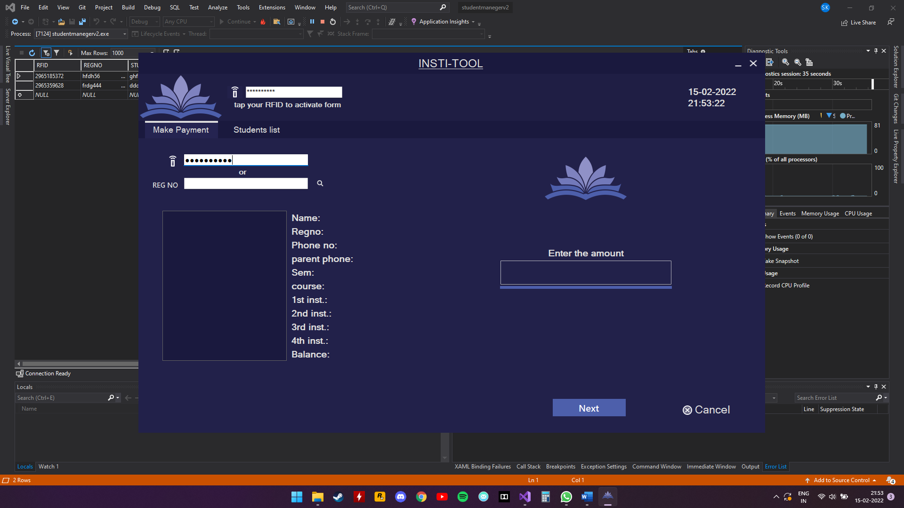

**Payment process**

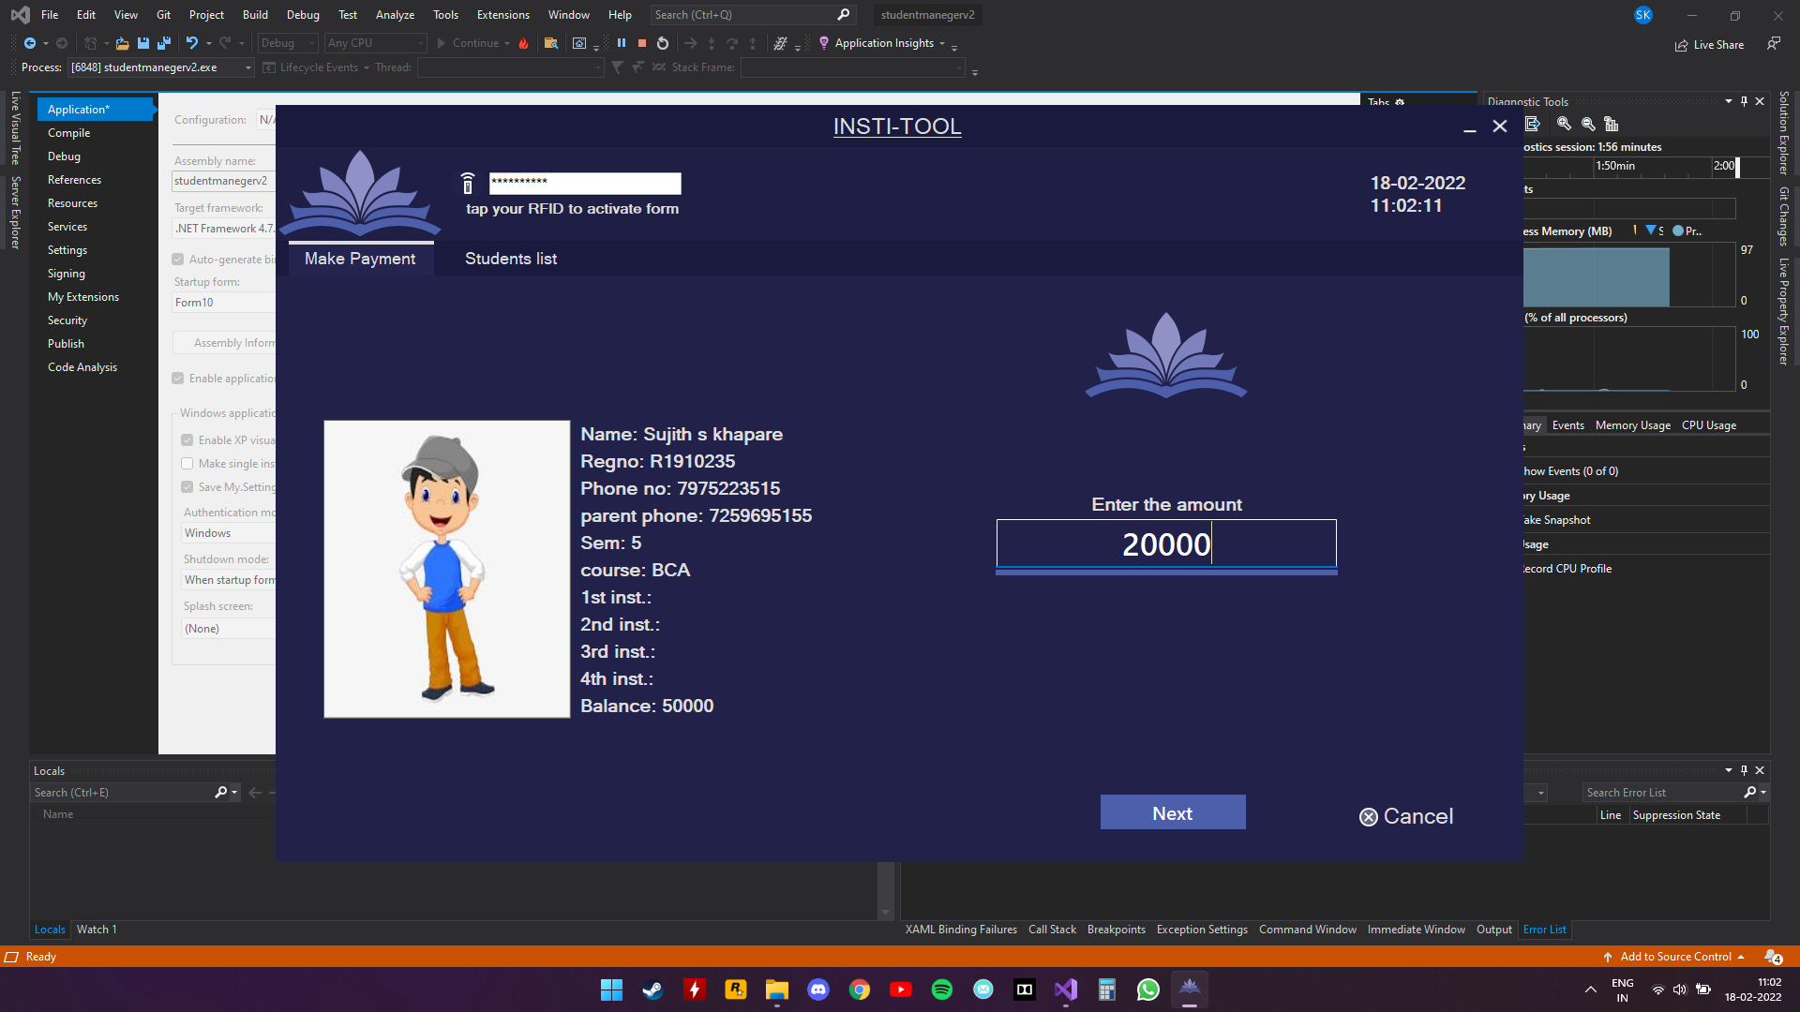

**Payment conformation**

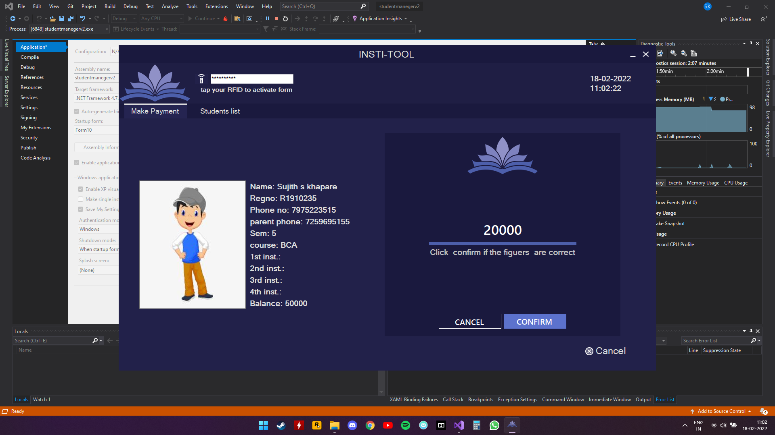

**Auto email after a successful payment**

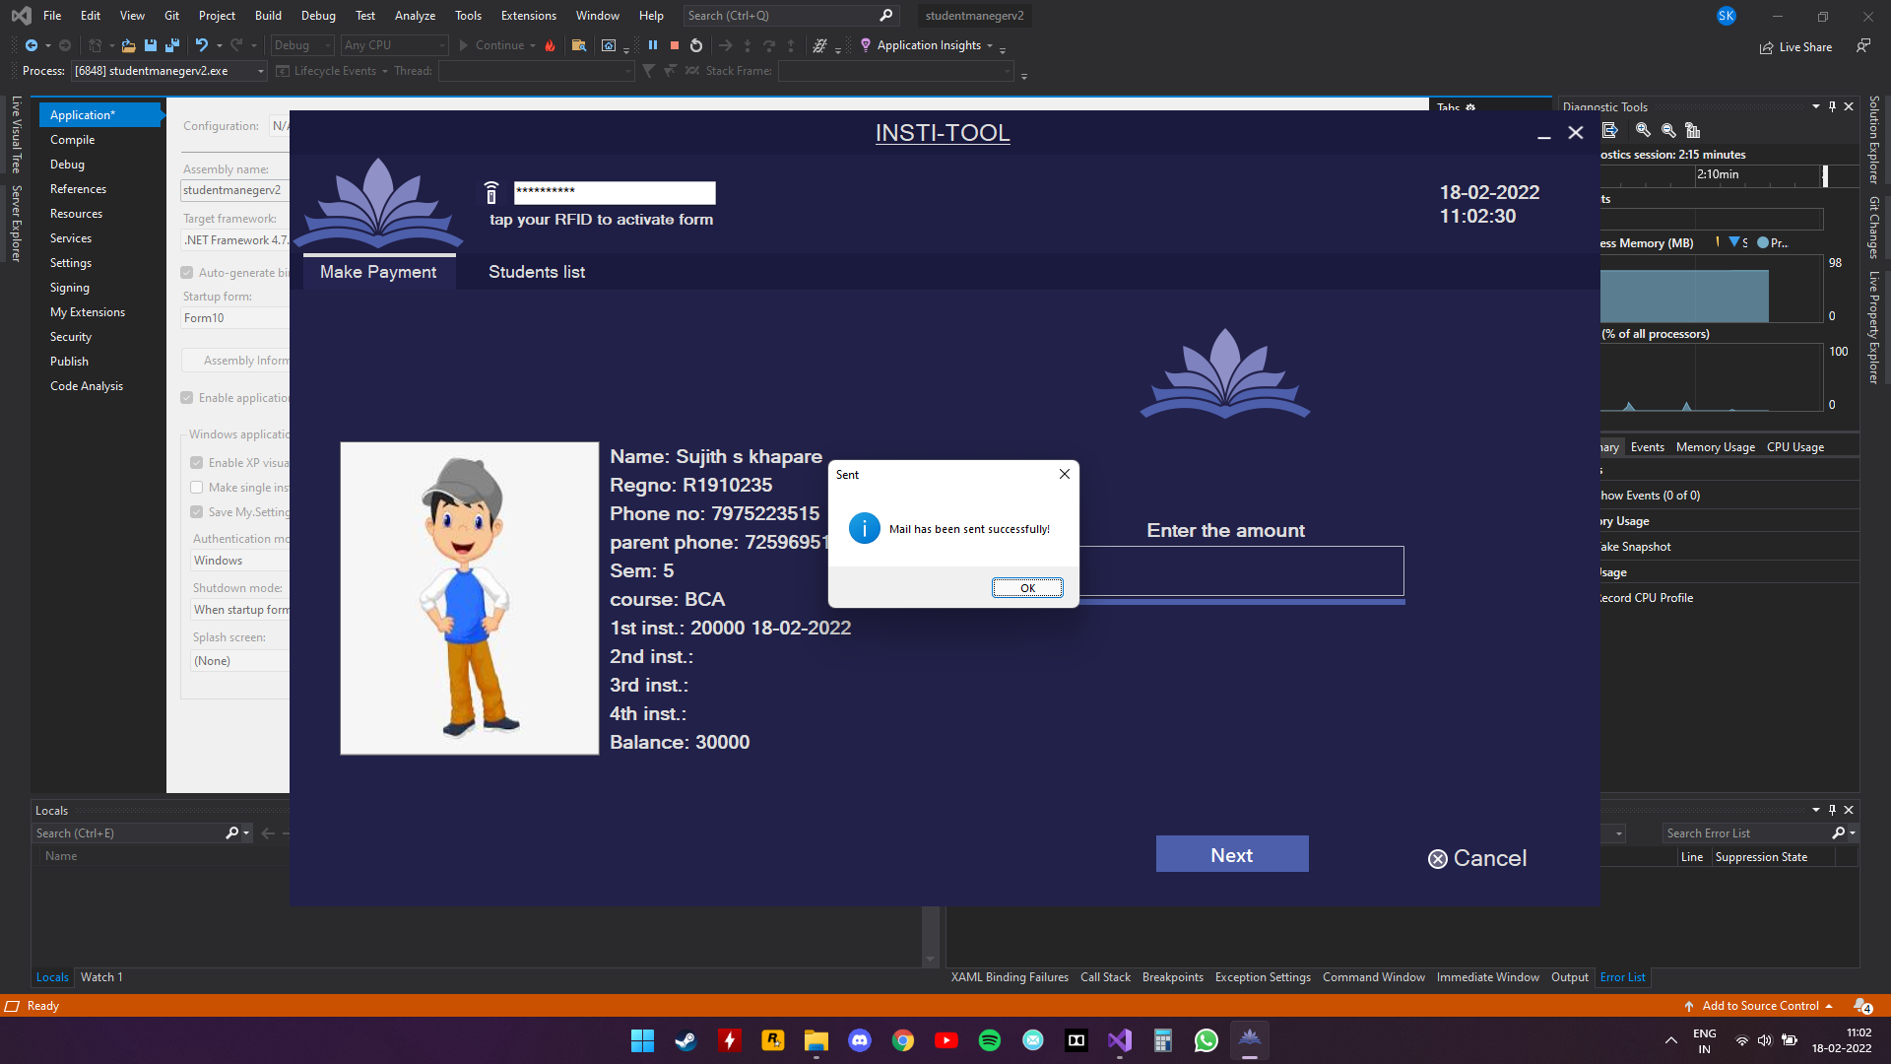

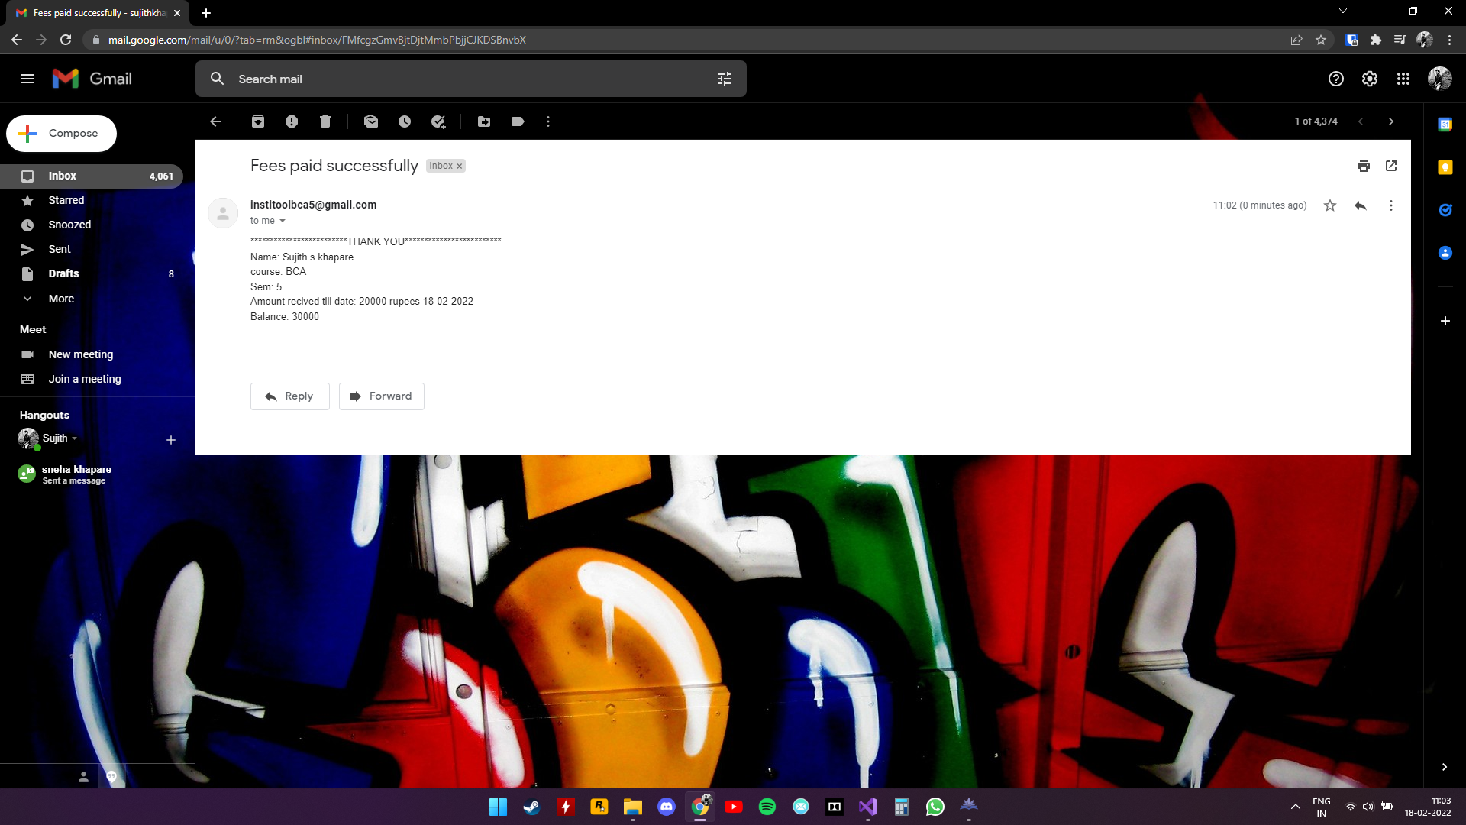

**Sending email remainder to all**

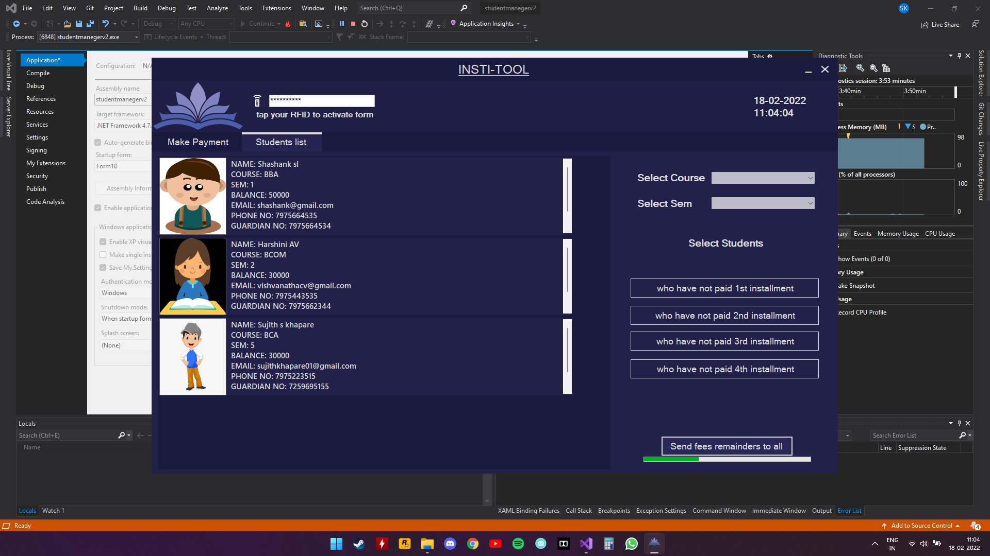

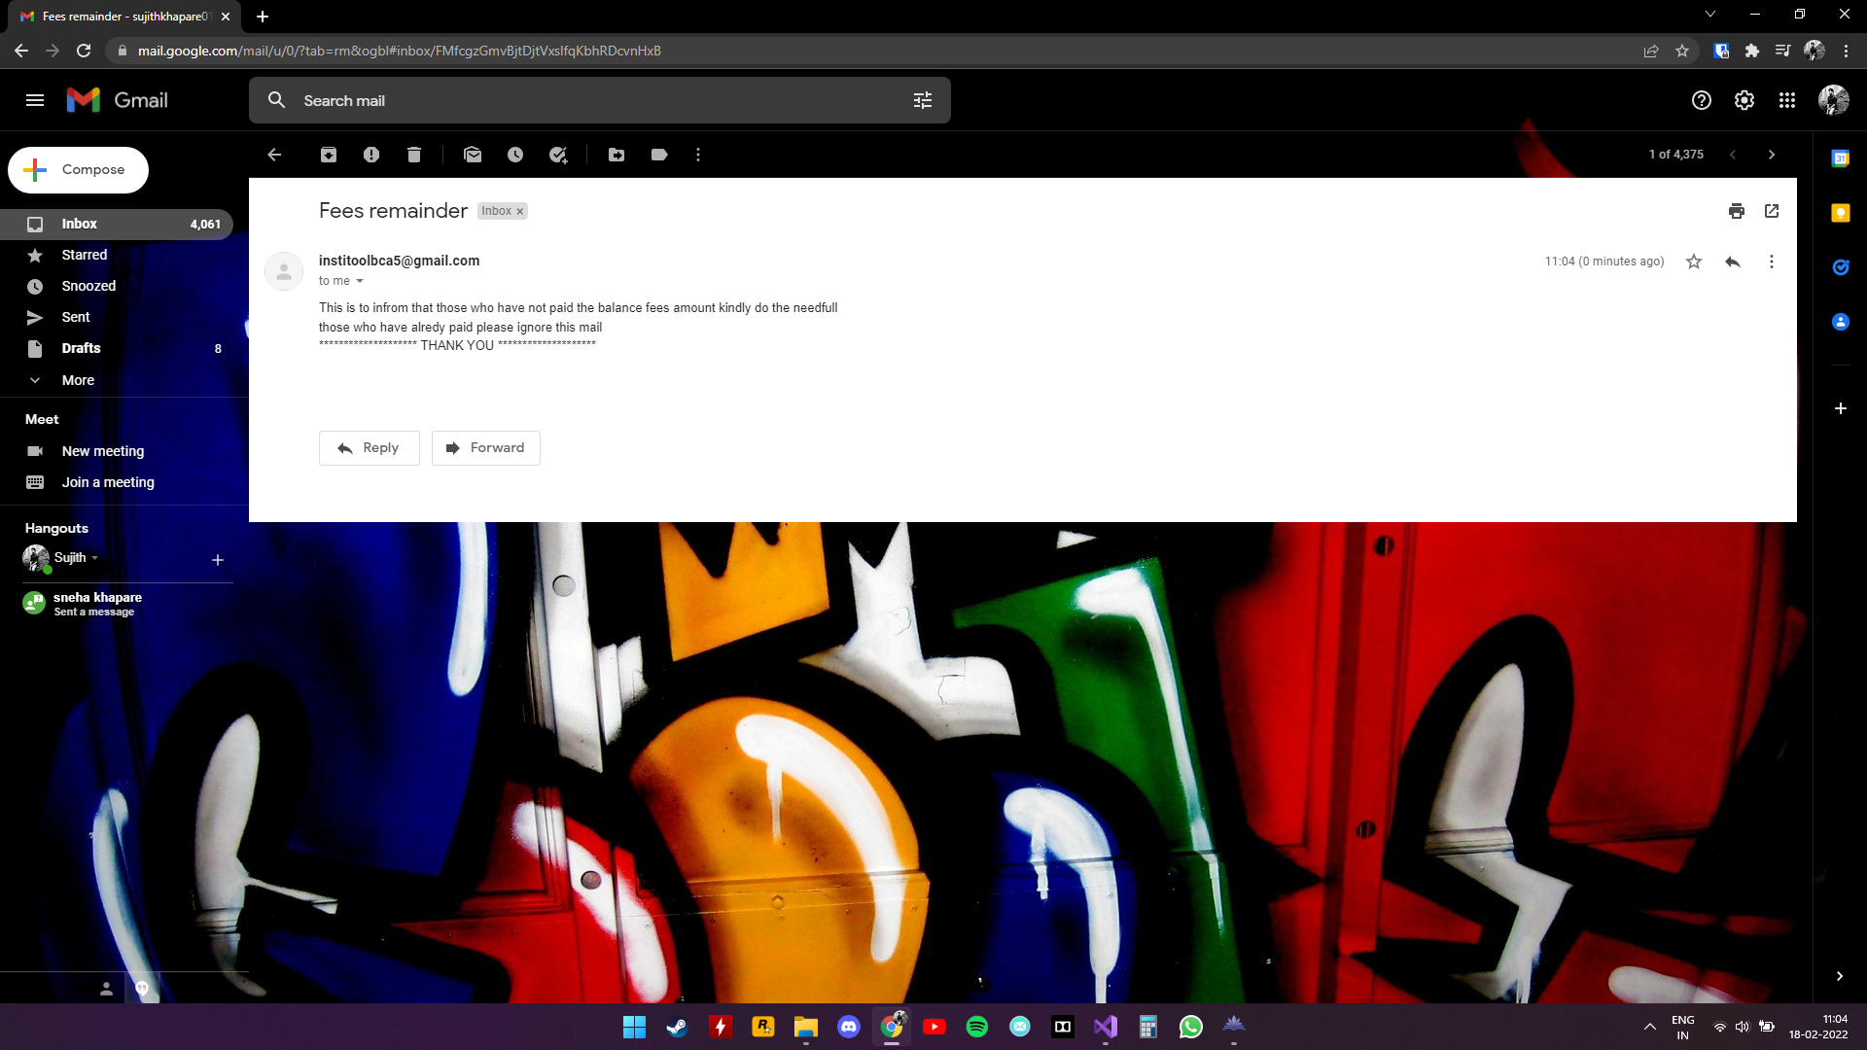

**STUDENT/GUARDIAN FORM:**

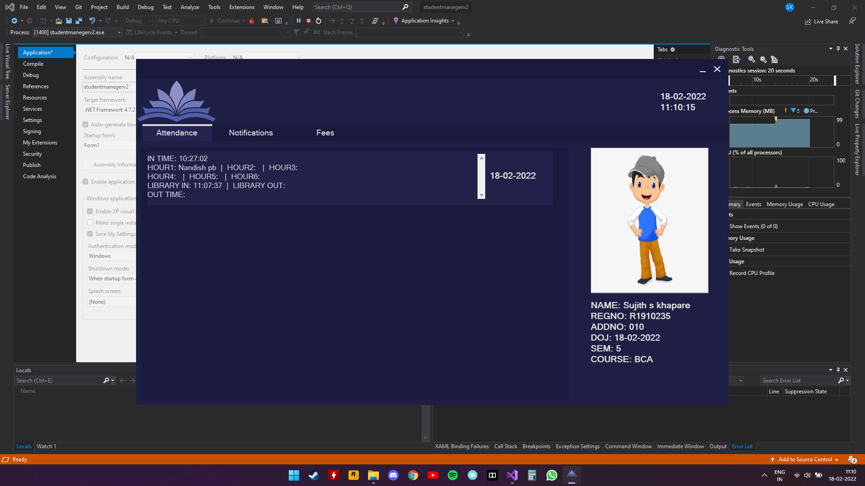

**Notification**

Parents\students can view notifications

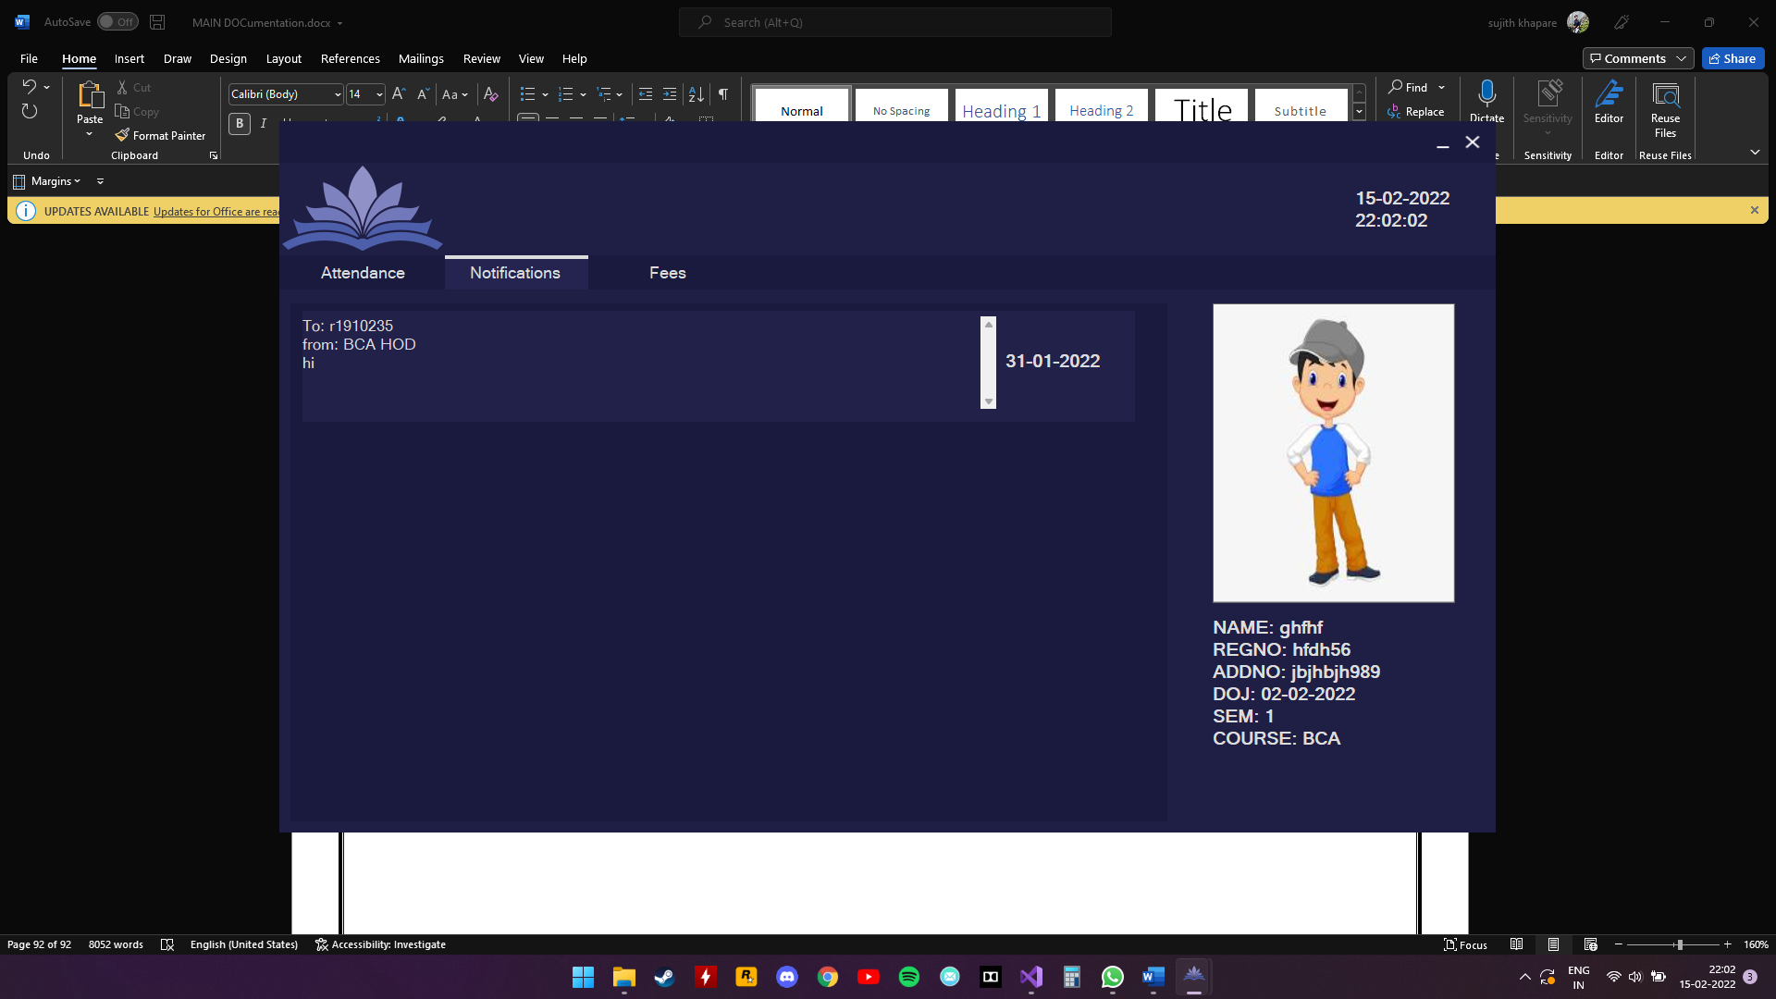

**Fees**

Parents\students can view fees receipts

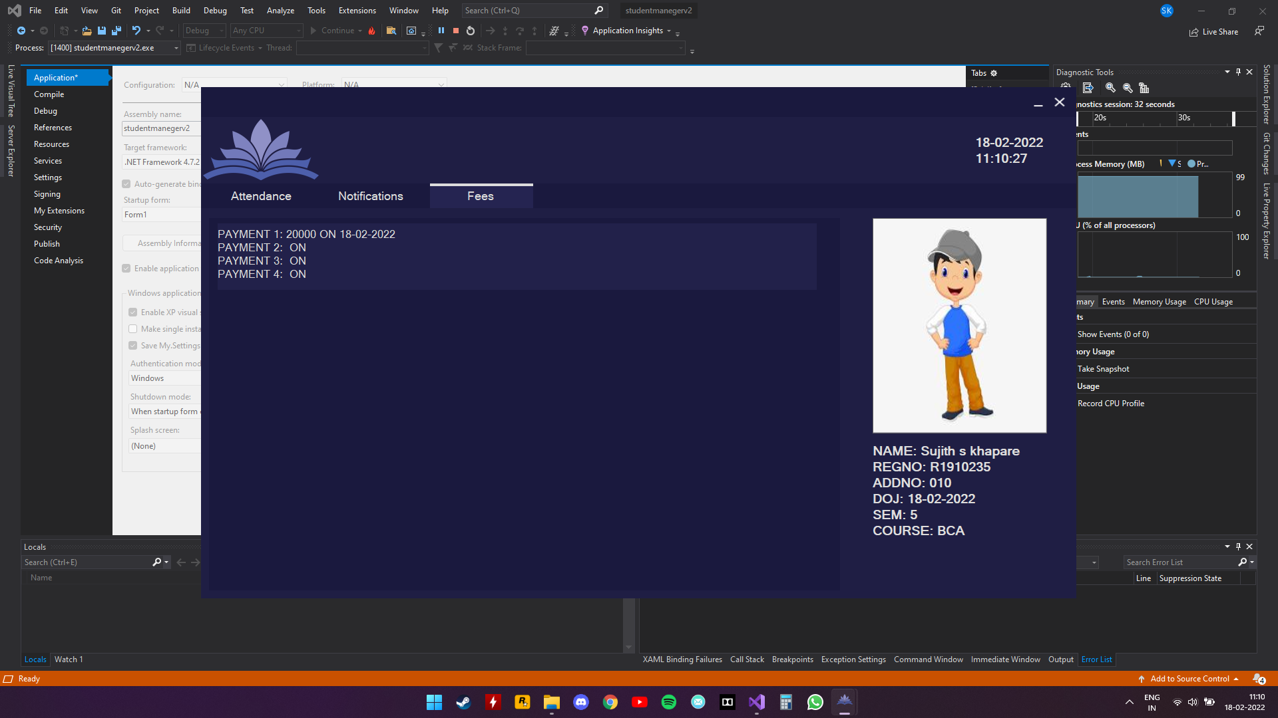

**REPORTS**

**STUDENTS’:**

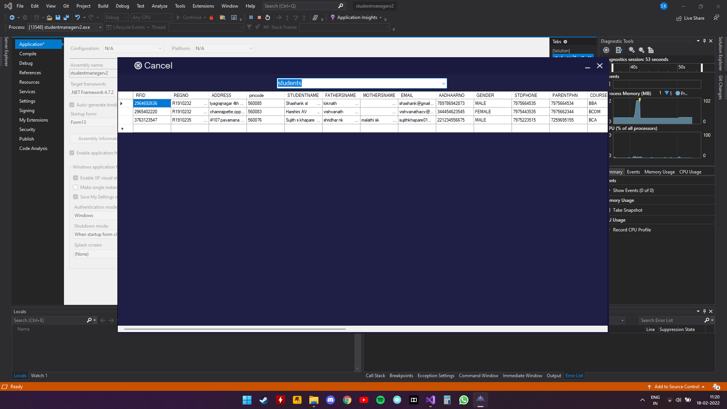



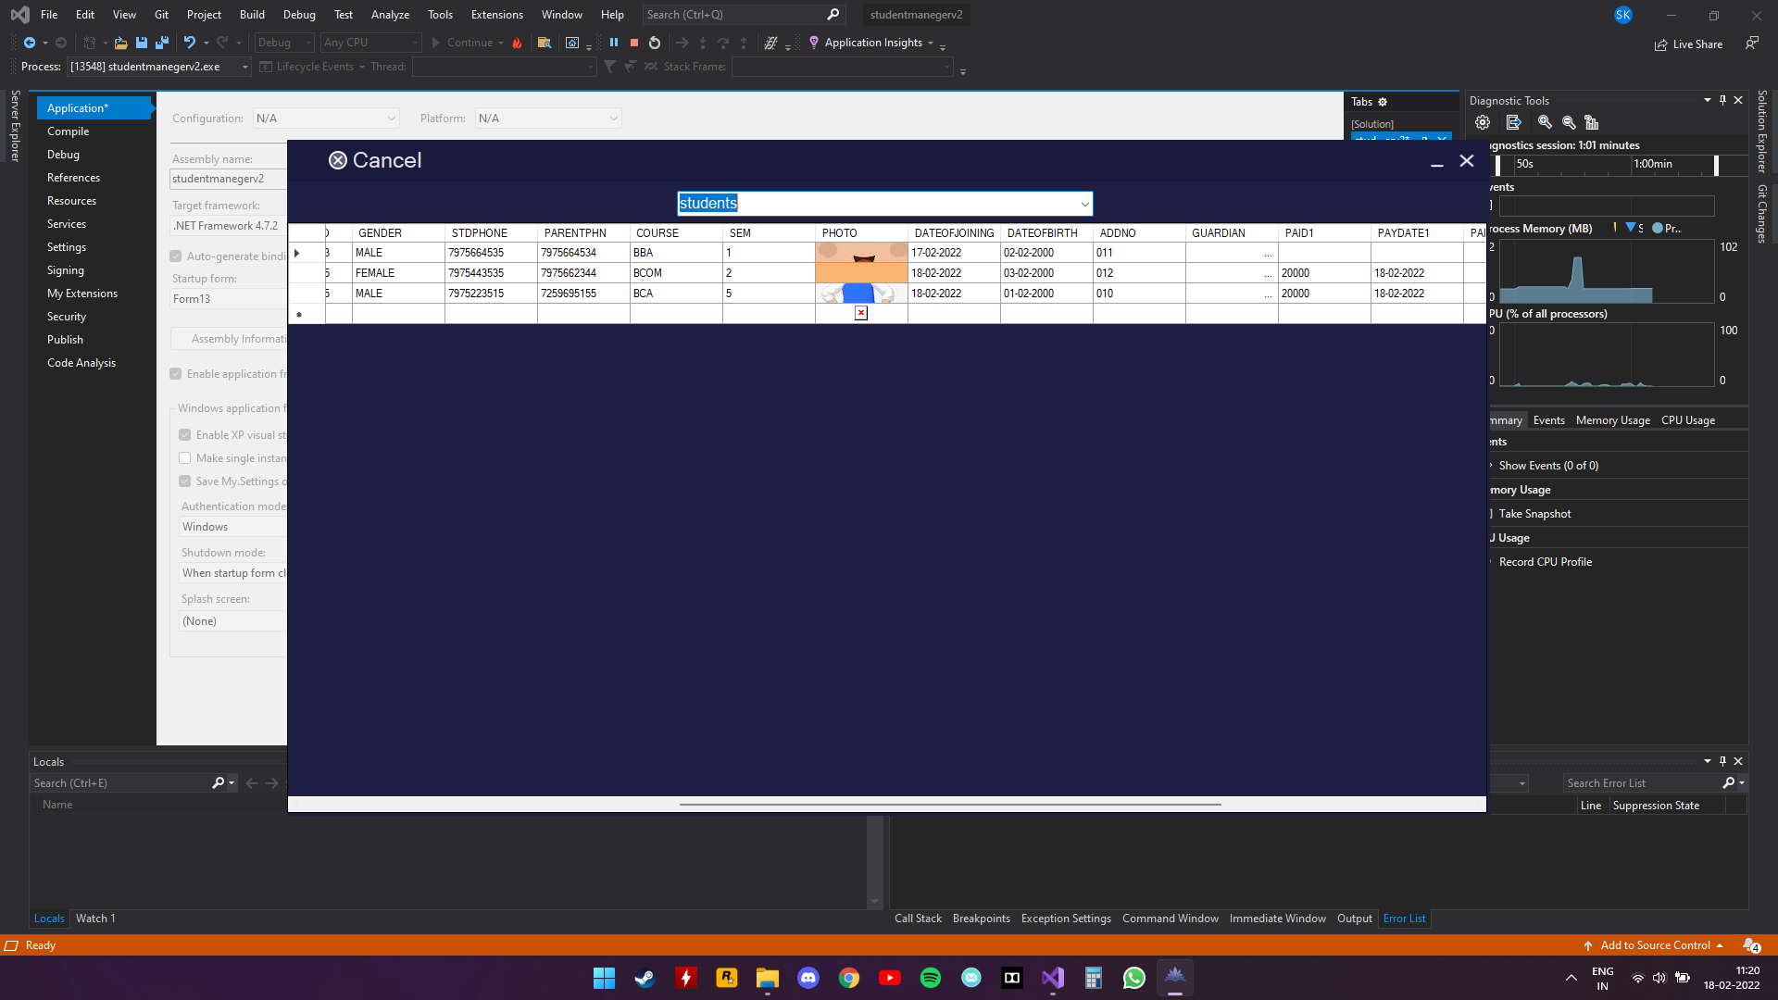



**STAFF:**





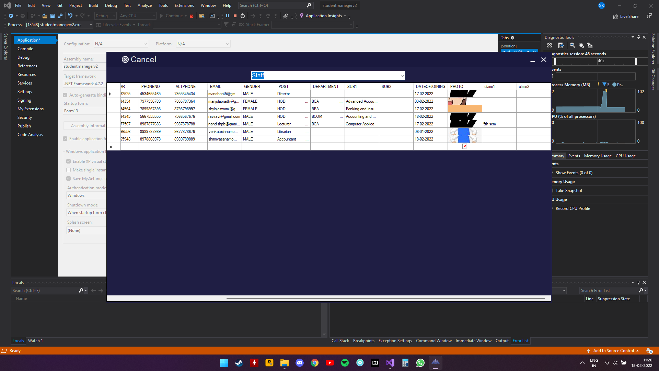

**Notification**

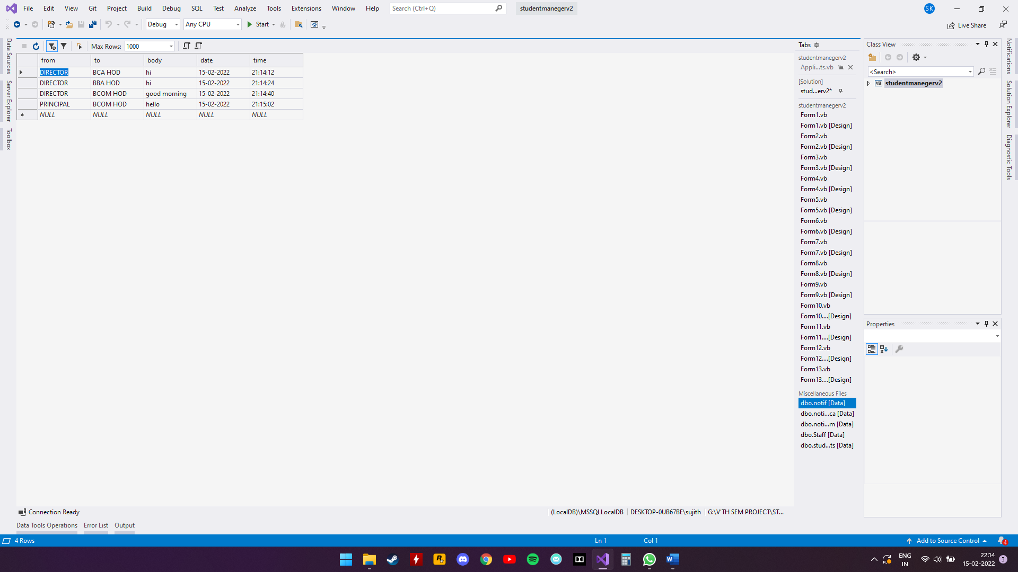

**MAIL**

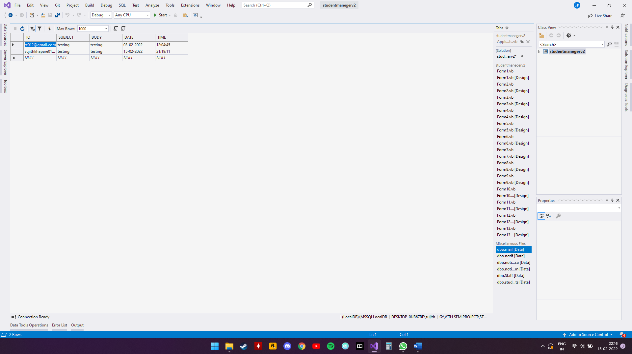

**Attendance:**

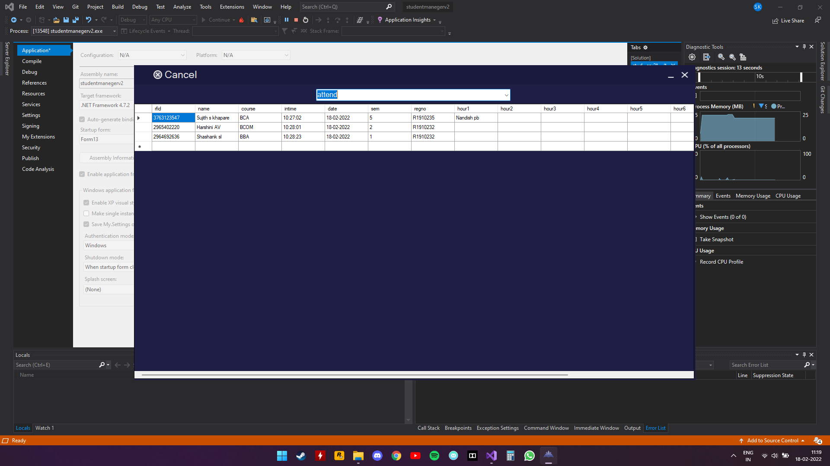

**LIBRARY INVENTORY:**

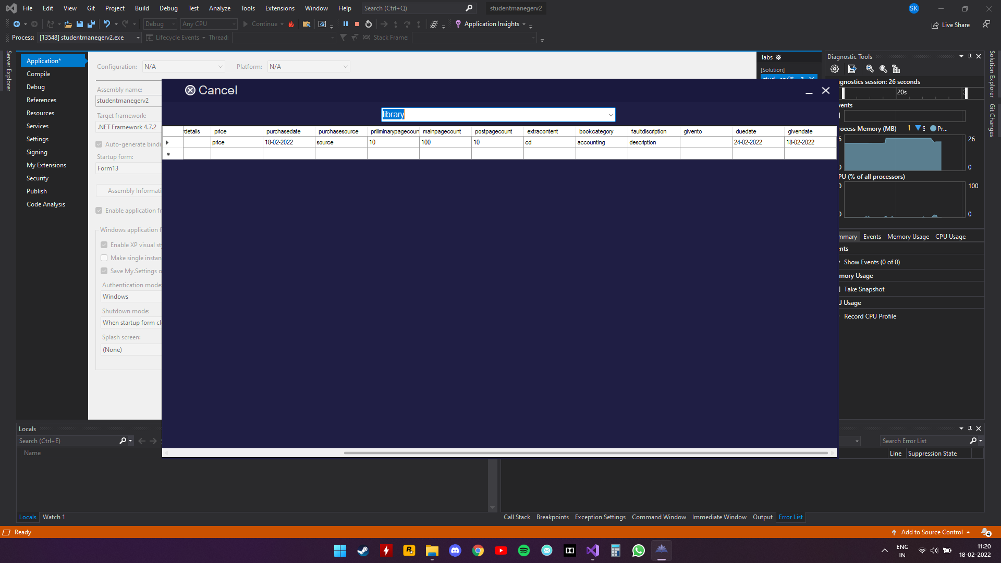



**CONCLUSION**

**CONCLUSION:**

INSTI-TOOL (institution tool) can be used by educational institutions to maintain their student\staff records easily. Achieving this objective is difficult using the manual system as the information is scattered, can be redundant, and collecting relevant information may be very time-consuming. All these problems are solved by this project.

This system helps in maintaining the information of pupils\staff of the organization. It can be easily accessed by the manager and kept safe for a long period of time without any changes.

**FUTURE SCOPE**

**FUTURE SCOPE:**

* It can be updated to maintain transportation service of an institution which provides security even outside the premises
* Monitoring can be updated to measure temperature to ensure healthy environment
* It can be converted into web application
* Cross platform support can be given

**BIBLIOGRAPHY**

**BIBLIOGRAPHY:**

* [**www.stackoverflow.com**](http://www.stackoverflow.com)
* [**www.vbforums.com**](http://www.vbforums.com)
* [**www.vbforums.com**](http://www.vbforums.com)
* [**www.youtube.com**](http://www.youtube.com)
* [**www.w3schools.com**](http://www.w3schools.com)
* [**www.msdn.com**](http://www.msdn.com)
* [**www.microsoftdocs.com**](http://www.microsoftdocs.com)
* [**www.danieweb.com**](http://www.danieweb.com)
* Microsoft Visual Basic 2005 Step by Step Paperback – Import, 5 October 2005

by [Michael Halvorson](https://www.amazon.in/Michael-Halvorson/e/B004N71K46/ref=dp_byline_cont_book_1)